Military History Anniversaries 16 thru 31 Oct

Events in History over the next 15 day period that had U.S. military involvement or impacted in some way on U.S military operations or American interests

- Oct 16 1690 – Colonial America: Battle of Quebec (16-24 OCT) » Fought between the colonies of New France and Massachusetts Bay, then ruled by the kingdoms of France and England, respectively. It was the first time Québec's defenses were tested.

Following the capture of Port Royal in Acadia, during King William's War, the New Englanders hoped to seize Québec itself, the capital of New France. The loss of the Acadian fort shocked the Canadians, and Governor-General Louis de Buade de Frontenac ordered the immediate preparation of the city for siege. When the envoys delivered the terms of surrender, the Governor-General famously declared that his only reply would be by "the mouth of my cannons." Major John Walley led the invading army, which landed at Beauport in the Basin of Québec. However, the militia on the shore were constantly harassed by Canadian militia until their retreat, while the expedition's ships, commanded by Sir William Phips, were nearly destroyed by cannon volley fire from the top of the city. Both sides learned from the battle: the French improved the city's defenses, while the New Englanders realized they needed more artillery and better support from England to take the city.

- Oct 16 1773 – American Revolution Era: Royalton Philadelphia Resolutions Criticize Tea Act » The first public statement against the British Parliament’s Tea Act was a document printed in the Pennsylvania Gazette on this day in 1773. The document became known as the “Philadelphia Resolutions.” The Tea Act of 1773 was a bill designed to save the faltering British East India Company by greatly lowering its tea tax and granting it a virtual monopoly on the American tea trade. The low tax allowed the company to undercut even tea smuggled into America by Dutch traders, and many colonists viewed the act as yet another example of taxation tyranny. In response, the “Philadelphia Resolutions” called the British tax upon America unfair and said that it introduced “arbitrary government and slavery” upon the American citizens. The resolutions urged all Americans to oppose the British tax and stated that anyone who transported, sold or consumed the taxed tea would be considered “an enemy to his country.”

- Oct 16 1775 – American Revolution Era: The Burning of Falmouth | Mowat's Revenge (16-19 Oct) » Five British ships sailed into Falmouth (now Portland, ME) harbor. The commander of this fleet, Henry Mowat, had been held hostage by the citizens of this same town half a year earlier. He was here for revenge. Mowat sent a messenger into the town alerting them to his plan...send out gunpowder, ammunition and hostages or suffer the consequences. Refuse to cooperate and the town would be blasted to bits. The people of Falmouth were Patriots. They had no interest in submitting to Mowat’s demands. Instead, they asked for time to clear the women and children out of town. Mowat, though the villain in this story, was a gentleman. He gave them two days.

By 19 OCT, the city was deserted. At 9:00 in the morning, the cannon fire began. Falmouth was shelled all day long, with much destruction as a result. Not satisfied with the attack, Mowat sent several marines ashore to burn the city manually. Although the local militia did attempt to put up a resistance, they were clearly undermanned. To their credit, the brief fight they put up before the retreat left one Redcoat dead and another wounded. The aftermath of the Burning of Falmouth was astounding. The entire town was burned. At least 300 (and possibly up to 400) buildings were destroyed. A thousand people, almost half of the population, were left homeless while winter began to set in. Though times were tough for the small community, donations and support from the Massachusetts Provincial Government helped them through. It took almost 20 years to fully rebuild the area.

- Oct 16 1780 – American Revolutionary War: Royalton, Vermont and Tunbridge, Vermont are the last major raids of the War.

- Oct 16 1781 – American Revolutionary War: George Washington captures Yorktown, Virginia after the Siege of Yorktown.

- Oct 16 1813 – War of 1812: The United States defeats the British Fleet at the Battle of Lake Erie

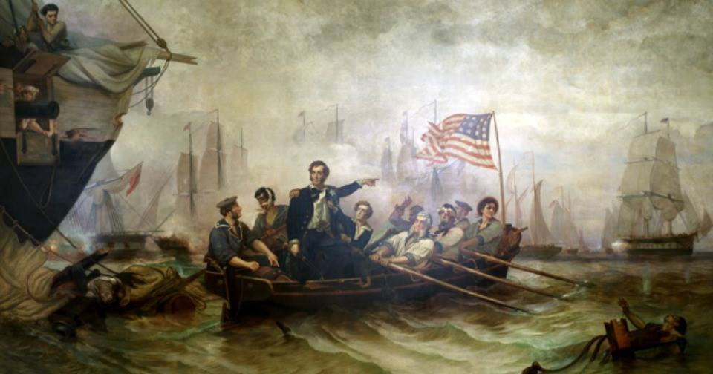

- Oct 16 1813 – Europe: Battle of Leipzig (16-19 Oct) » Also known as Battle of the Nations was fought at Leipzig, Saxony. The Coalition armies of Austria, Prussia, Sweden, and Russia, led by Emperor Alexander I and Karl von Schwarzenberg, decisively defeated the Grande Armée of French Emperor Napoleon I. Napoleon's army also contained Polish and Italian troops, as well as Germans from the Confederation of the Rhine. The battle was the culmination of the German Campaign of 1813 and involved 500,000 soldiers, 2,200 artillery pieces, the expenditure of 200,000 rounds of artillery ammunition, and 127,000 casualties, making it the largest battle in Europe prior to World War I. Decisively defeated again, Napoleon was compelled to return to France while the Sixth Coalition kept up its momentum, dissolving the Confederation of the Rhine and invading France early the next year. Napoleon was forced to abdicate and was exiled to Elba in May 1814.

- Oct 16 1821 – Cuba: The schooner Enterprise, commanded by Lawrence Kearny, engages four pirate schooners and one pirate sloop off Cape Antonio, Cuba who are in the act of robbing two American vessels and one British ship. The pirate leader, Capt. Charles Gibbs, escapes to shore but his ship and two others were burned. The remaining ships are sent to Charleston, S.C. as prizes.

- Oct 16 1854 – Pre Civil War: Lincoln Speaks Out Against Slavery » An obscure lawyer and Congressional hopeful from the state of Illinois named Abraham Lincoln delivers a speech regarding the Kansas-Nebraska Act, which Congress had passed five months earlier. In his speech, the future president denounced the act and outlined his views on slavery, which he called “immoral.”

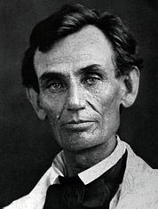

Under the terms of the Kansas-Nebraska Act, two new territories—Kansas and Nebraska—would be allowed into the Union and each territory’s citizens would be given the power to determine whether slavery would be allowed within the territory’s borders. It was believed that the act would set a precedent for determining the legality of slavery in other new territories. Controversy over the act influenced political races across the country that fall. Abolitionists, like Lincoln, hoped to convince lawmakers in the new territories to reject slavery.

Lincoln, who was practicing law at the time, campaigned on behalf of abolitionist Republicans in Illinois and attacked the Kansas-Nebraska Act. He denounced members of the Democratic Party for backing a law that “assumes there can be moral right in the enslaving of one man by another.” He believed that the law went against the founding American principle that “all men are created equal.” Lincoln was an abolitionist at heart, but he realized that the outlawing of slavery in states where it already existed might lead to civil war. Instead, he advocated outlawing the spread of slavery to new states. He hoped this plan would preserve the Union and slowly eliminate slavery by confining it to the South, where, he believed, “it would surely die a slow death.”

Lincoln and his fellow abolitionists were dismayed when Kansans voted a pro-slavery candidate into Congress in November. As Lincoln’s political career picked up momentum over the next several years, he continually referred to the Kansas-Nebraska Act and the seeming inevitability that Kansas should become a slave state as “a violence…it was conceived in violence, passed in violence, is maintained in violence, and is being executed in violence.”

Lincoln continued to actively campaign against slavery in Kansas and helped to raise money to support anti-slavery candidates in that state. Meanwhile he continued his law practice and ran for the U.S. Senate in 1859. Although he lost to Democrat Stephen Douglas, Lincoln began to make a name for himself in national politics and earned increasing support from the North and abolitionists across the nation. It was this constituency that helped him win the presidency in 1860.

- Oct 16 1859 – Civil War: John Brown's Raid on Harpers Ferry (16-18 Oct) » Abolitionist John Brown leads a small group on a raid against a federal armory in Harpers Ferry, Virginia (now West Virginia), in an attempt to start an armed slave revolt and destroy the institution of slavery.
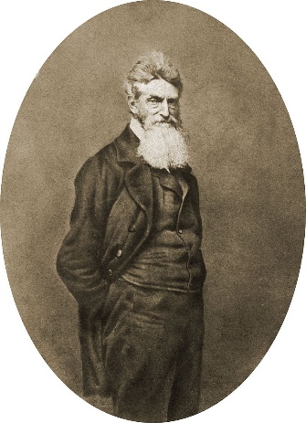

Born in Connecticut in 1800 and raised in Ohio, Brown came from a staunchly Calvinist and antislavery family. He spent much of his life failing at a variety of businesses–he declared bankruptcy at age 42 and had more than 20 lawsuits filed against him. In 1837, his life changed irrevocably when he attended an abolition meeting in Cleveland, during which he was so moved that he publicly announced his dedication to destroying the institution of slavery. As early as 1848 he was formulating a plan to incite an insurrection.

In the 1850s, Brown traveled to Kansas with five of his sons to fight against the proslavery forces in the contest over that territory. On May 21, 1856, proslavery men raided the abolitionist town of Lawrence, and Brown personally sought revenge. On May 25, Brown and his sons attacked three cabins along Pottawatomie Creek. They killed five men with broad swords and triggered a summer of guerilla warfare in the troubled territory. One of Brown’s sons was killed in the fighting. By 1857, Brown returned to the East and began raising money to carry out his vision of a mass uprising of slaves. He secured the backing of six prominent abolitionists, known as the “Secret Six,” and assembled an invasion force. His “army” grew to include 22 men, including five black men and three of Brown’s sons. The group rented a Maryland farm near Harpers Ferry and prepared for the assault.

On the night of October 16, 1859, Brown and his band overran the arsenal. Some of his men rounded up a handful of hostages, including a few slaves. Word of the raid spread, and by morning Brown and his men were surrounded. A company of U.S. marines arrived on 17 OCT, led by Colonel Robert E. Lee and Lieutenant J. E. B. Stuart. On the morning of 19 OCT, the soldiers overran Brown and his followers. Ten of his men were killed, including two of his sons.

The wounded Brown was tried by the state of Virginia for treason and murder, and he was found guilty on 2 NOV. The 59-year-old abolitionist went to the gallows on December 2, 1859. Before his execution, he handed his guard a slip of paper that read, “I, John Brown, am now quite certain that the crimes of this guilty land will never be purged away but with blood.” It was a prophetic statement. Although the raid failed, it inflamed sectional tensions and raised the stakes for the 1860 presidential election. Brown’s raid helped make any further accommodation between North and South nearly impossible and thus became an important impetus of the Civil War.

- Oct 16 1861 – Civil War: The Union screw steamer South Carolina captures the schooner Edward Barnard, with a cargo of turpentine on board, at Southwest Pass, Mississippi River.

- Oct 16 1891 – Chile: Two sailors from the cruiser Baltimore are killed and 17 are injured by a mob in Valparaiso, Chile. The incident shifts relations between the United States and Chile. In 1892 Chile pays $75,000 in gold for restitution and apologizes for the incident.

- Oct 16 1934 – China Civil War: The Long March » The embattled Chinese Communists under the leadership of Mao Tse-tung break through Nationalist Chiang Kai-shek’s enemy lines and begin an epic flight from their encircled headquarters in southwest China. Known as Ch’ang Cheng—the “Long March”—the retreat lasted 368 days and covered 6,000 miles, nearly twice the distance from New York to San Francisco.

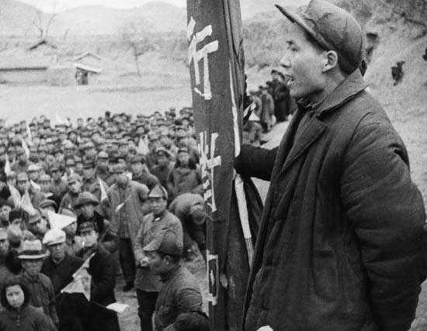
Mao Zedong (aka. Mao Tse-tung) addressing a group of his followers in 1944

Civil war in China between the Nationalists and the Communists broke out in 1927. In 1931, Communist leader Mao Zedong was elected chairman of the newly established Soviet Republic of China, based in Jiangxi province in the southeast. Between 1930 and 1934, the Nationalists under Chiang Kai-shek launched a series of five encirclement campaigns against the Soviet Republic. Under the leadership of Mao, the Communists employed guerrilla tactics to resist successfully the first four campaigns, but in the fifth, Chiang raised 700,000 troops and built fortifications around the Communist positions. Hundreds of thousands of peasants were killed or died of starvation in the siege, and Mao was removed as chairman by the Communist Central Committee. The new Communist leadership employed more conventional warfare tactics, and its Red Army was decimated.

With defeat imminent, the Communists decided to break out of the encirclement at its weakest points. The Long March began at 5:00 p.m. on October 16, 1934. Secrecy and rear-guard actions confused the Nationalists, and it was several weeks before they realized that the main body of the Red Army had fled. The retreating force initially consisted of 86,000 troops, 15,000 personnel, and 35 women. Weapons and supplies were borne on men’s backs or in horse-drawn carts, and the line of marchers stretched for 50 miles. The Communists generally marched at night, and when the enemy was not near, a long column of torches could be seen snaking over valleys and hills into the distance.

The first disaster came in November, when Nationalist forces blocked the Communists’ route across the Hsiang River. It took a week for the Communists to break through the fortifications and cost them 50,000 men—more than half their number. After that debacle, Mao steadily regained his influence, and in January he was again made chairman during a meeting of the party leaders in the captured city of Tsuni. Mao changed strategy, breaking his force into several columns that would take varying paths to confuse the enemy. There would be no more direct assaults on enemy positions. And the destination would now be Shaanxi Province, in the far northwest, where the Communists hoped to fight the Japanese invaders and earn the respect of China’s masses.

After enduring starvation, aerial bombardment, and almost daily skirmishes with Nationalist forces, Mao halted his columns at the foot of the Great Wall of China on October 20, 1935. Waiting for them were five machine-gun- and red-flag-bearing horsemen. “Welcome, Chairman Mao,” one said. “We represent the Provincial Soviet of Northern Shensi. We have been waiting for you anxiously. All that we have is at your disposal!” The Long March was over.

The Communist marchers crossed 24 rivers and 18 mountain ranges, mostly snow-capped. Only 4,000 troops completed the journey. The majority of those who did not perished. It was the longest continuous march in the history of warfare and marked the emergence of Mao Zedong as the undisputed leader of the Chinese Communists. Learning of the Communists’ heroism and determination in the Long March, thousands of young Chinese traveled to Shensi to enlist in Mao’s Red Army. After fighting the Japanese for a decade, the Chinese Civil War resumed in 1945. Four years later, the Nationalists were defeated, and Mao proclaimed the People’s Republic of China. He served as chairman until his death in 1976.

- Oct 16 1940 – U.S. Army: Benjamin O. Davis becomes the U.S. Army’s first African American Brigadier General.

- Oct 16 1941 – WW2 Era: U.S. Navy destroyers escorting Atlantic convoy use depth charges against U-boats daily thru 1 NOV.

- Oct 16 1942 – WW2: USS Thresher (SS 200) mines the approaches to Bangkok, Thailand, the first U.S. Navy submarine mine plant during the war.

- Oct 16 1943 – U.S. Navy: The Navy accepts its first helicopter, a Sikorsky YR-4B (HNS-1) at Bridgeport, Ct., following a 60-minute test flight by U.S. Coast Guard Lt. Cmdr. Frank A. Erickson.

- Oct 16 1944 – U.S. Navy: USS Tilefish (SS 307) sinks Japanese guard boat No.2 Kyowa Maru five miles north of Matsuwa Jima, Kuril Islands.

- Oct 16 1946 – Post WW2: Nazi War Criminals Executed » At Nuremberg, Germany, 10 high-ranking Nazi officials are executed by hanging for their crimes against humanity, crimes against peace, and war crimes during World War II.

Two weeks earlier, the 10 were found guilty by the International War Crimes Tribunal and sentenced to death along with two other Nazi officials. Among those condemned to die by hanging were Joachim von Ribbentrop, Nazi minister of foreign affairs; Hermann Goering, founder of the Gestapo and chief of the German air force; and Wilhelm Frick, minister of the interior. Seven others, including Rudolf Hess, Adolf Hitler’s former deputy, were given prison sentences ranging from 10 years to life. Three others were acquitted.

The trial, which had lasted nearly 10 months, was conducted by an international tribunal made up of representatives from the United States, the USSR, France, and Great Britain. It was the first trial of its kind in history, and the defendants faced charges ranging from crimes against peace, to crimes of war and crimes against humanity. On 16 OCT, 10 of the architects of Nazi policy were hanged one by one. Hermann Goering, who at sentencing was called the “leading war aggressor and creator of the oppressive program against the Jews,” committed suicide by poison on the eve of his scheduled execution. Nazi Party leader Martin Bormann was condemned to death in absentia; he is now known to have died in Berlin at the end of the war.

- Oct 16 1946 – Post WW2: Alfred Rosenberg is Executed » The primary fabricator and disseminator of Nazi ideology in America, is hanged as a war criminal. Rosenberg studied architecture at the University of Moscow. After receiving his degree, he stayed in Russia through the early days of the Russian Revolution and may have even flirted with communism briefly. In 1919, he immigrated to Munich, and met up with Dietrich Eckart, the poet-turned-editor of the Voelkischer Beobachter, the propagandistic newspaper of the Nazi Party. Through Eckart, Rosenberg met Adolf Hitler and Rudolf Hess and joined the newly formed Nazi Party.

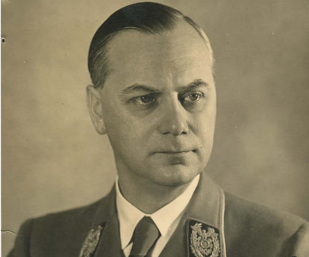

Hitler replaced Eckart with Rosenberg as editor of the paper, so impressed was Hitler with the “intellectual” architect. Rosenberg immediately began using the news organ to disseminate his racist philosophy, now also the official Nazi philosophy, which was cobbled together from the writings of two men extremely influential on Germany’s growing anti-Semitism, racism, and grandiose self-perception. Rosenberg’s roles during the war included working, from his Office of Foreign Affairs, with Norwegian fascist Vidkun Quisling in the overthrow of Norway’s government. Rosenberg was also responsible for overseeing the transportation of stolen artworks from Vichy France to Germany. At the Nuremberg trials, Rosenberg was found guilty of war crimes and ordered hanged.

- Oct 16 1962 – Cold War: Cuban Missile Crisis (16-24 Nov) » This was a 35 day confrontation between the United States and the Soviet Union which escalated into an international crisis when American deployments of missiles in Italy and Turkey were matched by Soviet deployments of similar ballistic missiles in Cuba. Despite the short time frame, the Cuban Missile Crisis remains a defining moment in U.S. national security and nuclear war preparation. The confrontation is often considered the closest the Cold War came to escalating into a full-scale nuclear war.

In response to the presence of American Jupiter ballistic missiles in Italy and Turkey, and the failed Bay of Pigs Invasion of 1961, Soviet First Secretary Nikita Khrushchev agreed to Cuba's request to place nuclear missiles on the island to deter a future invasion. An agreement was reached during a secret meeting between Khrushchev and Cuban Prime Minister Fidel Castro in July 1962, and construction of a number of missile launch facilities started later that summer. Meanwhile, the 1962 United States elections were under way, and the White House denied charges for months that it was ignoring dangerous Soviet missiles 90 miles from Florida. The missile preparations were confirmed when an Air Force U-2 spy plane produced clear photographic evidence of medium-range R-12 (NATO code name SS-4) and intermediate-range R-14 (NATO code name SS-5) ballistic missile facilities.

When this was reported to President John F. Kennedy, he then convened a meeting of the nine members of the National Security Council and five other key advisers in a group that became known as the Executive Committee of the National Security Council (EXCOMM). During this meeting, President Kennedy was originally advised to carry out an air strike on Cuban soil in order to compromise Soviet missile supplies, followed by an invasion of the Cuban mainland. After careful consideration, President Kennedy chose a less aggressive course of action to avoid a declaration of war. After consultation with them, Kennedy ordered a naval "quarantine" on 22 OCT to prevent further missiles from reaching Cuba. By declaring a quarantine rather than a blockade, the United States was able to avoid a further conflict. This quarantine fell short of a traditional blockade and so avoided the implications of a state of war. The US announced it would not permit offensive weapons to be delivered to Cuba and demanded that the weapons already in Cuba be dismantled and returned to the Soviet Union.

After several days of tense negotiations, an agreement was reached between Kennedy and Khrushchev. Publicly, the Soviets would dismantle their offensive weapons in Cuba and return them to the Soviet Union, subject to United Nations verification, in exchange for a US public declaration and agreement to not invade Cuba again. Secretly, the United States agreed that it would dismantle all of the Jupiter MRBMs, which had been deployed in Turkey against the Soviet Union. There has been debate on whether or not Italy was included in the agreement as well. While the Soviets dismantled their missiles, some Soviet bombers remained in Cuba, forcing the Naval quarantine to stay in place until November 20 of that year.

When all offensive missiles and the Ilyushin Il-28 light bombers had been withdrawn from Cuba, the blockade was formally ended on 20 NOV. The negotiations between the United States and the Soviet Union pointed out the necessity of a quick, clear, and direct communication line between the two Superpowers. As a result, the Moscow–Washington hotline was established. A series of agreements later reduced US–Soviet tensions for several years until both parties eventually resumed expanding their nuclear arsenals.

- Oct 16 1964 – Cold War: China Joins A-bomb Club » The People’s Republic of China joins the rank of nations with atomic bomb capability, after a successful nuclear test on this day. China is the fifth member of this exclusive club, joining the United States, the Soviet Union, Great Britain, and France.

U.S. officials were not terribly surprised by the test; intelligence reports since the 1950s indicated that China was working to develop an atomic bomb, possibly aided by Soviet technicians and scientists. Nevertheless, the successful test did cause concern in the U.S. government. During the early 1960s, China took a particularly radical stance that advocated worldwide revolution against the forces of capitalism, working strenuously to extend its influence in Asia and the new nations of Africa. The test, coming just two months after the Tonkin Gulf Resolution (a congressional resolution giving President Lyndon B. Johnson the power to respond to communist aggression in Vietnam) created a frightening specter of nuclear confrontation and conflict in Southeast Asia.

The test also concerned the Soviet Union; the split between the USSR and communist China over ideological and strategic issues had widened considerably by 1964. The Chinese acquisition of nuclear capabilities only heightened the tensions between the two nations. Indeed, the test might have been a spur to the Soviets to pursue greater efforts to stop the proliferation of nuclear weapons; in 1968, the United States and the Soviet Union signed the Treaty on the Non-Proliferation of Nuclear Weapons. Little wonder that the Soviets would wish to see China’s nuclear force limited, since the first Chinese intermediate-range missiles were pointedly aimed at Russia. The Cold War nuclear arms race had just become a good deal more complicated.

- Oct 16 1968 – Vietnam War: Bombing Halt Discussed » In a series of meetings with U.S. Ambassador Ellsworth Bunker, South Vietnamese President Nguyen Van Thieu insists that North Vietnam assent to three conditions prior to a bombing halt. He said the North Vietnamese had to (1) agree to respect the neutrality of the Demilitarized Zone (DMZ), (2) stop shelling South Vietnamese cities and towns, and (3) agree to South Vietnamese participation in the Paris talks. He also demanded that the National Liberation Front, the Communist political organization in South Vietnam, be excluded from the negotiations. Thieu seemed to soften during his discussions with Bunker: on 22 OCT, he announced that he would not oppose a bombing halt.

- Oct 16 1973 – Vietnam War: Henry Kissinger and Le Duc Tho are awarded Nobel Peace Prize for negotiating the Paris peace accords. Kissinger accepted, but Tho declined the award until such time as “peace is truly established.

- Oct 16 1973 – Israel: Israeli General Ariel Sharon crosses the Suez Canal and begins to encircle two Egyptian armies.

- Oct 16 1993 – U.S. Navy: USS Kearsarge (LHD 3) is commissioned at Pascagoula, Miss. The Navy’s third Wasp-class amphibious assault ship is the fifth named for Mount Kearsarge in New Hampshire, although the fourth commissioned into the Navy. The name also honors the Union sloop-of-war Kearsarge of Civil War fame that sank CSS Alabama June 19, 1864 near Cherbourg Harbor, France. The ship is homeported at Norfolk, Va.

-o-o-O-o-o-

- Oct 17 1777 – American Revolutionary War: Americans Win More Than a Battle at Saratoga » British general and playwright John Burgoyne surrenders 5,000 British and Hessian troops to American General Horatio Gates at Saratoga, New York, on this day in 1777.

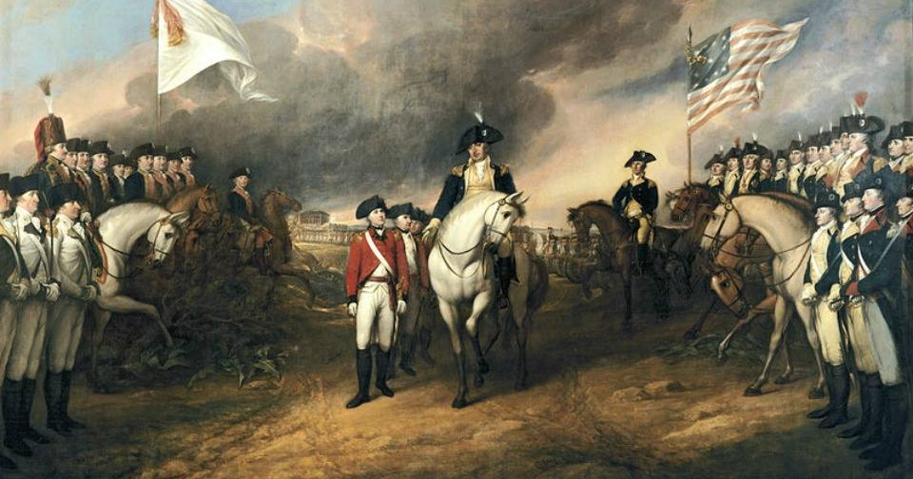

In the summer of 1777, General Burgoyne led an army of 8,000 men south through New York in an effort to join forces with British General Sir William Howe’s troops along the Hudson River. After capturing several forts, Burgoyne’s force camped near Saratoga while a larger Patriot army under General Gates gathered just four miles away. On September 19, a British advance column marched out and engaged the Patriot force at the Battle of Freeman’s Farm, or the First Battle of Saratoga. Failing to break through the American lines, Burgoyne’s force retreated. On October 7, another British reconnaissance force was repulsed by an American force under General Benedict Arnold in the Battle of Bemis Heights, also known as the Second Battle of Saratoga.

Gates retreated north to the village of Saratoga with his 5,000 surviving troops. By 13 OCT, some 20,000 Americans had surrounded the British, and four days later Burgoyne was forced to agree to the first large-scale surrender of British forces in the Revolutionary War. Burgoyne successfully negotiated that his surviving men would be returned to Britain by pledging that they would never again serve in North America. The nearly 6,000-man army was kept in captivity at great expense to the Continental Congress until the end of the war.

Soon after word of the Patriot victory at Saratoga reached France, King Louis XVI agreed to recognize the independence of the United States and French Foreign Minister Charles Gravier, Count de Vergennes, made arrangements with U.S. Ambassador Benjamin Franklin to begin providing formal French aid to the Patriot cause. This assistance was crucial to the eventual American victory in the Revolutionary War.

- Oct 17 1781 – American Revolutionary War: British peer and Lieutenant General Charles Cornwallis surrenders at the Siege of Yorktown, marking a decisive victory by a combined force of American Continental Army troops led by General George Washington and French Army troops led by the Comte de Rochambeau. The culmination of the Yorktown campaign, the siege proves to be the last major land battle of the Revolutionary War in the North American theater, as the surrender by Cornwallis, and the capture of both him and his army, prompt the British government to negotiate an end to the conflict.

- Oct 17 1814 – Louisiana: US Marines and Sailors landed on Grand Terre Island, LA to punish pirates.

- Oct 17 1835 – Mexico*Texas: Texas Rangers Created » Texans approve a resolution to create the Texas Rangers, a corps of armed and mounted lawmen designed to “range and guard the frontier between the Brazos and Trinity Rivers.”

In the midst of their revolt against Mexico, Texan leaders felt they needed a semi-official force of armed men who would defend the isolated frontier settlers of the Lone Star Republic against both Santa Ana’s soldiers and hostile Indians; the Texas Rangers filled this role. But after winning their revolutionary war with Mexico the following year, Texans decided to keep the Rangers, both to defend against Indian and Mexican raiders and to serve as the principal law enforcement authority along the sparsely populated Texan frontier.

Although created and sanctioned by the Texas government, the Rangers was an irregular body made up of civilians who furnished their own horses and weapons. Given the vast expanse of territory they patrolled and the difficulty of communicating with the central government, the government gave the men of the Rangers considerable independence to act as they saw fit. Sometimes the Rangers served as a military force, taking on the role of fighting the Indians that in the U.S. was largely the responsibility of the Army. At other times the Rangers mainly served as the principal law enforcement power in many frontier regions of Texas, earning lasting fame for their ability to track down and eliminate outlaws, cattle thieves, train robbers, and murderers, including such notorious bandits as John Wesley Hardin and King Fisher.

Even as late as the first two decades of the 20th century, the state of Texas continued to rely on the Rangers to enforce order in the wilder regions of the state, like the oil boomtowns along the Rio Grande. Increasingly, though, some Texans began to criticize the Rangers, arguing that they used excessive violence and often failed to observe the finer points of the law when apprehending suspects. As a result, in the 1930s, the state won control over the Rangers, transforming it into a modern and professional law enforcement organization.

- Oct 17 1863 – Civil War: Sailors from the Union screw steam gunboat Tahoma and side-wheel steamer Adela board the blockade runners Scottish Chief and Kate Dale at Old Tampa Bay, Fla. and destroy them. During the battle, five of the landing party are killed, 10 are wounded and five are taken prisoner. This mission also diverts the real attention from the shelling of Tampa, Fla.

- Oct 17 1863 – Old West: General Ulysses S. Grant is named overall Union Commander of the West.

- Oct 17 1864 – Civil War: Longstreet Returns to Command » Confederate General James Longstreet assumes command of his corps in Robert E. Lee’s Army of Northern Virginia. Wounded at the Battle of the Wilderness in Virginia in May of that year, Longstreet missed the campaign for Richmond, Virginia, and spent five months recovering before returning to his command. Longstreet was one of the most effective corps commanders in the war.

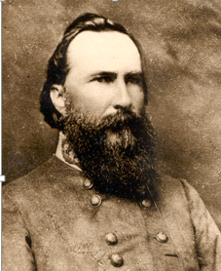

- Oct 17 1877 – Old West: Brigadier General Alfred Terry meets with Sitting Bull in Canada to discuss the Indians’ return to the United States.

- Oct 17 1906 – Germany: A Shoemaker Leads German Soldiers in a Robbery » Wilhelm Voigt, a 57-year-old German shoemaker, impersonates an army officer and leads an entire squad of soldiers to help him steal 4,000 marks. Voigt, who had a long criminal record, humiliated the German army by exploiting their blind obedience to authority and getting them to assist in his audacious robbery.

Wearing a captain’s uniform, Voigt approached a troop of soldiers in Tegel, Germany, just outside Berlin and ordered the unit to follow him 20 miles to the town of Kopenik. After lunch, he put the men in position and stormed into the mayor’s office. Declaring that the mayor was under arrest, Voigt commanded the troops to take him into custody. He then demanded to see the cash box and confiscated the 4,000 marks inside. The mayor was put in a car, and Voigt ordered that he be delivered to the police in Berlin.

On the way to Berlin, Voigt managed to disappear with the money. Still, it took more than a few hours at the police station before everyone realized that it was all a hoax. Although the Kaiser thought the story was funny, the German army didn’t find it so amusing, and a massive campaign to find Voigt was instituted. Days later, Voigt was caught in Berlin. He received a four-year sentence for his caper, but the Kaiser himself pulled some strings to get him out in less than two. Voigt wound up a folk hero for the rest of his days. Wearing the captain’s uniform, he posed for pictures for years.

- Oct 17 1912 – First Balkan War: Serbia and Greece Declare War on Ottoman Empire » following the example of Montenegro, their smaller ally in the tumultuous Balkan region of Europe, Serbia and Greece declare war on the Ottoman Empire, beginning the First Balkan War in earnest.

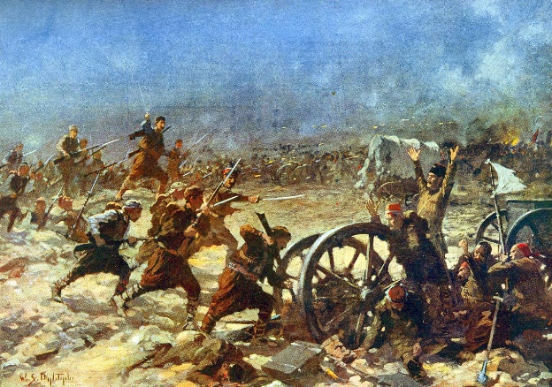

Four years earlier, a rebellion in Ottoman-held Macedonia by the nationalist society known as the Young Turks had shaken the stability of the sultan’s rule in Europe. Austria-Hungary had acted quickly to capitalize on this weakness, annexing the dual Balkan provinces of Bosnia and Herzegovina and urging Bulgaria, also under Turkish rule, to proclaim its independence. These actions quickly upset the delicate balance of power on the Balkan Peninsula: Ambitious Serbia was outraged, considering Bosnia-Herzegovina to be part of its own rightful territory due to their shared Slavic heritage. Czarist Russia, the other great power with influence in the region—and a strong supporter of Serbia—also felt threatened by Austria’s actions.

By the spring of 1912, Russia had encouraged the cluster of Balkan nations—Serbia, Bulgaria, Montenegro and Greece—to form an alliance aimed at taking control of some or all of the European territory still occupied by the Ottoman Empire. Though often at odds with one another, the disparate Balkan peoples were able to join forces when driven by the singular goal of striking at a distracted Turkey, by then ensnared in a war with Italy over territory in Libya. Montenegro declared war on October 8, 1912; Serbia, Bulgaria and Greece followed suit nine days later.

The outcome of the First Balkan War surprised many, as the combined Balkan forces quickly and decisively defeated the Ottoman army, driving the Turks from almost all of their territory in southeastern Europe within a month. In the wake of Turkey’s withdrawal, the great European powers—Britain, France, Germany, Austria-Hungary and Russia—scrambled to exert control over the region, convening a congress with the belligerent nations in London in December 1912 to draw up post-war boundaries in the Balkans. The resulting agreement—which partitioned Macedonia between the four victorious Balkan powers—led to a peace concluded on May 30, 1913, which nonetheless left Bulgaria feeling cheated out of its rightful share by Serbia and Greece. This led to a Second Balkan War just one month later, in which Bulgaria turned against its two former allies in a surprise attack ordered by King Ferdinand I without consultation with his own government.

In the ensuing conflict, Bulgaria was quickly defeated by forces from Serbia, Greece, Turkey and Romania. By the terms of the Treaty of Bucharest, signed 10 AUG, Bulgaria lost a considerable amount of territory, and Serbia and Greece received control of most of Macedonia. In the wake of the two Balkan wars, tensions in the region only increased, simmering just beneath the surface and threatening to explode at any point. Austria-Hungary—which had expected first Turkey and then Bulgaria to triumph and had badly wanted to see Serbia crushed—became increasingly wary of growing Slavic influence in the Balkans, in the form of the upstart Serbia and its sponsor, Russia. Significantly, the Dual Monarchy’s own powerful ally, Germany, shared this concern.

In a letter to the Austro-Hungarian foreign minister in October 1913 that foreshadowed the devastating global conflict to come, Kaiser Wilhelm II characterized the outcome of the Balkan wars as “a historic process to be classed in the same category as the great migrations of people, the present case was a powerful forward surge of the Slavs. War between East and West was in the long run inevitable…The Slavs are born not to rule but to obey.”

- Oct 17 1913 – Germany: Military Zeppelin LII (also known as LZ 18) exploded near Johannisthal Air Field about 10 miles southeast of Berlin. Accident happened because hydrogen escaped and got into engine. 28 died.

- Oct 17 1918 – WW1: German submarine U-155 torpedoes and sinks the freighter S.S. Lucia in the Atlantic. Despite being rigged with buoyancy boxes to render her virtually unsinkable, a torpedo penetrates the engine room, killing two men and sinking her the next day. USS Fairfax (DD 93) rescues her crew and transfers them to armored cruiser No. 5 USS Huntington.

- Oct 17 1922 – U.S. Navy: The Vought VE-7SF, piloted by Lt. Cmdr. Virgil C. Griffin, makes the Navy’s first carrier takeoff from USS Langley (CV 1), anchored in York River, Va.

- Oct 17 1933 – Germany: Due to rising anti-Semitism and anti-intellectualism in Hitler’s Germany, Albert Einstein, the Nobel-prize-winning physicist, flees Nazi Germany and moves to the United States. He will become an American citizen in 1940 and on the eve of World War II warn President Franklin D. Roosevelt of the potential development of “extremely powerful bombs of a new type,” recommending that the United States begin similar research.

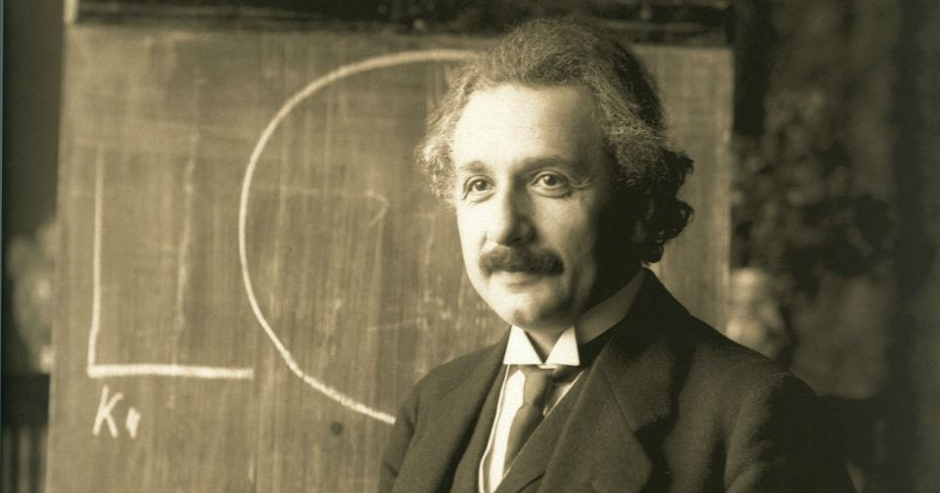

- Oct 17 1941 –WW2 Era: Before the United States entry into World War II, German submarine U-568 torpedoes and damages USS Kearny (DD 432) while escorting a convoy near Iceland, killing 11 and injuring 22.

- Oct 17 1941 – WW2 Era: The U.S. destroyer Kearny is damaged by a German U-boat torpedo off Iceland; 11 Americans are killed.

- Oct 17 1941 –WW2 Era: Konoye Government Falls » The government of Prince Fumimaro Konoye, prime minister of Japan collapses, leaving little hope for peace in the Pacific.

- Oct 17 1942 – WW2: USS Trigger (SS 237) sinks the Japanese freighter Holland Maru near the mouth of Bungo Strait off Kyushu, Japan. Lost in action with all hands later in the war, Trigger receives 11 battle stars for her World War II service and the Presidential Unit Citation for her fifth, sixth, and seventh war patrols.

- Oct 17 1943 – WW2: USS Tarpon (SS 175) sinks German auxiliary cruiser Michel (Schiffe No. 28) off Chichi Jima, Bonin Islands.

- Oct 17 1944 – WW2: USS Escolar (SS–294) missing. Possibly sunk by a Japanese mine in the Yellow Sea. 82 killed.

- Oct 17 1944 – WW2: Naval forces land Army rangers on islands at the entrance to Leyte Gulf in preparation for landing operations on Leyte Island.

- Oct 17 1966 – Vietnam War: President Johnson Goes to Asia » Johnson leaves Washington for a 17-day trip to seven Asian and Pacific nations and a conference scheduled in Manila where he met with other Allied leaders who had forces in South Vietnam and they pledged to withdraw their troops within six months if North Vietnam “withdraws its forces to the North and ceases infiltration of South Vietnam.” A communiqué signed by the seven participants (the Philippines, Australia, New Zealand, South Korea, South Vietnam, Thailand, and the United States) included a four-point “Declaration of Peace” that stressed the need for a “peaceful settlement of the war in Vietnam and for future peace and progress” in the rest of Asia and the Pacific. When the conference concluded on October 26, Johnson flew to South Vietnam for a surprise two-and-a-half hour visit with U.S. troops at Cam Ranh Bay.

- Oct 17 1972 – Vietnam War: Peace talks between the Pathet Lao and the Royal Lao government begin in Vietnam.

- Oct 17 1986 – U.S.*Nicaragua: U.S. Aid to Contras Signed into Law » In a short-lived victory for the Nicaraguan policy of the Reagan administration, the President signs into law an act of Congress approving $100 million of military and “humanitarian” aid for the Contras. Unfortunately for Ronald Reagan and his advisors, the Iran-Contra scandal is just about to break wide open, seriously compromising their goal of overthrowing the leftist Sandinista government in Nicaragua.

Congress, and a majority of the American public, had not been supportive of the Reagan administration’s efforts to topple the Sandinista government in Nicaragua. Reagan began a “secret war” to bring down the Nicaraguan government soon after taking office in 1981. Millions of dollars, training, and arms were funneled to the Contras (an armed force of Nicaraguan exiles intent on removing the leftist Nicaraguan regime) through the CIA. American involvement in the Contra movement soon became public, however, as did disturbing reports about the behavior of the Contra force. Charges were leveled in newspapers and in Congress that the Contras were little more than murderers and drug runners; rumors of corruption and payoffs were common. Congress steadily reduced U.S. assistance to the Contras, and in 1984 passed the second Boland Amendment prohibiting U.S. agencies from giving any aid to the group.

Even before this action, however, the Reagan administration had been covertly subverting any attempts to limit the Contra war through extra-legal and illegal means (one result being the Iran-Contra scandal). Even with this illegal aid the Contra effort stalled by late 1985. Reagan went on a full pressure media campaign to convince the American people and Congress that the Contras were worthy of assistance. Reagan claimed that the Sandinista government was a satellite of the Soviet Union, that Nicaragua was instigating revolution in neighboring Central American nations, and that the Contras were merely to be used as a “shield” against any possible Sandinista encroachments in the region. He was able to convince Congress to provide $100 million of aid, some of it designated as “humanitarian” assistance to the hungry and sick Contras and their supporters.

However, news sources began to break the story about the Iran-Contra scandal only a short time later. Congress began an investigation into the Reagan administration’s clandestine and illegal support of the Contras during the years prior to the passage of the $100 million aid package. The investigation uncovered a scheme whereby some of the funds from illegal U.S. arms sales to Iran were funneled to the Contras. The Contra war effort staggered on, creating death and destruction in the Nicaraguan countryside and little else, until a peace plan put together by Costa Rican President Oscar Arias was finally accepted by the Sandinista government. In 1990, elections were held in Nicaragua, which resulted in the Sandinistas losing the presidency.

-o-o-O-o-o-

- Oct 18 1767 – American Colonies: Mason and Dixon Draw a Line Dividing the Colonies » Charles Mason and Jeremiah Dixon complete their survey of the boundary between the colonies of Pennsylvania and Maryland as well as areas that would eventually become the states of Delaware and West Virginia. The Penn and Calvert families had hired Mason and Dixon, English surveyors, to settle their dispute over the boundary between their two proprietary colonies, Pennsylvania and Maryland.

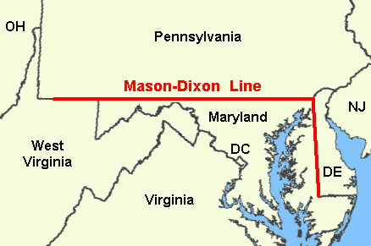

In 1760, tired of border violence between the colonies’ settlers, the British crown demanded that the parties involved hold to an agreement reached in 1732. As part of Maryland and Pennsylvania’s adherence to this royal command, Mason and Dixon were asked to determine the exact whereabouts of the boundary between the two colonies. Though both colonies claimed the area between the 39th and 40th parallel, what is now referred to as the Mason-Dixon line finally settled the boundary at a northern latitude of 39 degrees and 43 minutes. The line was marked using stones, with Pennsylvania’s crest on one side and Maryland’s on the other.

When Mason and Dixon began their endeavor in 1763, colonists were protesting the Proclamation of 1763, which was intended to prevent colonists from settling beyond the Appalachians and angering Native Americans. As the Britons concluded their survey in 1767, the colonies were engaged in a dispute with the Parliament over the Townshend Acts, which were designed to raise revenue for the empire by taxing common imports including tea.

Twenty years later, in late 1700s, the states south of the Mason-Dixon line would begin arguing for the perpetuation of slavery in the new United States while those north of line hoped to phase out the ownership of human chattel. This period, which historians consider the era of “The New Republic,” drew to a close with the Missouri Compromise of 1820, which accepted the states south of the line as slave-holding and those north of the line as free. The compromise, along with those that followed it, eventually failed.

One hundred years after Mason and Dixon began their effort to chart the boundary, soldiers from opposite sides of the line let their blood stain the fields of Gettysburg, Pennsylvania, in the Southern states’ final and fatal attempt to breach the Mason-Dixon line during the Civil War. One hundred and one years after the Britons completed their line, the United States finally admitted men of any complexion born within the nation to the rights of citizenship with the ratification of the 14th Amendment.

- Oct 18 1775 – American Revolution Era: Continental Navy Motivation » A Committee of Conference, who was sent to Cambridge to evaluate the status of the Continental Army, happened to be with General Washington when news of the Burning of Falmouth (now Portland, Maine) arrived. Consisting of Thomas Lynch, Benjamin Franklin and Benjamin Harrison, this Committee noted in their official report to the Continental Congress that every enlisted person from Falmouth begged leave to return home and find lodging and food for their families. While it was, “too reasonable Request, to be refused,” this activity was a frightening premonition of what could happen in the near future. Word was the British Navy anticipated bombarding towns all along the New England coast, which could lead to the resignations of thousands of soldiers. The Burning of Falmouth, along with the arrival of the King’s declaration that the colonies were in open rebellion, led directly to Congress establishing the Continental Navy in an effort to combat the British at sea.

- Oct 18 1776 – American Revolutionary War: Battle of Pelham » Though considered a defeat for the Americans, scholars attribute the Battle of Pelham (or Pells Point) for saving the Continental Army. British ships sailed up the Long Island Sound and landed troops in the rear of Washington’s retreating army. Supreme commander General Howe hoped to race across Westchester County and entrap the Americans between this force and other British troops pushing up from the south. The least he hoped for was to disrupt Washington’s supply line and cut his army off from New England. Colonel John Glover, whose Massachusetts seamen ferried a third of Washington’s army from Brooklyn to Manhattan after the Battle of Long Island, initiated a hit and run delaying tactic that effectively forestalled General Howe’s plans; once more coming to the army’s rescue. Washington was given the precious time to slip by Howe’s forces and man the fortifications around White Plains, thereby thwarting Howe’s plans to ensnare the American army.

- Oct 18 1779 – American Revolutionary War: The Franco-American Siege of Savannah is lifted.

- Oct 18 1812 – War of 1812: The sloop-of-war Wasp, commanded by Master Commandant Jacob Jones, captures HMS Frolic. After a severe engagement of 43 minutes, both vessels are dismasted. HMS Poictiers appears shortly thereafter and Wasp has to surrender as it can neither run nor hope to fight such an overwhelming opponent as the 74-gun ship-of-the-line. Wasp serves the British as HMS Peacock until it is lost off the Virginia Capes in 1813.

- Oct 18 1813 – France: The Allies defeat Napoleon Bonaparte at Leipzig.

- Oct 18 1859 – Civil War Era: John Brown and his men were captured after the US Marines attacked the fire engine house in Harpers Ferry, WV

- Oct 18 1860 – Second Opium War: Peking’s Summer Palace Destroyed » British troops occupying Peking, China, loot and then burn the Yuanmingyuan, the fabulous summer residence built by the Manchu emperors in the 18th century. China’s Qing leadership surrendered to the Franco-British expeditionary force soon after, ending the Second Opium War and Chinese hopes of reversing the tide of foreign domination in its national affairs. In the 1870s, Chinese Empress Dowager Cixi began rebuilding the palace and its stunning gardens, renaming it Yiheyuan, or “Garden of Good Health and Harmony.” In 1900, during the Boxer Rebellion, the palace was burned again by Western troops, and it remained dilapidated until the Chinese Communists rebuilt it in the 1950s.

- Oct 18 1862 –– Civil War: Morgan's raiders capture federal garrison at Lexington, KY.

- Oct 18 1863 – Civil War: General Sickles Visits his Troops » Union General Daniel Sickles returns to visit his old command, the Third Corps of the Army of the Potomac. He was recovering from the loss of his leg at the Battle of Gettysburg, Pennsylvania, in July 1863, and the visit turned sour when the army’s commander, General George Meade, informed Sickles that he would not be allowed to resume command until he completely recovered from his injury. Sickles had a somewhat checkered past. In 1859, while a U.S. congressman from New York, he killed his wife’s lover across from the White House in Washington, D.C., but was acquitted when his lawyers employed a temporary insanity defense. He used his political leverage to secure a commission as a brigadier general when the Civil War began, and his personal skills endeared him to his men. He rose quickly, and by early 1863 was commander of the Third Corps.

- Oct 18 1863 – Civil War: Battle of Charlestown, WV » This was a small engagement between Confederate cavalry forces under Brig. Gen. John D. Imboden and the Union forces under Col. Benjamin L. Simpson as part of the Bristoe and Mine Run Campaigns. Imboden successfully attacked and defeated the Union garrison at Charlestown, exposing the weakness of Union forces in the Shenandoah Valley, taking only light losses. While his raid was successful, it had little overall impact on the fall campaigns, which ended shortly thereafter as the two armies went into winter quarters. For the Union's part, at considerable loss, they saved Charlestown from being sacked and burned and turned back Imboden's raid, which if had been allowed to continue may have had a larger strategic impact on the campaign in central Virginia. Confederate victory. Casualties and losses: Union - 452 (22 killed, 50 wounded, 382 captured) and CSA 61 (40 killed and wounded, 21 captured).

- Oct 18 1867 – U.S.*Russia: The United States Formally Takes Possession of Alaska » Separated from the far eastern edge of the Russian empire by only the narrow Bering Strait, the Russians had been the first Europeans to significantly explore and develop Alaska. During the early 19th century, the state-sponsored Russian-American Company established the settlement of Sitka and began a lucrative fur trade with the Native Americans. However, Russian settlement in Alaska remained small, never exceeding more than a few hundred people. By the 1860s, the Russian-American Company had become unprofitable. Faced with having to heavily subsidize the company if an active Russian presence in the territory was to be maintained, the tsar and his ministers chose instead to sell to the Americans.

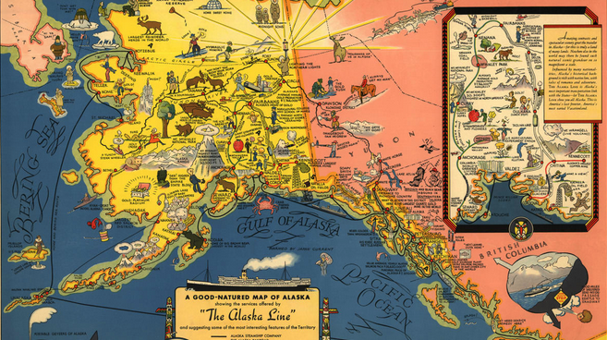

Negotiations between William Henry Seward, the enthusiastically expansionist secretary of state under President Andrew Johnson and the Russian minister to the U.S., Eduard de Stoeckl, began in March 1867. The U.S. agreed to pay a mere $7 million for some 591,000 square miles of land. The sloop-of-war Ossipee and the third-class screw steamer Resaca participated in formal transfer of Alaska from Russia to U.S. authority at Sitka and remained to enforce law and order in the new territory.

However, the American public believed the land to be barren and worthless and dubbed the purchase “Seward’s Folly” and “Andrew Johnson’s Polar Bear Garden,” among other derogatory names. Some animosity toward the project may have been a byproduct of President Johnson’s own unpopularity. As the 17th U.S. president, Johnson battled with Radical Republicans in Congress over Reconstruction policies following the Civil War. He was impeached in 1868 and later acquitted by a single vote.

Nevertheless, Congress eventually ratified the Alaska deal. Public opinion of the purchase turned more favorable when gold was discovered in a tributary of Alaska’s Klondike River in 1896, sparking a gold rush. Alaska became the 49th state on January 3, 1959, and is now recognized for its vast natural resources. Today, 25 percent of America’s oil and over 50 percent of its seafood come from Alaska. It is also the largest state in area, about one-fifth the size of the lower 48 states combined, though it remains sparsely populated. The name Alaska is derived from the Aleut word alyeska, which means “great land.” Alaska has two official state holidays to commemorate its origins: Seward’s Day, observed the last Monday in March, celebrates the March 30, 1867, signing of the land treaty between the U.S. and Russia, and Alaska Day, observed every October 18, marks the anniversary of the formal land transfer.

- Oct 18 1898 – Spanish American War: U.S. Takes Control of Puerto Rico » Only one year after Spain granted Puerto Rico self-rule, American troops raise the U.S. flag over the Caribbean nation, formalizing U.S. authority over the island’s one million inhabitants.

In July 1898, near the end of the Spanish-American War, U.S. forces launched an invasion of Puerto Rico, the 108-mile-long, 40-mile-wide Island that was one of Spain’s two principal possessions in the Caribbean. With little resistance and only seven American deaths, U.S. troops were able to secure the island by mid-August. After the signing of an armistice with Spain, the island was turned over to the U.S forces on 18 OCT. U.S. General John R. Brooke became military governor. In December, the Treaty of Paris was signed, ending the Spanish-American War and officially approving the cession of Puerto Rico to the United States.

In the first three decades of its rule, the U.S. government made efforts to Americanize its new possession, including granting full U.S. citizenship to Puerto Ricans in 1917 and considering a measure that would make English the island’s official language. However, during the 1930s, a nationalist movement led by the Popular Democratic Party won widespread support across the island, and further U.S. assimilation was successfully opposed. Beginning in 1948, Puerto Ricans could elect their own governor, and in 1952 the U.S. Congress approved a new Puerto Rican constitution that made the island an autonomous U.S. commonwealth, with its citizens retaining American citizenship. The constitution was formally adopted by Puerto Rico on July 25, 1952.

Movements for Puerto Rican statehood, along with lesser movements for Puerto Rican independence, have won supporters on the island, but popular referendums in 1967 and 1993 demonstrated that the majority of Puerto Ricans still supported their special status as a U.S. commonwealth.

- Oct 18 1915 – WW1 Era: Third Battle of the Isonzo » In the eastern sector of the Italian front the Italians launch their third offensive of the year. Located in present-day Slovenia, the 60-mile-long Isonzo River ran north to south just inside what was then the Austrian border with Italy, at the head of the Adriatic Sea. The river was flanked by mountains on either side and was prone to flooding, making the terrain especially ill-suited to offensive operations. Nonetheless, it became the most practical spot for Italian forces to attack their Austrian enemy, due to Austro-Hungarian dominance of most other sections of the border. After the Italian entrance into World War I in late May 1915, Chief of Staff Luigi Cadorna determined that his troops could most effectively strike in the eastern section of the Isonzo region, aiming to capture points on the line from Gorizia to Trieste. For this reason, he poured an immense amount of resources into this area, launching no fewer than 11 offensive operations against the Austrians from June 1915 to September 1917. Like the two attacks that preceded it, the Third Battle of the Isonzo proved disappointing for the Italians. Despite their numerical superiority—19 divisions of troops versus 11 Austrian divisions—Cadorna’s forces failed over two weeks of fighting to capture the two objectives of the attack, Mount Sabotino and Mount San Michele, suffering heavy casualties along the way.

- Oct 18 1916 – WW1 Era: British Soldier Henry Farr Executed for Cowardice » At dawn Private Henry Farr of the British Expeditionary Force (BEF) is executed for cowardice after he refused to go forward into the front-line trenches on the Western Front during World War I.

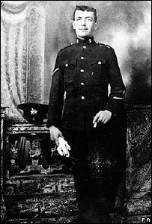

After joining the BEF in 1914, Farr was sent to the front in France; the following May, he collapsed, shaking, and was sent to a hospital for treatment. He returned to the battlefield and participated in the Somme Offensive. In mid-September 1916, however, Farr refused to go ahead into the trenches with the rest of his squadron; after being dragged forward, struggling, he broke away and ran back. He was subsequently court-martialed for cowardice and given a death sentence, which was carried out on 16 OCT.

Farr was one of 306 soldiers from Britain and the Commonwealth who were executed for cowardice during the Great War. According to his descendants, who have fought a long battle to clear his name, Farr suffered from severe shell-shock, a condition that was just being recognized at the time, and had been damaged both physically and psychologically by his experience of combat, especially the repeated heavy bombardments to which he and his comrades at the front had been subjected. The symptoms of “shell-shock”—a term first used in 1917 by a medical officer named Charles Myers—included debilitating anxiety, persistent nightmares and physical afflictions ranging from diarrhea to loss of sight. By the end of World War I, the British army had been forced to deal with 80,000 cases of this affliction, including among soldiers who had never experienced a direct bombardment. Despite undergoing treatment, only one-fifth of the men affected ever resumed military duty.

Several successive governments rejected pleas from Farr’s family and others for their loved ones to be pardoned and honored alongside the rest of those soldiers killed in World War I. Finally, in August 2006, after a 14-year struggle, the British High Court granted a pardon to Farr; hours after informing Farr’s family of its verdict, the government announced it would seek Parliament’s approval to pardon all 306 soldiers executed for cowardice during World War I.

- Oct 18 1939 –WW2 Era: President Franklin D. Roosevelt bans war submarines from U.S. ports and waters.

- Oct 18 1942 – WW2: Halsey Named New Commander of the South Pacific » Vice. Adm. William F. Halsey replaces Vice Adm. Robert L. Ghormley as commander, South Pacific. Brilliant work in the capture of the Solomon Islands and New Guineas led to Halsey’s promotion to full admiral.

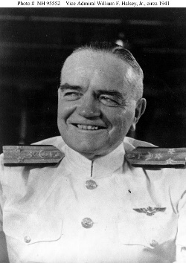

- Oct 18 1942 – WW2: Hitler’s Commando Order » Adolf Hitler’s was very blunt in what it stated. The ‘Commando Order’ read:

1. For a long time now our opponents have been employing in their conduct of the war, methods which contravene the International Convention of Geneva. The members of the so-called Commandos behave in a particularly brutal and underhand manner; and it has been established that those units recruit criminals not only from their own country but even former convicts set free in enemy territories. From captured orders it emerges that they are instructed not only to tie up prisoners, but also to kill out-of-hand unarmed captives who they think might prove an encumbrance to them, or hinder them in successfully carrying out their aims. Orders have indeed been found in which the killing of prisoners has positively been demanded of them.

2. In this connection it has already been notified in an Appendix to Army Orders of 7.10.1942. that in future, Germany will adopt the same methods against these Sabotage units of the British and their Allies; i.e. that, whenever they appear, they shall be ruthlessly destroyed by the German troops.

3. I order, therefore: From now on all men operating against German troops in so-called Commando raids in Europe or in Africa, are to be annihilated to the last man. This is to be carried out whether they be soldiers in uniform, or saboteurs, with or without arms; and whether fighting or seeking to escape; and it is equally immaterial whether they come into action from Ships and Aircraft, or whether they land by parachute. Even if these individuals on discovery make obvious their intention of giving themselves up as prisoners, no pardon is on any account to be given. On this matter a report is to be made on each case to Headquarters for the information of Higher Command.

4. Should individual members of these Commandos, such as agents, saboteurs etc., fall into the hands of the Armed Forces through any means – as, for example, through the Police in one of the Occupied Territories – they are to be instantly handed over to the S.D. To hold them in military custody – for example in P.O.W. Camps, etc., – even if only as a temporary measure, is strictly forbidden.

5. This order does not apply to the treatment of those enemy soldiers who are taken prisoner or give themselves up in open battle, in the course of normal operations, large scale attacks; or in major assault landings or airborne operations. Neither does it apply to those who fall into our hands after a sea fight, nor to those enemy soldiers who, after air battle, seek to save their lives by parachute.

6. I will hold all Commanders and Officers responsible under Military Law for any omission to carry out this order, whether by failure in their duty to instruct their units accordingly, or if they themselves act contrary to it.

A Hitler

Why did Hitler order such a draconian measure? Two ideas have been forwarded and a combination of the two is likely to be accurate. Commandos were a very effective fighting force and units such as the British Commandos and the Special Air Service were capable of doing a great deal of damage to the Germans in small and frequently undetected raiding parties. Also on the Channel Island of Sark, some German soldiers were found with their hands tied behind their back. They had been shot. Their deaths were blamed on commandos who had raided the island. Hitler in his fury ordered that any commandos caught after this, should be summarily shot without a trial – the ‘Commando Order’.

Six men from the Royal Marine Commandos were shot on the Cockleshell Raid of 1942 and towards the end of the war, the bodies of 24 Special Air Service men were found in France. They had been captured, tortured and shot by the Gestapo.

- Oct 18 1944 – WW2: Lt. General Joseph Stilwell is recalled from China by President Franklin Roosevelt.

- Oct 18 1944 – WW2: Allied generals Dwight D. Eisenhower, Omar Bradley and Bernard Montgomery confer in Brussels, Belgium.

- Oct 18 1944 – WW2: USS Bluegill (SS 242) and USS Raton (SS 270) attack a Japanese convoy in the South China Sea. Bluegill sinks the army cargo ships Arabia Maru and Chinsei Maru and freighter Hakushika Maru. Raton sinks the army cargo ships Taikai Maru and Shiranesan Maru.

- Oct 18 1950 – Korean War: The First Turkish Brigade arrives in Korea to assist the U.N. forces fighting there.

- Oct 18 1955 – Vietnam: Emperor Bao Dai Attempts to Dismiss Diem » A communique from Emperor Bao Dai’s office in Paris announces that he has dismissed Ngo Dinh Diem (right below) from the premiership and annulled his powers. In a message to the Vietnamese people Bao Dai (left below) prophetically declared, “police methods and personal dictatorship must be brought to an end, and I can no longer continue to lend my name and my authority to a man who will drag you into ruin, famine and war.” Unfortunately, Diem suppressed the message and it was never publicly transmitted to the people.

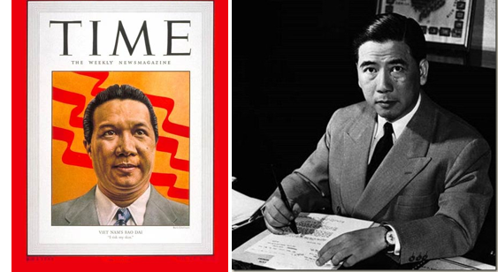

Bao Dai had appointed Diem prime minister in June 1954, but soon decided that he was the wrong man to lead South Vietnam. However, by late 1955, Diem was firmly entrenched, having retained control of the government through a questionable referendum. Emperor Bao Dai retired and remained in France. From the beginning, Communists and other rivals caused trouble for Diem’s regime. His refusal to institute necessary political reforms and the rising unrest among the people, especially the Buddhists, eventually led to a coup in November 1963, in which he and his brother were murdered.

- Oct 18 1977 – U.S. Navy: USS Dwight D. Eisenhower (CVN 69) is commissioned at Norfolk, Va. The Ike, named after the nation's 34th president, is the third nuclear-powered and second Nimitz-class aircraft carrier. Ike is currently homeported in Norfolk.

- Oct 18 1977 – Terrorism: West German Commandos Liberate Boeing 737 with 86 Hostages at Mogadishu » Lufthansa Flight 181 was a Boeing 737–230 Adv aircraft named Landshut that was hijacked on 13 October 1977 by four members of the Popular Front for the Liberation of Palestine, who called themselves Commando Martyr Halima. The objective of the hijacking was to secure the release of imprisoned Red Army Faction leaders. On 18 OCT the aircraft was stormed by the West German counter-terrorism group GSG 9 in Mogadishu, Somalia, and all 86 passengers rescued. The rescue operation was codenamed Feuerzauber (German term for "Fire Spell"). The hijacking is considered to be part of the German Autumn.

- Oct 18 1989 – Europe: East Germany and Hungary Move Toward Democracy » The Iron Curtain nations of East Germany and Hungary take significant steps toward ending the communist domination of their countries to replace it with more democratic politics and free market economies. In Hungary, the Communist Party had disbanded on 7 OCT. This action was followed by the razing of the barbed wire fence that had for years separated Hungary from Austria. The destruction of the fence effectively marked the end of the Berlin Wall as an impediment to travel between East and West Germany, since East Germans could now simply travel to Hungary, enter Austria, and go on from there to West Germany. Not surprisingly, the Berlin Wall came down shortly thereafter.

- Oct 18 2003 – U.S. Navy: USS Chafee (DDG 90) is commissioned at Newport, R.I. The first U.S. Navy ship named to honor John Hubbard Chafee, the late Senator from Rhode Island, who also served as Secretary of the Navy under President Nixon.

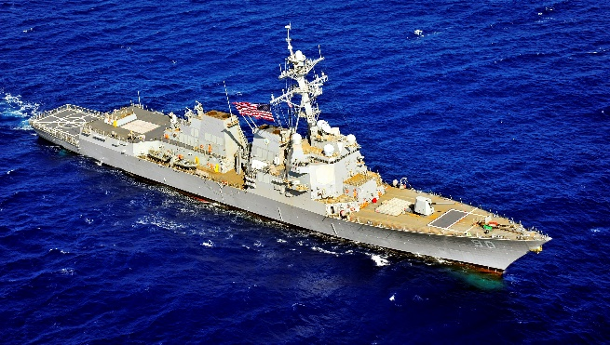

-o-o-O-o-o-

- Oct 19 1739 – Colonial America: England declares war on Spain over borderlines in Florida. The war is known as the War of Jenkins’ Ear because the Spanish coast guards cut off the ear of British seaman Robert Jenkins.

- Oct 19 1781 – American Revolutionary War: Cornwallis Surrenders at Yorktown » Hopelessly trapped at Yorktown, Virginia, British General Lord Cornwallis surrenders 8,000 British soldiers and seamen to a larger Franco-American force, effectively bringing an end to the American Revolution.

Lord Cornwallis was one of the most capable British generals of the American Revolution. In 1776, he drove General George Washington’s Patriots forces out of New Jersey, and in 1780 he won a stunning victory over General Horatio Gates’ Patriot army at Camden, South Carolina. Cornwallis’ subsequent invasion of North Carolina was less successful, however, and in April 1781 he led his weary and battered troops toward the Virginia coast, where he could maintain seaborne lines of communication with the large British army of General Henry Clinton in New York City. After conducting a series of raids against towns and plantations in Virginia, Cornwallis settled in the tidewater town of Yorktown in August. The British immediately began fortifying the town and the adjacent promontory of Gloucester Point across the York River.

General George Washington instructed the Marquis de Lafayette, who was in Virginia with an American army of around 5,000 men, to block Cornwallis’ escape from Yorktown by land. In the meantime, Washington’s 2,500 troops in New York were joined by a French army of 4,000 men under the Count de Rochambeau. Washington and Rochambeau made plans to attack Cornwallis with the assistance of a large French fleet under the Count de Grasse, and on August 21 they crossed the Hudson River to march south to Yorktown. Covering 200 miles in 15 days, the allied force reached the head of Chesapeake Bay in early September.

Meanwhile, a British fleet under Admiral Thomas Graves failed to break French naval superiority at the Battle of Virginia Capes on September 5, denying Cornwallis his expected reinforcements. Beginning September 14, de Grasse transported Washington and Rochambeau’s men down the Chesapeake to Virginia, where they joined Lafayette and completed the encirclement of Yorktown on 28 SEP. De Grasse landed another 3,000 French troops carried by his fleet. During the first two weeks of October, the 14,000 Franco-American troops gradually overcame the fortified British positions with the aid of de Grasse’s warships. A large British fleet carrying 7,000 men set out to rescue Cornwallis, but it was too late.

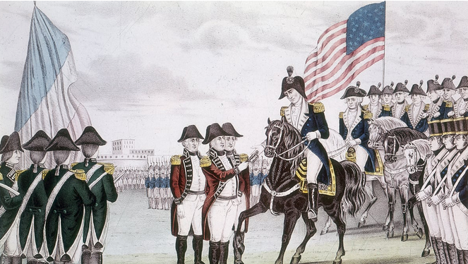

On 19 OCT, General Cornwallis surrendered 7,087 officers and men, 900 seamen, 144 cannons, 15 galleys, a frigate, and 30 transport ships. Pleading illness, he did not attend the surrender ceremony, but his second-in-command, General Charles O’Hara, carried Cornwallis’ sword to the American and French commanders. As the British and Hessian troops marched out to surrender, the British bands played the song “The World Turned Upside Down.”

Although the war persisted on the high seas and in other theaters, the Patriot victory at Yorktown effectively ended fighting in the American colonies. Peace negotiations began in 1782, and on September 3, 1783, the Treaty of Paris was signed, formally recognizing the United States as a free and independent nation after eight years of war.

- Oct 19 1812 – France: Napoleon Bonaparte begins his retreat from Moscow.

- Oct 19 1812 – War of 1812: Old Ironsides Earns its Name » The U.S. Navy frigate Constitution defeats the British frigate Guerrière in a furious engagement off the coast of Nova Scotia. Witnesses claimed that the British shot merely bounced off the Constitution‘s sides, as if the ship were made of iron rather than wood. By the war’s end, “Old Ironsides” destroyed or captured seven more British ships. The success of the USS Constitution against the supposedly invincible Royal Navy provided a tremendous boost in morale for the young American republic.

The Constitution was one of six frigates that Congress requested be built in 1794 to help protect American merchant fleets from attacks by Barbary pirates and harassment by British and French forces. It was constructed in Boston, and the bolts fastening its timbers and copper sheathing were provided by the industrialist and patriot Paul Revere. Launched on October 21, 1797, the Constitution was 204 feet long, displaced 2,200 tons, and was rated as a 44-gun frigate (although it often carried as many as 50 guns).

In July 1798 it was put to sea with a crew of 450 and cruised the West Indies, protecting U.S. shipping from French privateers. In 1803, President Thomas Jefferson ordered the American warship to the Mediterranean to fight Barbary pirates off the coast of Tripoli. The vessel performed commendably during the conflict, and in 1805 a peace treaty with Tripoli was signed on the Constitution‘s deck.

When war broke out with Britain in June 1812, the Constitution was commanded by Isaac Hull, who served as lieutenant on the ship during the Tripolitan War. Scarcely a month later, on 16 JUL, the Constitution encountered a squadron of five British ships off Egg Harbor, New Jersey. Finding itself surrounded, the Constitution was preparing to escape when suddenly the wind died. With both sides dead in the water and just out of gunnery range, a legendary slow-speed chase ensued. For 36 hours, the Constitution‘s crew kept their ship just ahead of the British by towing the frigate with rowboats and by tossing the ship’s anchor ahead of the ship and then reeling it in. At dawn on 18 JU:, a breeze sprang, and the Constitution was far enough ahead of its pursuers to escape by sail.

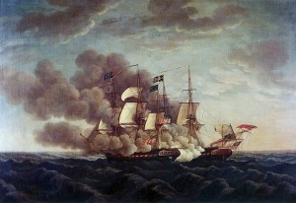
Battle between the USS Constitution vs HMS Guerriere

One month later, on 19 AUG, the Constitution caught the British warship Guerrière alone about 600 miles east of Boston. After considerable maneuvering, the Constitution delivered its first broadside, and for 20 minutes the American and British vessels bombarded each other in close and violent action. The British man-of-war was de-masted and rendered a wreck while the Constitution escaped with only minimal damage. The unexpected victory of Old Ironsides against a British frigate helped unite America behind the war effort and made Commander Hull a national hero. The Constitution went on to defeat or capture seven more British ships in the War of 1812 and ran the British blockade of Boston twice.

After the war, Old Ironsides served as the flagship of the navy’s Mediterranean squadron and in 1828 was laid up in Boston. Two years later, the navy considered scrapping the Constitution, which had become unseaworthy, leading to an outcry of public support for preserving the famous warship. The navy refurbished the Constitution, and it went on to serve as the flagship of the Mediterranean, Pacific, and Home squadrons. In 1844, the frigate left New York City on a global journey that included visits to numerous international ports as a goodwill agent of the United States. In the early 1850s, it served as flagship of the African Squadron and patrolled the West African coast looking for slave traders. In 1855, the Constitution retired from active military service, but the famous vessel continued to serve the United States, first as a training ship and later as a touring national landmark.

- Oct 19 1818 – Native Americans: Treaty with The Chickasaw » A treaty to settle all territorial controversies, and to remove all grounds of complaint or dissatisfaction, that might arise to interrupt the peace and harmony between the United States of America and the Chickesaw nation of Indians. To see what each party ceded efer to the treaty’s seven articles at https://www.firstpeople.us/FP-Html-Treaties/TreatyWithTheChickasaw1818.html.

- Oct 19 1843 – U.S. Navy: While commanding the first screw propelled U.S. naval steamer Princeton, Capt. Robert F. Stockton challenges the British merchant ship Great Western to a speed race off New York. Princeton easily wins the race.

- Oct 19 1848 – Old West: John “The Pathfinder” Fremont moves out from near Westport, Missouri, on his fourth Western expedition–a failed attempt to open a trail across the Rocky Mountains along the 38th parallel.

- Oct 19 1863 – Civil War: Battle of Buckland Mills » Three months after the Gettysburg Campaign, the Army of the Potomac under Maj. Gen. George G. Meade and Robert E. Lee's Army of Northern Virginia maintained close contact with each other in Virginia as Meade moved north towards Centreville. After defeat at Bristoe Station five days earlier, Maj. Gen. J. E. B. Stuart’s cavalry shielded the withdrawal of Lee’s army south from the vicinity of Manassas toward the Rappahannock River. Union cavalry under Brig. Gen. Judson Kilpatrick pursued Stuart’s troopers along the Warrenton Turnpike west of Gainesville but were lured into an ambush near Chestnut Hill on October 19th.

A division of Rebel cavalry under Maj. Gen. Fitzhugh Lee turned on the Yankee cavalrymen under Brig. Gen. George A. Custer as they rested near the turnpike. Lee's division suddenly attacked from the south, pushing Custer's troopers back across the Broad Run bridge and separating his brigade from the rest of Kilpatrick's command. The Federal troopers were scattered and chased five miles in an affair that came to be known as the “Buckland Races.” Most of the Federal casualties were captured during the retreat. Stuart termed the rout, his last victory over cavalry, “the most complete that any cavalry…suffered during this war.” Custer called the day “the most disastrous this division ever passed through.” Estimated Casualties U.S. 260 | Rebels 50.

- Oct 19 1864 – Civil War: Battle of Cedar Creek » In the late summer of 1864, Maj. Gen. Phil Sheridan was given command of the Union Army of the Shenandoah by Grant, with orders to root out the remaining Southern resistance in the Valley and deny the Confederacy the benefit of the area's food and supplies. From late September to early October, Sheridan's men aggressively burned barns, mills, and crops that could be used to feed Rebel armies. The Confederate force in the valley, Gen. Jubal A. Early's Army of the Valley, had been unsuccessful in slowing Sheridan since the recent Union victories at Third Winchester, Fisher's Hill and Tom's Brook. By mid-October, Early was determined to strike Sheridan.

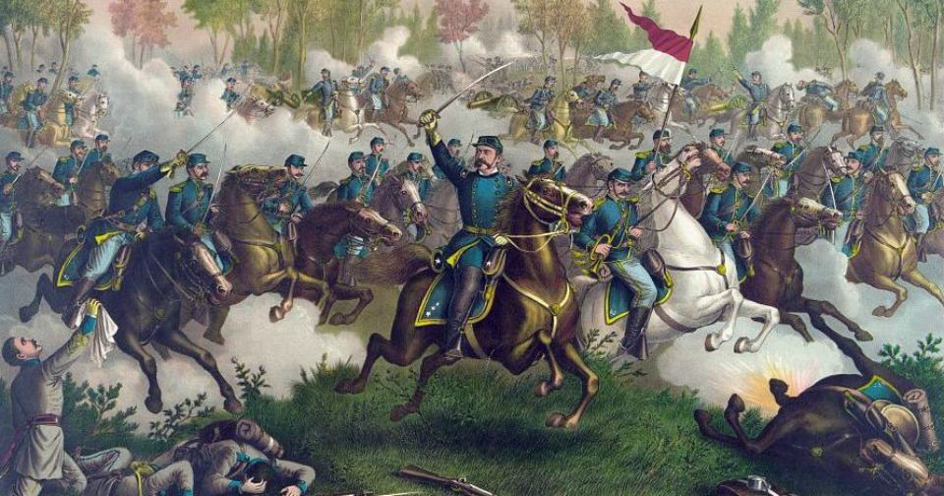

The Confederate army was camped near Strasburg, and the Union men were in camps along the east bank of Cedar Creek. Early executed a surprise attack early on October 19, 1864 and drove first one, then another, then a third Union Corps from the field. As Early paused to reorganize, Sheridan arrived after a dramatic ride from his headquarters in Winchester just in time to rally his troops and launch a crushing counterattack, from which Early’s forces could not recover. Sheridan’s victory at Cedar Creek extinguished any hope of further Confederate offensives in the Shenandoah Valley, and was one of the Union victories in late 1864 that helped ensure President Abraham Lincoln's reelection that November. Estimated casualties: US 5,764 - CSA 3,060.

- Oct 19 1864 – Civil War: The steamer Mobile captures schooner Emily off San Luis Pass, Texas with a cargo of 150 bales of cotton.

- Oct 19 1864 – Civil War: St. Alban’s Raid » The mission was to rob banks to raise money, and to trick the Union Army into diverting troops to defend their northern border against further raids. The raiders had recently failed in engagements with the Union Army and evaded subsequent capture in the United States. On 19 OCT about 25 Confederate soldiers based in Canada raided the town of St. Albans, Vt., killed one man, robbed three banks, and then retreated to Canadian territory. A U.S. posse pursued the raiders and captured several of them, but it was forced to surrender them to the Canadian authorities. On October 21 about half the Confederates were arrested by the Canadians, but they were released again on December 13, and the $200,000 they had stolen was returned.

Although the Canadian government reimbursed the plundered banks, the release of the raiders led to strong protests in the United States. Consequently, five of the raiders were rearrested and remained in custody for a time for violating Canadian neutrality. In 1872 a claims commission established under the Anglo-American Treaty of Washington (1871) ruled against further American claims to compensation.

- Oct 19 1914 – WWI Era: First Battle of Ypres (19 Oct thru 22 Nov) » Near the Belgian city of Ypres, Allied and German forces begin the first of what would be three battles to control the city and its advantageous positions on the north coast of Belgium during the First World War. After the German advance through Belgium and eastern France was curtailed by a decisive Allied victory in the Battle of the Marne in late September 1914, the so-called “Race to the Sea” began, as each army attempted to outflank the other on their way northwards, hastily constructing trench fortifications as they went. The race ended in mid-October at Ypres, the ancient Flemish city with its fortifications guarding the ports of the English Channel and access to the North Sea beyond.

After the Germans captured the Belgian city of Antwerp early in October, Antwerp’s remaining Belgian forces along with troops of the British Expeditionary Force (BEF), commanded by Sir John French, withdrew to Ypres, arriving at the city between October 8 and 19 to reinforce the Belgian and French defenses there. Meanwhile, the Germans prepared to launch the first phase of an offensive aimed at breaking the Allied lines and capturing Ypres and other channel ports, thus controlling the outlets to the North Sea.

On 19 OCT, a protracted period of fierce combat began, as the Germans opened their Flanders offensive and the Allies steadfastly resisted, while seeking their own chances to go on the attack wherever possible. Fighting continued, with heavy losses on both sides. During the battle, the Germans send waves of inexperienced 17 to 20-year-old volunteer soldiers, some fresh out of school. They advance shoulder-to-shoulder while singing patriotic songs only to be systematically gunned down in what the Germans themselves later call the "massacre of the innocents." By November, overall casualties totaled 250,000 men, including nearly half of the British Regular Army until 22 NOV. t

The arrival of winter weather forced the battle to a halt. The area between the positions established by both sides during this period—from Ypres on the British side to Menin and Roulers on the German side—became known as the Ypres Salient, a region that over the course of the next several years would see some of the war’s bitterest and most brutal struggles.

- Oct 19 1914– WWI Era: The German cruiser Emden captures her thirteenth Allied merchant ship in 24 days.

- Oct 19 1915 – U.S. Navy: The Naval Submarine Base at New London, Conn. is established.

- Oct 19 1917 – WWI: The first doughnut is fried by Salvation Army volunteer women for American troops in France.

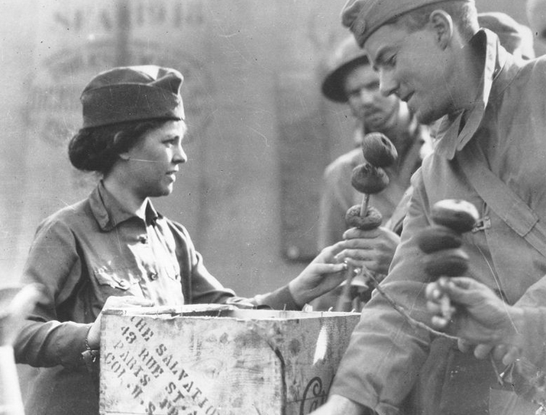

- Oct 19 1933 – Germany: Nine months after Adolf Hitler was appointed chancellor of Germany, the German government announced its withdrawal from the League of Nations. The ostensible reason was the refusal of the Western powers to acquiesce in Germany’s demands for military parity.

- Oct 19 1934 – Germany: Adolf Hitler Becomes President of Germany » Adolf Hitler, already chancellor, is also elected president of Germany in an unprecedented consolidation of power in the short history of the republic.

In 1932, German President Paul von Hindenburg, old, tired, and a bit senile, had won re-election as president, but had lost a considerable portion of his right/conservative support to the Nazi Party. Those close to the president wanted a cozier relationship to Hitler and the Nazis. Hindenburg had contempt for the Nazis’ lawlessness, but ultimately agreed to oust his chancellor, Heinrich Bruning, for Franz von Papen, who was willing to appease the Nazis by lifting the ban on Hitler’s Brown Shirts and unilaterally canceling Germany’s reparation payments, imposed by the Treaty of Versailles at the close of World War I.

But Hitler was not appeased. He wanted the chancellorship for himself. Papen’s policies failed on another front: His authoritarian rule alienated his supporters, and he too was forced to resign. He then made common cause with Hitler, persuading President Hindenburg to appoint Hitler chancellor and himself vice-chancellor. He promised the president that he would restrain Hitler’s worst tendencies and that a majority of the Cabinet would go to non-Nazis. As Hindenburg’s current chancellor could no longer gain a majority in the Reichstag, and Hitler could bring together a larger swath of the masses and a unified right/conservative/nationalist coalition, the president gave in. In January 1933, Hitler was named chancellor of Germany.

But that was not enough for Hitler either. In February 1933, Hitler blamed a devastating Reichstag fire on the communists (its true cause remains a mystery) and convinced President Hindenburg to sign a decree suspending individual and civil liberties, a decree Hitler used to silence his political enemies with false arrests. Upon the death of Hindenburg in 1934, Hitler proceeded to purge the Brown Shirts (his storm troopers), the head of which, Ernst Roem, had begun voicing opposition to the Nazi Party’s terror tactics. Hitler had Roem executed without trial, which encouraged the army and other reactionary forces within the country to urge Hitler to further consolidate his power by merging the presidency and the chancellorship. This would make Hitler commander of the army as well. A plebiscite vote was held on August 19. Intimidation, and fear of the communists, brought Hitler a 90 percent majority. He was now, for all intents and purposes, dictator.

- Oct 19 1941 – WW2 Era: Unarmed US merchantman Lehigh is sunk by German U-126 off Freetown, Sierra Leone.

- Oct 19 1942 – WW2: The Japanese submarine I–36 launches a floatplane for a reconnaissance flight over Pearl Harbor. The pilot and crew report on the ships in the harbor, after which the aircraft is lost at sea.

- Oct 19 1943 – WW2: Stalag Luft III Escape » The German POW camp is best known for two famous prisoner escapes that took place there by tunneling, which were depicted in the films The Great Escape (1963) and The Wooden Horse (1950), and the books by former prisoners Paul Brickhill and Eric Williams from which these films were adapted. The camp was very secure. Despite being an officers-only camp, it was referred to as a Stalag camp rather than Oflag (Offizier Lager) as the Luftwaffe had their own nomenclature. Later camp expansions added compounds for non-commissioned officers. Captured Fleet Air Arm (Royal Navy) aircrew were considered to be Air Force by the Luftwaffe and no differentiation was made. At times non-airmen were interned.

Conjuring up a modern Trojan Horse the kriegies (prisoners) constructed a gymnastic vaulting horse largely from plywood from Red Cross parcels. The horse was designed to conceal men, tools and containers of soil. Each day the horse was carried out to the same spot near the perimeter fence and while prisoners conducted gymnastic exercises above, a tunnel was dug. At the end of each working day, a wooden board was placed over the tunnel entrance and covered with surface soil. The gymnastics disguised the real purpose of the vaulting horse and kept the sound of the digging from being detected by the microphones.

For three months three prisoners, Lieutenant Michael Codner, Flight Lieutenant Eric Williams and Flight Lieutenant Oliver Philpot, in shifts of one or two diggers at a time, dug over 100 ft of tunnel, using bowls as shovels and metal rods to poke through the surface of the ground to create air holes. No shoring was used except near the entrance. On the evening of 19 October, the three POWs made their escape. Williams and Codner were able to reach the port of Stettin where they stowed away on a Danish ship and eventually returned to Britain. Philpot, posing as a Norwegian margarine manufacturer, was able to board a train to Danzig (now Gdańsk) and from there stowed away on a Swedish ship headed for Stockholm, from where he was repatriated to Britain. Accounts of this escape were recorded in the book Goon in the Block (later retitled The Wooden Horse) by Williams, the book Stolen Journey by Philpot and the 1950 film The Wooden Horse.

- Oct 19 1943 – WW2: Chinese and Suluks Revolt against Japanese in North Borneo » Local Chinese and native Suluks rise up against the Japanese occupation of North Borneo. The treatment of Allied and civilian prisoners in the Japanese-controlled islands was horrendous, with hundreds dying of disease and starvation. The rebellion of Chinese settlers and native Suluks in the Borneo capital of Jesselton, although delivering a blow to the Japanese to the tune of 40 dead occupying soldiers, was dealt with quickly and brutally. The Japanese destroyed dozens of Suluk villages, rounded up and tortured thousands of civilians, and executed almost 200 without trial. In one extreme example of cruelty, several dozen Suluk women and children had their hands tied behind them and were hanged from their wrists from a pillar of a mosque. They were then shot down by machine-gun fire.

- Oct 19 1944 – WW2: USS Gilligan (DE 508) bombards Mili Atoll, Marshall.

- Oct 19 1944 – WW2: United States forces land in the Philippines followed the next day by Gen. MacArthur wading ashore on the island of Leyte.

- Oct 19 1944 – WW2: U.S. Navy WAVES » By the middle of 1943, more than 27,000 women had taken part in the U.S. Navy WAVES program. Although there were still a number of clerical and secretarial positions filled by women (similar to their World War 1 role), the WAVES also took positions as photographers, intelligence personnel, control tower operators, and aviation mechanics. On 19 OCT President Franklin D. Roosevelt approved Secretary of Navy James V. Forrestal's order for African American women to be accepted into the Naval Reserve (i.e. WAVES).By 1944, African American women were accepted into the WAVES program at a rate of one black woman for every 36 white women enlisted into the program. Over the course of the entire war, there were more than 84,000 women who would sever as a navy WAVE to include 8,000 female officers. This would be about 2.5% of the American Navy’s total personnel end-strength during the war.

- Oct 19 1949 – China: The People’s Republic of China is formally proclaimed.

- Oct 19 1950 – Korean War: The People's Liberation Army takes control of the town of Qamdo. This is sometimes called the "Invasion of Tibet".

- Oct 19 1950 – Korea War: The People's Republic of China joins the Korean War by sending thousands of troops across the Yalu river to fight United Nations forces

- Oct 19 1950 – Korean War: 1st ROK Division and U.S. 1st Cavalry Division capture The North Korean capital of P'yongyang.

- Oct 19 1953 – Cold War: CIA-assisted Coup Overthrows Government of Iran » The Iranian military, with the support and financial assistance of the United States government, overthrows the government of Premier Mohammad Mosaddeq and reinstates the Shah of Iran. Iran remained a solid Cold War ally of the United States until a revolution ended the Shah’s rule in 1979.

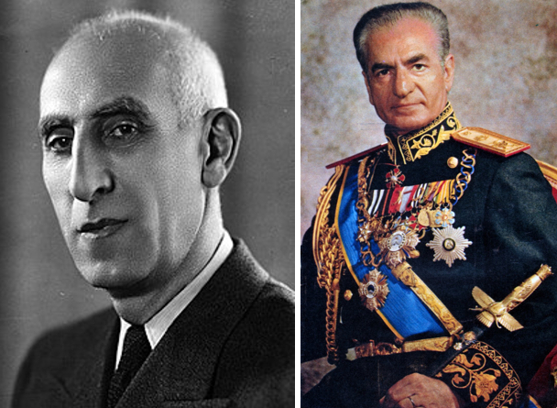
Premier Mohammad Mosaddeq & Shah of Iran

Mosaddeq came to prominence in Iran in 1951 when he was appointed premier. A fierce nationalist, Mosaddeq immediately began attacks on British oil companies operating in his country, calling for expropriation and nationalization of the oil fields. His actions brought him into conflict with the pro-Western elites of Iran and the Shah, Mohammed Reza Pahlevi. Indeed, the Shah dismissed Mossadeq in mid-1952, but massive public riots condemning the action forced the Shah to reinstate Mossadeq a short time later. U.S. officials watched events in Iran with growing suspicion. British intelligence sources, working with the American Central Intelligence Agency (CIA), came to the conclusion that Mossadeq had communist leanings and would move Iran into the Soviet orbit if allowed to stay in power.

Working with Shah, the CIA and British intelligence began to engineer a plot to overthrow Mossadeq. The Iranian premier, however, got wind of the plan and called his supporters to take to the streets in protest. At this point, the Shah left the country for “medical reasons.” While British intelligence backed away from the debacle, the CIA continued its covert operations in Iran. Working with pro-Shah forces and, most importantly, the Iranian military, the CIA cajoled, threatened, and bribed its way into influence and helped to organize another coup attempt against Mossadeq. On August 19, 1953, the military, backed by street protests organized and financed by the CIA, overthrew Mossadeq. The Shah quickly returned to take power and, as thanks for the American help, signed over 40 percent of Iran’s oil fields to U.S. companies.

Mossadeq was arrested, served three years in prison, and died under house arrest in 1967. The Shah became one of America’s most trusted Cold War allies, and U.S. economic and military aid poured into Iran during the 1950s, 1960s, and 1970s. In 1978, however, anti-Shah and anti-American protests broke out in Iran and the Shah was toppled from power in 1979. Angry militants seized the U.S. embassy and held the American staff hostage until January 1981. Nationalism, not communism, proved to be the most serious threat to U.S. power in Iran.

- Oct 19 1954 – Suez Canal: Egypt and Britain conclude a pact on the Suez Canal, ending 72 years of British military occupation. Britain agrees to withdraw its 80,000-man force within 20 months, and Egypt agrees to maintain freedom of canal navigation.

- Oct 19 1958 – Cold War: The First Cold War World's Fair Closes » In Brussels, Belgium, the first world’s fair held since before World War II closes its doors, after nearly 42 million people have visited the various exhibits. Officially called the Brussels Universal and International Exhibition, the fair’s overall theme was “A World View, A New Humanism.” As such, the fair was supposed to celebrate the universality of the human condition and encourage dialogue and peaceful relations among the nations of a world only recently torn asunder by war, and now caught in the clutches of the Cold War. Officials in the United States, however, saw the fair as something quite different: An opportunity to promote America’s particular “world view,” and to meet the Soviets head-on in the continuing propaganda battle for the “hearts and minds” of the world’s people. The fair, therefore, became a showplace for the American and Soviet ways of life, and their exhibition halls became the headquarters for this battle.

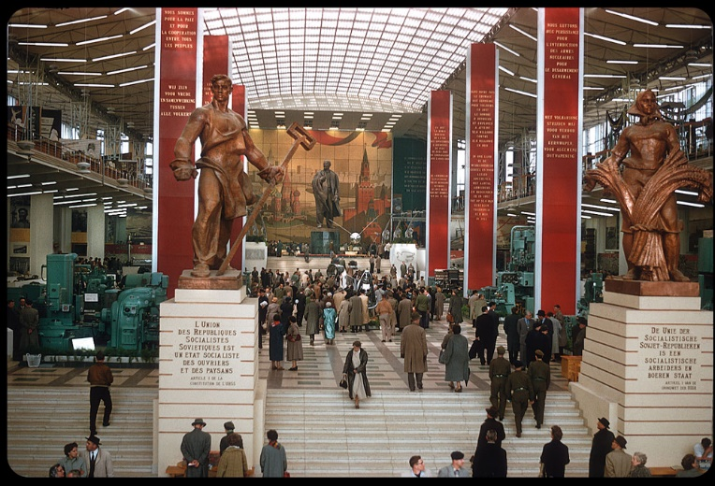

- Oct 19 1960 – Cold War: Captured U.S. Spy Pilot Sentenced in Russia » In the USSR, captured American U-2 pilot Francis Gary Powers is sentenced to 10 years imprisonment for his confessed espionage.

On May 1, 1960, Powers took off from Pakistan at the controls of an ultra-sophisticated Lockheed U-2 high-altitude reconnaissance aircraft. A CIA-employed pilot, he was to fly over some 2,000 miles of Soviet territory to BodØ military airfield in Norway, collecting intelligence information en route. Roughly halfway through his journey, he was shot down by the Soviets over Sverdlovsk in the Ural Mountains. Forced to bail out at 15,000 feet, he survived the parachute jump but was promptly arrested by Soviet authorities.

On 5 MAY, Soviet leader Nikita Khrushchev announced that the American spy aircraft had been shot down and two days later revealed that Powers was alive and well and had confessed to being on an intelligence mission for the CIA. On 7 MAY, the United States acknowledged that the U-2 had probably flown over Soviet territory but denied that it had authorized the mission. On 16 MAY, leaders of the United States, the USSR, Britain, and France met in Paris for a long-awaited summit meeting. The four powers were to discuss tensions in the two Germanys and negotiate new disarmament treaties. However, at the first session, the summit collapsed after President Dwight D. Eisenhower refused to apologize to Khrushchev for the U-2 incident. Khrushchev also canceled an invitation for Eisenhower to visit the USSR.

In August, Powers pleaded guilty to espionage charges in Moscow and was sentenced to 10 years imprisonment–three in prison and seven in a prison colony. However, only 18 months later, the Soviets agreed to release him in exchange for Rudolf Abel, a senior KGB spy who was caught and convicted in the United States five years earlier. On February 10, 1962, Powers and Abel were brought to separate sides of the Glienicker Bridge, which connected East and West Berlin across Lake Wannsee. As the spies waited, negotiators talked in the center of the bridge where a white line divided East from West. Finally, Powers and Abel were waved forward and walked past each other to freedom.

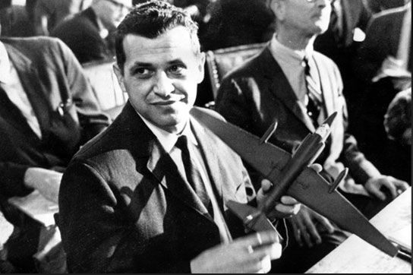

Upon returning to the United States, Powers was cleared by the CIA and the Senate of any personal blame for the U-2 incident. In 1970, he published a book, Operation Overflight, about the incident and in 1977 was killed in the crash of a helicopter he flew as a reporter for a Los Angeles television station.

- Oct 19 1965 – Vietnam War: Communists Attack Plei Me Special Forces Camp » North Vietnamese troops launch a major assault on U.S. and South Vietnamese Special Forces Camp at Plei Me in the Central Highlands, 215 miles north of Saigon. Brigadier General Chu Huy Man of the PAVN was tasked with destroying special forces outposts as a prelude to capturing Pleiku city, the headquarters of the Army of the Republic of Vietnam (ARVN) in the II Corps region, and gaining control of Highway 19, which led from Pleiku to the coast of South Vietnam.

During a week of savage fighting, defenders of the besieged outpost, manned by 12 U.S. Green Berets, 400 Montagnard tribesmen, and a handful of South Vietnamese guerrilla specialists, repelled repeated Viet Cong attacks. The tide of the battle turned finally with the arrival of several hundred South Vietnamese reinforcements and numerous Allied air strikes. Casualties and losses: CIDG: 14 killed, ARVN: 16 killed, U.S. 3 killed and PAVN U.S. body count: 326 killed during siege.

- Oct 19 1972 – Vietnam War: Kissinger Discusses Draft Peace Treaty with President Thieu » U.S. officials hold meetings in Saigon with South Vietnamese President Nguyen Van Thieu to discuss the proposed peace treaty drafted by Kissinger and Le Duc Tho, the chief North Vietnamese negotiator in Paris.Thieu remained adamant in his opposition to the draft treaty provisions that permitted North Vietnamese troops to remain in place in the South. Kissinger tried to convince Thieu to agree to the provisions anyway, but Thieu still balked. This would be a major stumbling block in the continuing negotiations. In an attempt to further the peace process, President Nixon announced a halt in bombing of North Vietnam above the 20th parallel. He also sent a message to North Vietnamese Premier Pham Van Dong confirming that the peace agreement was complete and pledging that it would be signed by the two foreign ministers on October 31.However, Thieu’s continued recalcitrance caused so much friction at the negotiating table that the North Vietnamese walked out. They returned only after Nixon ordered the resumption of the Linebacker II bombing campaign against North Vietnam.

- Oct 19 1973 – Yom Kipper War: Oil Embargo » Saudi Arabia, Libya, and other Arab states proclaim an embargo on oil exports to the United States. The embargo was targeted at nations perceived as supporting Israel during the Yom Kippur War. The initial nations targeted were Canada, Japan, the Netherlands, the United Kingdom and the United States with the embargo also later extended to Portugal, Rhodesia and South Africa. By the end of the embargo in March 1974, the price of oil had risen nearly 300%, from US$3 per barrel to nearly $12 globally; US prices were significantly higher. The embargo caused an oil crisis, or "shock", with many short- and long-term effects on global politics and the global economy. It was later called the "first oil shock", followed by the 1979 oil crisis, termed the "second oil shock".

- Oct 19 1987 – Middle East: Iran | Operation Nimble Archer » U.S. Navy destroyers destroy two Iranian oil-drilling platforms in the Persian Gulf during Operation Nimble Archer. This action was in response to the Iranian Silkworm Missile that hit MV Sea Isle City, which was under the protection of Operation Earnest Will and retaliation for Iranian attacks on ships in the Persian Gulf. Having been damaged by Iraq a year earlier, the platforms were not producing oil, but had been used by the Iranian Revolutionary Guard Corps for military purposes.

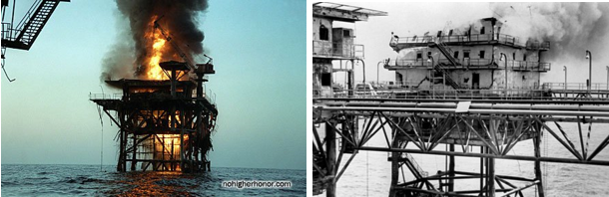

Twenty minutes before the surface action group opened fire, USS Thach radioed the platforms, telling the crews to abandon them. At 2 pm, four U.S. destroyers opened fire: USS Hoel, USS Leftwich, USS Kidd, and USS John Young. One platform was boarded by U.S. special forces, who recovered teletype messages and other documents, then planted explosives to destroy the platform. Air cover was provided by the cruisers USS Long Beach, USS Gridley (CG-21) and USS William H. Standley, two F-14 Tomcat fighters and an E-2 Hawkeye from USS Ranger. The high-explosive shells did negligible blast damage to the steel-lattice platforms, but eventually set them ablaze.

U.S. officials said the platforms were being used by Iranian forces as command-and-control posts with radars to track shipping in the area and communications gear to relay messages between the mainland and Iranian forces operating near the platforms. U.S. Defense Secretary Caspar W. Weinberger said Iran used the facility to "launch small boat attacks against nonbelligerent shipping." U.S. President Ronald Reagan called the operation "an appropriate and proportionate response" to the Silkworm strike. When asked by reporters if the situation constituted a state of war, Reagan replied: "No, we're not going to have a war with Iran: they're not that stupid."[

Iran subsequently filed a lawsuit against the United States for reparations at the International Court of Justice. The Court ruled, by 14 votes to two, that the retaliatory attacks by the U.S. Navy against certain Iranian oil platforms in the Persian Gulf in 1987 and 1988 constituted an unlawful use of force but did not violate 1955 Treaty of Amity.

- Oct 19 2005 – Middle East : Former Iraqi dictator Saddam Hussein’s trial for crimes against humanity begins in Baghdad.

- Oct 19 2005 – Terrorism: Hosam Smadi, a Jordanian practitioner of that "religion of peace" caught in an FBI sting trying to blow up a Dallas skyscraper, was sentenced to 24 years in prison after telling the court he was ashamed of his actions and renouncing al-Qaida

-o-o-O-o-o-

- Oct 20 1774 – American Revolution Era: Congress Creates the Continental Association » The First Continental Congress creates the Continental Association, which calls for a complete ban on all trade between America and Great Britain of all goods, wares or merchandise.

The creation of the association was in response to the Coercive Acts—or “Intolerable Acts” as they were known to the colonists–which were established by the British government to restore order in Massachusetts following the Boston Tea Party. The Intolerable Acts were a set of four acts: The first was the Boston Port Act, which closed the port of Boston to all colonists until damages from the Boston Tea Party were paid. The second, the Massachusetts Government Act, gave the British government total control of town meetings, taking all decisions out of the hands of the colonists. The third, the Administration of Justice Act, made British officials immune to criminal prosecution in America and the fourth, the Quartering Act, required colonists to house and quarter British troops on demand, including in private homes as a last resort.

Outraged by the new laws mandated by the British Parliament, the Continental Association hoped that cutting off all trade with Great Britain would cause enough economic hardship there that the Intolerable Acts would be repealed. It was one of the first acts of Congress behind which every colony firmly stood.

- Oct 20 1864 – Civil War: A boat expedition under Acting Master George E. Hill, with the screw steam gunboat Stars and Stripes, ascends the Ochlockonee River in Western Florida and destroys an extensive Confederate fishery on Marshs Island, capturing a detachment of soldiers assigned to guard the works.

- Oct 20 1864 – Old West: Louisiana Purchase » The U.S. Senate approves a treaty with France providing for the purchase of the territory of Louisiana, which would double the size of the United States.

At the end of 18th century, the Spanish technically owned Louisiana, the huge region west of the Mississippi that had once been claimed by France and named for its monarch, King Louis XIV. Despite Spanish ownership, American settlers in search of new land were already threatening to overrun the territory by the early 19th century. Recognizing it could not effectively maintain control of the region, Spain ceded Louisiana back to France in 1801, sparking intense anxieties in Washington, D.C. Under the leadership of Napoleon Bonaparte, France had become the most powerful nation in Europe, and unlike Spain, it had the military power and the ambition to establish a strong colony in Louisiana and keep out the Americans.

Realizing that it was essential that the U.S. at least maintain control of the mouth of the all-important Mississippi River, early in 1803 President Thomas Jefferson sent James Monroe to join the French foreign minister, Robert Livingston, in France to see if Napoleon might be persuaded to sell New Orleans and West Florida to the U.S. By that spring, the European situation had changed radically. Napoleon, who had previously envisioned creating a mighty new French empire in America, was now facing war with Great Britain. Rather than risk the strong possibility that Great Britain would quickly capture Louisiana and leave France with nothing, Napoleon decided to raise money for his war and simultaneously deny his enemy plum territory by offering to sell the entire territory to the U.S. for a mere $15 million. Flabbergasted, Monroe and Livingston decided that they couldn’t pass up such a golden opportunity, and they wisely overstepped the powers delegated to them and accepted Napoleon’s offer.

Despite his misgivings about the constitutionality of the purchase (the Constitution made no provision for the addition of territory by treaty), Jefferson finally agreed to send the treaty to the U.S. Senate for ratification, noting privately, “The less we say about constitutional difficulties the better.” Despite his concerns, the treaty was ratified and the Louisiana Purchase now ranks as the greatest achievement of Jefferson’s presidency.

- Oct 20 1918 – WWI: Turks Send British Officer to Negotiate Armistice Terms » Turkish government dispatches Charles Townshend, a British general and prisoner-of-war, to approach the British in Greece. Townshend, who had surrendered to the Ottoman army at the town of Kut-al-Amara in Mesopotamia in the spring of 1916, had lived since then under house arrest on an island off Constantinople. Despite his prisoner-of-war status, he enjoyed relative freedom and moved in some of the highest Ottoman political circles.

- Oct 20 1921 – Post WWI: German War Reparations » Imposed during the Paris Peace Conference upon the Central Powers following their defeat in the First World War by the Allied and Associate Powers. Each of the defeated powers were required to make payments in either cash or kind. Because of the financial situation in Austria, Hungary, and Turkey after the war, few to no reparations were paid and the requirements for reparations were cancelled. Bulgaria, having paid only a fraction of what was required, saw its reparation figure reduced and then cancelled. Historians have recognized the German requirement to pay reparations as the "chief battleground of the post-war era" and "the focus of the power struggle between France and Germany over whether the Versailles Treaty was to be enforced or revised".

The Treaty of Versailles (signed in 1919) and the 1921 London Schedule of Payments agreed upon 20 OCT in a meeting at Wiensbaden required Germany to pay 132 billion gold marks (US$33 billion [all values are contemporary, unless otherwise stated]) in reparations to cover civilian damage caused during the war. This figure was divided into three categories of bonds: A, B, and C. Of these, Germany was required to pay towards 'A' and 'B' bonds totaling 50 billion marks (US$12.5 billion) unconditionally. The payment of the remaining 'C' bonds was interest free and contingent on the Weimar Republic's ability to pay, as was to be assessed by an Allied committee.

Due to the lack of reparation payments by Germany, France occupied the Ruhr in 1923 to enforce payments, causing an international crisis that resulted in the implementation of the Dawes Plan in 1924. This plan outlined a new payment method and raised international loans to help Germany to meet its reparation commitments. Despite this, by 1928 Germany called for a new payment plan, resulting in the Young Plan that established the German reparation requirements at 112 billion marks (US$26.3 billion) and created a schedule of payments that would see Germany complete payments by 1988. With the collapse of the German economy in 1931, reparations were suspended for a year and in 1932 during the Lausanne Conference they were cancelled altogether. Between 1919 and 1932, Germany paid less than 21 billion marks in reparations.

The German people saw reparations as a national humiliation; the German Government worked to undermine the validity of the Treaty of Versailles and the requirement to pay. British economist John Maynard Keynes called the treaty a Carthaginian peace that would economically destroy Germany. His arguments had a profound effect on historians, politicians, and the public at large. Despite Keynes' arguments and those by later historians supporting or reinforcing Keynes' views, the consensus of contemporary historians is that reparations were not as intolerable as the Germans or Keynes had suggested and were within Germany's capacity to pay had there been the political will to do so. Following the Second World War, West Germany took up payments. The 1953 London Agreement on German External Debts resulted in an agreement to pay 50 per cent of the remaining balance. The final payment was made on 3 October 2010, settling German loan debts in regard to reparations.

- Oct 20 1923 – U.S. Navy: USS O–5 (SS–66) rammed and sunk by United Fruit steamer Abangarez in Limon Bay, Canal Zone. 3 died.

- Oct 20 1935 – China: Mao's Long March Concludes » Just over a year after the start of the Long March, Mao Zedong arrives in Shensi Province in northwest China with 4,000 survivors and sets up Chinese Communist headquarters. The epic flight from Chiang Kai-shek’s Nationalist forces lasted 368 days and covered 6,000 miles, nearly twice the distance from New York to San Francisco.

Civil war in China between the Nationalists and the Communists broke out in 1927. In 1931, Communist leader Mao Zedong was elected chairman of the newly established Soviet Republic of China, based in Kiangsi province, in the southwest. Between 1930 and 1934, the Nationalists launched a series of five encirclement campaigns against the Soviet Republic. Under the leadership of Mao, the Communists employed guerrilla tactics to successfully resist the first four campaigns, but in the fifth, Chiang raised 700,000 troops and built fortifications around the Communist positions. Hundreds of thousands of peasants were killed or died of starvation in the siege, and Mao was removed as chairman by the Communist Central Committee. The new Communist leadership employed more conventional warfare tactics, and its Red Army was decimated.

With defeat imminent, the Communists decided to break out of the encirclement at its weakest points. The Long March began on October 16, 1934. Secrecy and rear-guard actions confused the Nationalists, and it was several weeks before they realized that the main body of the Red Army had fled. The retreating force initially consisted of 86,000 troops, 15,000 personnel, and 35 women. Weapons and supplies were borne on men’s backs or in horse-drawn carts, and the line of marchers stretched 50 miles. The Communists generally marched at night, and when the enemy was not near, a long column of glowing torches could be seen snaking over valleys and hills into the distance.

- Oct 20 1941 – WW2 Era: USS Hornet (CV 8) is Commissioned » During World War II, she participates in the Doolittle Raid on Japan, the Battle of Midway, and the Solomon Campaign. On Oct. 26, 1942, at the Battle of Santa Cruz Islands, Hornet is severely damaged by the Japanese enemy and abandoned. Though U.S. destroyers attempt to scuttle her, Hornet remained afloat and was sunk by Japanese destroyers early the next morning with the loss of 140 sailors.

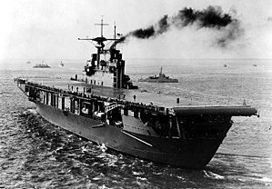

- Oct 20 1941 – WW2 Era: German troops reach the approaches to Moscow.

- Oct 20 1943 – WW2: Torpedo bombers (TBF Avengers) from Composite Squadron (VC) 13, then based on board the escort carrier USS Core (CVE 13), sink the German submarine U-378 north of the Azores.

- Oct 20 1943 – WW2: The cargo vessel Sinfra is attacked by US Army Air Force F B–25s and RAF Beaufighters aircraft at Suda Bay, Crete, and sunk. 2,098 Italian prisoners of war are drowned.

- Oct 20 1944 – WW2: MacArthur Returns to the Philippines » After advancing island by island across the Pacific Ocean, U.S. General Douglas MacArthur wades ashore onto the Philippine island of Leyte, fulfilling his promise to return to the area he was forced to flee in 1942.

The son of an American Civil War hero, MacArthur served as chief U.S. military adviser to the Philippines before World War II. The day after Pearl Harbor was bombed on December 7, 1941, Japan launched its invasion of the Philippines. After struggling against great odds to save his adopted home from Japanese conquest, MacArthur was forced to abandon the Philippine island fortress of Corregidor under orders from President Franklin Roosevelt in March 1942. Left behind at Corregidor and on the Bataan Peninsula were 90,000 American and Filipino troops, who, lacking food, supplies, and support, would soon succumb to the Japanese offensive.

After leaving Corregidor, MacArthur and his family traveled by boat 560 miles to the Philippine island of Mindanao, braving mines, rough seas, and the Japanese navy. At the end of the hair-raising 35-hour journey, MacArthur told the boat commander, John D. Bulkeley, “You’ve taken me out of the jaws of death, and I won’t forget it.” On 17 MAR, the general and his family boarded a B-17 Flying Fortress for northern Australia. He then took another aircraft and a long train ride down to Melbourne. During this journey, he was informed that there were far fewer Allied troops in Australia than he had hoped. Relief of his forces trapped in the Philippines would not be forthcoming. Deeply disappointed, he issued a statement to the press in which he promised his men and the people of the Philippines, “I shall return.” The promise would become his mantra during the next two and a half years, and he would repeat it often in public appearances.

For his valiant defense of the Philippines, MacArthur was awarded the Congressional Medal of Honor and celebrated as “America’s First Soldier.” Put in command of Allied forces in the Southwestern Pacific, his first duty was conducting the defense of Australia. Meanwhile, in the Philippines, Bataan fell in April, and the 70,000 American and Filipino soldiers captured there were forced to undertake a death march in which at least 7,000 perished. Then, in May, Corregidor surrendered, and 15,000 more Americans and Filipinos were captured. The Philippines were lost, and the U.S. Joint Chiefs of Staff had no immediate plans for their liberation.

After the U.S. victory at the Battle of Midway in June 1942, most Allied resources in the Pacific went to U.S. Admiral Chester Nimitz, who as commander of the Pacific Fleet planned a more direct route to Japan than via the Philippines. Undaunted, MacArthur launched a major offensive in New Guinea, winning a string of victories with his limited forces. By September 1944, he was poised to launch an invasion of the Philippines, but he needed the support of Nimitz’s Pacific Fleet. After a period of indecision about whether to invade the Philippines or Formosa, the Joint Chiefs put their support behind MacArthur’s plan, which logistically could be carried out sooner than a Formosa invasion.

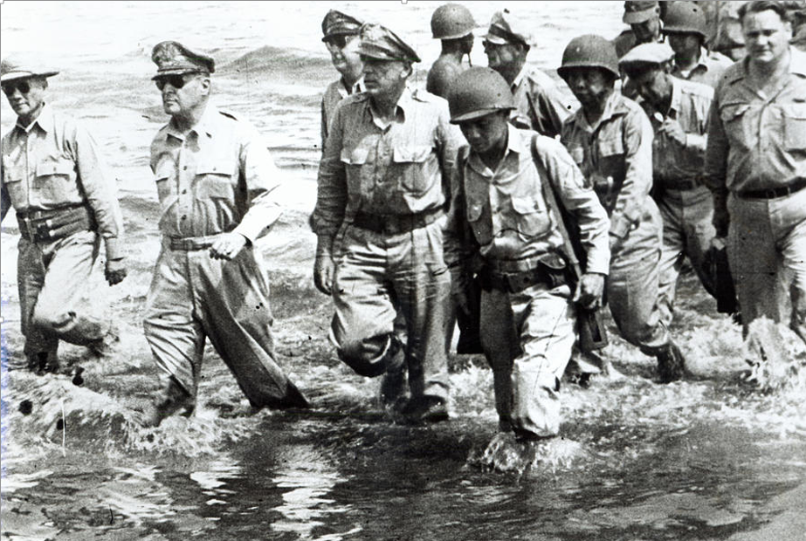

On October 20, 1944, a few hours after his troops landed, MacArthur waded ashore onto the Philippine island of Leyte. That day, he made a radio broadcast in which he declared, “People of the Philippines, I have returned!” In January 1945, his forces invaded the main Philippine island of Luzon. In February, Japanese forces at Bataan were cut off, and Corregidor was captured. Manila, the Philippine capital, fell in March, and in June MacArthur announced his offensive operations on Luzon to be at an end; although scattered Japanese resistance continued until the end of the war, in August. Only one-third of the men MacArthur left behind in March 1942 survived to see his return. “I’m a little late,” he told them, “but we finally came.”

- Oct 20 1944 – WW2: Battle of Leyte Gulf Began » Largest naval battle of the war. United States troops invaded the island of Leyte as part of a strategy aimed at isolating Japan from the countries it had occupied in Southeast Asia, and in particular depriving Japanese forces and industry of vital oil supplies. The Imperial Japanese Navy (IJN) mobilized nearly all of its remaining major naval vessels in an attempt to defeat the Allied invasion

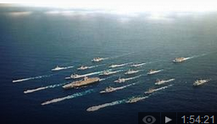

- Oct 20 1947– Cold War: Red Scare Comes to Hollywood » After World War II, the Cold War began to heat up between the world’s two superpowers—the United States and the communist-controlled Soviet Union. In Washington, conservative watchdogs worked to out communists in government before setting their sights on alleged “Reds” in the famously liberal movie industry

The House Un-American Activities Committee (HUAC) of the U.S. Congress opened an investigation into communist infiltration of the American movie industry on 20 OCT. Chaired by Congressman Parnell Thomas, the subsequent hearings focused on identifying political subversives among Hollywood actors and actresses, writers, and directors. Although initially opposed by a group of Hollywood heavyweights such as Humphrey Bogart, Lauren Bacall, and Gene Kelly, the hearings proceeded. A number of witnesses, including studio owners Walt Disney and Jack Warner, and movie stars Robert Taylor and Gary Cooper, gave statements decrying the communist influence in the film industry; some specifically named colleagues whom they suspected of communist affiliations or sympathies. Another group of witnesses, including writers Dalton Trumbo and Ring Lardner Jr., were less forthcoming, and loudly complained that the hearings were illegal, and that questions about their political loyalties were inappropriate.

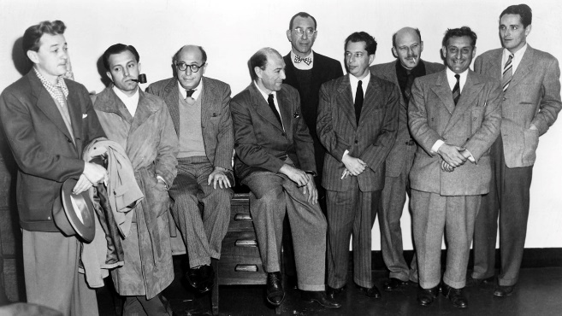

Eventually, the “Hollywood Ten,” as these protesting witnesses came to be known, were found in contempt of Congress and went on to serve jail terms. Pressured by Congress, the Hollywood establishment started a blacklist policy, banning the work of about 325 screenwriters, actors and directors who had not been cleared by the committee. Some of the blacklisted writers used pseudonyms to continue working, while others wrote scripts that were credited to other writer friends.

Starting in the early 1960s, after the downfall of Senator Joseph McCarthy, the most public face of anti-communism, the ban began to lift slowly. In 1997, the Writers’ Guild of America unanimously voted to change the writing credits of 23 films made during the blacklist period, reversing—but not erasing—some of the damage done during the Red Scare

- Oct 20 1964 – U.S.*Cuba: Kennedy Secretly Plans Blockade of Cuba » The White House press corps is told that President John F. Kennedy has a cold; in reality, he is holding secret meetings with advisors on the eve of ordering a blockade of Cuba. Kennedy was in Seattle and scheduled to attend the Seattle Century 21 World’s Fair when his press secretary announced that he had contracted an “upper respiratory infection.” The president then flew back to Washington, where he supposedly went to bed to recover from his cold.

Four days earlier, Kennedy had seen photographic proof that the Soviets were building 40 ballistic missile sites on the island of Cuba—within striking distance of the United States. Kennedy’s supposed bed rest was actually a marathon secret session with advisors to decide upon a response to the Soviet action. The group believed that Kennedy had three choices: to negotiate with the Russians to remove the missiles; to bomb the missile sites in Cuba; or implement a naval blockade of the island. Kennedy chose to blockade Cuba, deciding to bomb the missile sites only if further action proved necessary.

The blockade began 21 OCT and, the next day, Kennedy delivered a public address alerting Americans to the situation and calling on Soviet Premier Nikita Khrushchev to remove the missiles or face retaliation by the United States. Khrushchev responded by sending more ships—possibly carrying military cargo—toward Cuba and allowing construction at the sites to continue. Over the following six days, the Cuban Missile Crisis, as it is now known, brought the world to the brink of global nuclear war while the two leaders engaged in tense negotiations via telegram and letter. By October 28, Kennedy and Khrushchev had reached a settlement and people on both sides of the conflict breathed a collective but wary sigh of relief. The Cuban missile sites were dismantled and, in return, Kennedy agreed to close U.S. missile sites in Turkey.

- Oct 20 1964 – Vietnam War Era: Relations between South Vietnam, the United States, and Cambodia Deteriorate » A series of incidents and charges bring relations between Cambodia, South Vietnam, and the United States to a low point. Cambodia under Prince Norodom Sihanouk had tried to maintain its neutrality in the growing conflict between Saigon and the Communists in Vietnam, but the country became a sanctuary for Viet Cong and North Vietnamese forces fighting the Saigon government. Sihanouk, not strong enough to prevent the Communists from using his territory, came under increasing political and military pressure from the United States and South Vietnam. In this incident, South Vietnamese planes strafed a Cambodian village; when Cambodia protested, Saigon replied by reiterating its accusation that Cambodia was providing refuge for Viet Cong forces that were attacking across the border into South Vietnam.

-o-o-O-o-o-

- Oct 21 1774 – American Revolution Era: First display of the word "Liberty" on a flag, raised by colonists in Taunton, Massachusetts and which was in defiance of British rule in Colonial America.

- Oct 21 1797 – U.S. Navy: USS Constitution Launched » The 44-gun frigate Constitution, built to fight Barbary pirates off the coast of Tripoli, launches at Edmund Hartts Shipyard, Boston, Mass. The ship is now the oldest commissioned ship in the U.S. Navy.

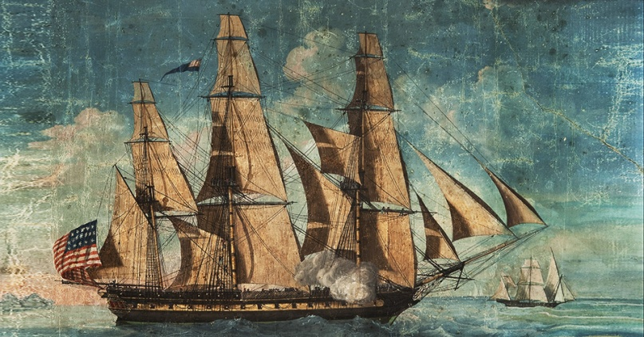

- Oct 21 1805 – England: Battle of Trafalgar » In one of the most decisive naval battles in history, a British fleet under Admiral Lord Nelson defeats a combined French and Spanish fleet at the Battle of Trafalgar, fought off the coast of Spain.

At sea, Lord Nelson and the Royal Navy consistently thwarted Napoleon Bonaparte, who led France to preeminence on the European mainland. Nelson’s last and greatest victory against the French was the Battle of Trafalgar, which began after Nelson caught sight of a Franco-Spanish force of 33 ships. Preparing to engage the enemy force on October 21, Nelson divided his 27 ships into two divisions and signaled a famous message from the flagship Victory: “England expects that every man will do his duty.”

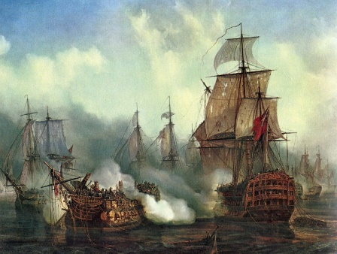

In five hours of fighting, the British devastated the enemy fleet, destroying 19 enemy ships. No British ships were lost, but 1,500 British seamen were killed or wounded in the heavy fighting. The battle raged at its fiercest around the Victory, and a French sniper shot Nelson in the shoulder and chest. The admiral was taken below and died about 30 minutes before the end of the battle. Nelson’s last words, after being informed that victory was imminent, were “Now I am satisfied. Thank God I have done my duty.” Victory at the Battle of Trafalgar ensured that Napoleon would never invade Britain. Nelson, hailed as the savior of his nation, was given a magnificent funeral in St. Paul’s Cathedral in London. A column was erected to his memory in the newly named Trafalgar Square, and numerous streets were renamed in his honor.

- Oct 21 1837 – Native Americans: U.S. Troops Siege the Indian Seminole Chief Osceola in Florida » Osceola's capture, under a controversial flag of truce offered by Gen. Thomas Jessup, remains today one of the blackest marks in American military history. Osceola masterminded successful battles against five baffled U.S. generals, murdered the United States Indian agent, took punitive action against any who cooperated with the white man and stood as a national manifestation of the Seminoles' strong reputation for non-surrender. Osceola was not a chief with the heritage of a Micanopy or Jumper, but his skill as an orator and his bravado in conflict earned him great influence over Seminole war actions. His 1838 death in a Charleston, S.C. prison was noted on front pages around the world. At the time of his death, Osceola was the most famous American Indian.

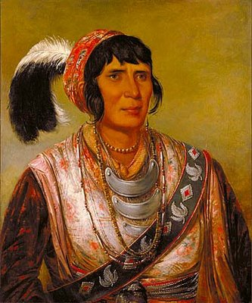

- Oct 21 1854 – Great Britain: Florence Nightingale is Sent to the Crimean War » Florence and her group of 38 nurses that she trained, went to Crimea when the Crimean War began. The reports of the war in the newspapers described the lack of proper medical facilities for the British soldiers. The British army could not accommodate the battle injuries and casualties, which led to cholera, lack of supplies, and a massive problem with sanitation. To say that the battlefield medical facilities were deplorable, was an understatement. There was absolute filth, overcrowding, rats, and shortages of supplies, surgeons, clothes, food, and medicine. The Minister at War, Sidney Herbert, appointed Nightingale to oversee the care of the wounded in Constantinople, Turkey. Florence’s first priority was to scrub all of the injured men’s clothes, making them more sanitary and germ free. In addition to insisting that all dirty clothing be removed from the hospital and taken outside to be washed, she spent her own money to purchase bandages, extra clothes, 200 scrub brushes, better food, operating tables, and basic necessities for the hospital.

- Oct 21 1861 – Civil War: The Battle of Wildcat Mountain » Early in the war, the Lincoln administration knew well the importance of keeping the border state of Kentucky in the Union. Any Rebel armies operating successfully there could encourage secessionist sympathies. In late 1861, a Confederate force of around 6,000 men under Brig. Gen. Felix Zollicoffer entered the southeast corner of the state just north of the Tennessee border and occupied the strategic Cumberland Gap. To counter Confederate moves in the area, Union Brig. Gen. George H. Thomas sent a detachment under Col. T.T. Garrard to secure the ford on the Rockcastle River, establish a camp at Wildcat Mountain, and obstruct the Wilderness Road passing through the area.

Garrard informed Thomas that if he did not receive reinforcements, he would have to retreat because he was outnumbered seven to one. Thomas sent Brig. Gen. A. Schoepf with a brigade to Garrard, bringing the total force to about 7,000. On the morning of 21 OCT, soon after Schoepf arrived, some of his men moved forward and ran into Rebel forces, commencing a fight. The heavily fortified Federals repelled the Confederate attacks. The Confederates withdrew during the night and continued their retreat to Cumberland Ford, which they reached on the 26th. A Union victory was welcomed, countering the Confederate victories at First Manassas and Ball's Bluff. Estimated casualties: Union 25 | Confederate 53.

- Oct 21 1861 – Civil War: The Battle of Ball’s Bluff, Virginia » On the evening of October 20, 1861, Union army commander George B. McClellan ordered Gen. Charles Stone to send a scouting party across the Potomac River to identify the positions of Confederate Col. Nathan Evans’s troops near Leesburg. In the darkness the party’s inexperienced leader, Capt. Chase Philbrick, mistook a line of trees for a line of tents, and reported that he had stumbled across an unguarded Confederate camp. Early the next day, Col. Charles Devens was sent across the river to attack the camp, and after realizing that the supposed “camp” was nothing but a line of trees, his men encountered a company of Mississippi infantry and a skirmish began. Col. Edward Baker, a U.S. Senator, decided to reinforce Devens, but with only four small boats available to transport men, Union reinforcements arrived slowly. Evans used the Federal delay to organize his men, and when Col. Baker was killed in the afternoon, Union resistance crumbled. The victorious Confederates drove the Yankees over the bluff and into the Potomac, where many drowned and hundreds surrendered rather than risk escape into the river. The battle, while small in scale, had major political implications that would haunt the Union army for the rest of the war. The Battle of Ball’s Bluff in Virginia produced the war’s first martyr and led to the creation of a Congressional committee to monitor the conduct of the war. Casualties and losses: US 921 - CSA 155.

- Oct 21 1862 – Civil War: The Cairo class ironclad river gunboat Louisville, under the command of Lt. Cmdr. R.W. Meade III, escorts the steamer Meteor, whose embarked Army troops landed at Bledsoes Landing and Hamblins Landing, Ark. The towns are burned in reprisal for attacks by Confederate guerrillas on mail steamer Gladiator early in the morning of Oct. 19.

- Oct 21 1864 – Civil War: Battle of Westport (21-23 OCT) » The Battle was the last full-scale action of the Civil War in Missouri and west of the Mississippi. This major battle, the largest engagement west of the Mississippi River, marked the climactic end of a decade of war and turbulence along the Missouri and Kansas border. It involved 32,000 troops over the three day engagement and marked the final dramatic and decisive conclusion to a decade of strife in Missouri. It sounded the death knell for Confederate hopes of fomenting a popular uprising in Missouri and wresting the state from Union control. As a consequence of the battle, Kansas City and Fort Leavenworth were saved from falling into Confederate hands. Missouri remained firmly under Federal domination. Casualties and losses: Union about 1500 of a force of 22,000 – CSA about 1500 of a force of 8,500.

- Oct 21 1864 – Civil War: The wooden side-wheel cruiser Fort Jackson captures steamer Wando at sea, east of Cape Romain, S.C., with cargo of cotton.

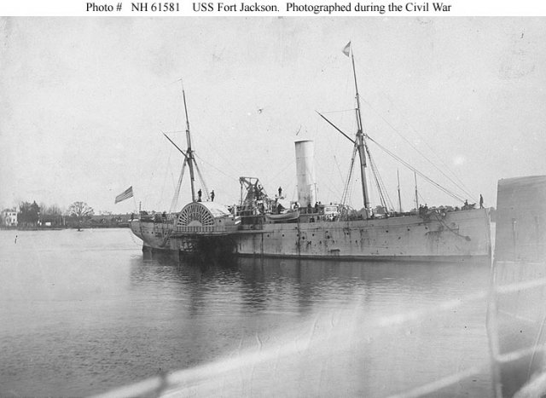

- Oct 21 1867 – Native Americans: The Plains Indians sign key provisions of the Medicine Lodge Treaty in Kansas » More than 7,000 Southern Plains Indians gather near Medicine Lodge Creek, Kansas, as their leaders sign one of the most important treaties in the history of U.S.-Indian relations. For decades, Americans had viewed the arid Great Plains country west of the 100th meridian as unsuitable for white settlement; many maps even labeled the area as the Great American Desert. Because of this, policy makers since the days of the Jefferson administration had largely agreed that the territory should be used as one big reservation on which all American Indians could be relocated and left alone to continue their traditional ways of life. This plan was followed for decades. Unfortunately, by 1865, the Indians, roaming freely over the Great Plains, had become a threat to the increasingly important communication and transportation lines connecting the east and west coasts of the nation. At the same time, new dryland farming techniques had led a growing number of white Americans to settle in Kansas and Nebraska, and many others were now eager to move even farther west. With the treaties signed, the old idea of a giant continuous Great Plains reservation was abandoned forever and replaced with a new system in which the Plains Tribes were required to relocate to a clearly bounded reservation in Western Oklahoma.

- Oct 21 1904 – Panama: Panamanians clash with U.S. Marines in Panama in a brief uprising. The 2nd Marine Regiment had arrived there on 3 JAN with the primary mission of enforcement of provisions of the Hay–Herrán Treaty made with Panama on 18 November 1903 which provided for the construction of a cross-isthmus canal.

- Oct 21 1917 – WWI: The first U.S. troops enter the front lines at Sommerviller, a commune in north-eastern France, under French command.

- Oct 21 1918 – WWI: Germany Ceases Unrestricted Submarine Warfare » A German U-boat submarine in the Irish Sea fires the last torpedo of World War I sinking a small British merchant ship, the Saint Barcham, and drowning its eight crewmen. Admiral Reinhardt Scheer dealt the final blow to Germany’s U-boat strategy, ordering all his navy’s submarines to return to their German bases thus ending Germany's policy of unrestricted submarine warfare.

- Oct 21 1938 – WW2 Era: Japanese Troops Occupy Canton » The Canton Operation was part of a campaign by Japan during the Second Sino-Japanese War to blockade China to prevent it from communicating with the outside world and importing needed arms and materials. Control of Canton and the Pearl River Delta would provide a base to make the blockade of Guangdong province more effective by seizing southern China's major port and isolate the British port of Hong Kong.

- Oct 21 1940 – WW2 Era: RAF drops 1st anti-nazi pamphlets on Netherlands

- Oct 21 1941 – WW2 Era: Germans Massacre Men, Women, and Children in Yugoslavia » German soldiers go on a rampage, killing thousands of Yugoslavian civilians, including whole classes of schoolboys.

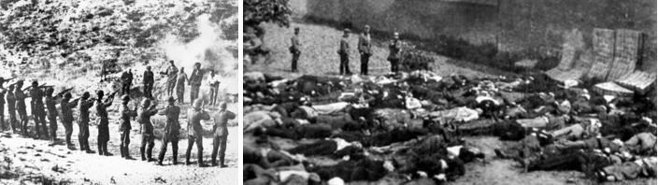

Despite attempts to maintain neutrality at the outbreak of World War II, Yugoslavia finally succumbed to signing a “friendship treaty” with Germany in late 1940, finally joining the Tripartite “Axis” Pact in March 1941. The masses of Yugoslavians protested this alliance, and shortly thereafter the regents who had been trying to hold a fragile confederacy of ethnic groups and regions together since the creation of Yugoslavia at the close of World War I fell to a coup, and the Serb army placed Prince Peter into power. The prince-now the king–rejected the alliance with Germany-and the Germans retaliated with the Luftwaffe bombing of Belgrade, killing about 17,000 people.

With Yugoslavian resistance collapsing, King Peter removed to London, setting up a government-in-exile. Hitler then began to carve up Yugoslavia into puppet states, primarily divided along ethnic lines, hoping to win the loyalty of some-such as the Croats-with the promise of a postwar independent state. (In fact, many Croats did fight alongside the Germans in its battle against the Soviet Union.) Hungary, Bulgaria, and Italy all took bites out of Yugoslavia, as Serb resisters were regularly massacred. On 21 OCT, in Kragujevac, 2,300 men and boys were murdered; Kraljevo saw 7,000 more killed by German troops, and in the region of Macva, 6,000 men, women, and children were murdered.

Serb partisans, fighting under the leadership of the socialist Josef “Tito” Brozovich, won support from Britain and aid from the USSR in their battle against the occupiers. “The people just do not recognize authority…they follow the Communist bandits blindly,” complained one German official reporting back to Berlin.

- Oct 21 1942 – WW2: The British submarine HMS Seraph lands Navy Capt. Jerauld Wright and four Army officers including Maj. Gen. Mark Clark at Cherchel, French North Africa to meet with a French military delegation to assess French attitude towards future Allied landings (Operation Torch). Eventually, the French agreed to the mission.

- Oct 21 1942 – WW2: USS Guardfish (SS 217) sinks Japanese freighter Nichiho Maru about 120 miles north-northeast of Formosa while USS Gudgeon (SS 211) attacks a Japanese convoy in the Bismarck Sea and sinks the transport Choko Maru.

- Oct 21 1944 – WW2: The first kamikaze attack: A Japanese plane carrying a 200 kilograms (440 lb) bomb attacks HMAS Australia off Leyte Island, as the Battle of Leyte Gulf began.

- Oct 21 1944 - WW2: Battle of Aachen (2-21 OCT) » The city of Aachen had been incorporated into the Siegfried Line, the main defensive network on Germany's western border; the Allies had hoped to capture it quickly and advance into the industrialized Ruhr Basin. Although most of Aachen's civilian population was evacuated before the battle began, much of the city was destroyed and both sides suffered heavy losses. It was one of the largest urban battles fought by U.S. forces in World War II, and the first city on German soil to be captured by the Allies. The battle ended with a German surrender, but their tenacious 19-day defense significantly disrupted Allied plans for the advance into Germany. It was the first German city to fall to the Allies. Casualties and losses: U.S. ~7,000 - GER 10,600.

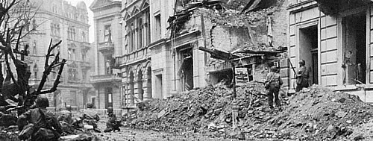

- Oct 21 1944 – WW2: Canadian Troops Occupy Breskens » Operation Switchback, one of a series of operations in The Battle of the Scheldt, aimed to clear the Breskens Pocket, an area of land north of the Leopold Canal and south of the Western Scheldt, Belgium. The German forces had blown up dykes to flood the ground, which was a maze of ditches and canals, making military maneuvers impossible except on the narrow roads built on top of the dykes. What’s more, the Germans had 10,000 men who were well supplied with machine guns, mortars and artillery. Despite the Germans’ robust defenses, the Canadians, with the support of amphibious vehicles and WASP flamethrower carriers, captured Breskens on 21 OCT. On 2 NOV, Canadian soldiers stormed a pillbox and captured the German commander Knut Eberding, who, despite his own orders to fight to the death for the Führer, surrendered without firing a shot. Operation Switchback ended successfully when the remaining German forces laid down their weapons the next day.

- Oct 21 1952 – Korea: USS Lewis (DE 535) aids two Korean minesweepers under fire at Wonson Harbor. As she approaches, at least four enemy batteries open up on the destroyer escort. Lewis returns fire and lays down a smoke screen to cover the minesweepers retreat. Shortly thereafter the destroyer escort takes two 75mm shell hits, killing six crewmen outright and mortally wounding a seventh. The second hit explodes on the main deck, port side, lightly wounding one sailor.

- Oct 21 1967 – Vietnam War: Thousands Protest the War » In Washington, D.C. nearly 100,000 people gather to protest the American war effort in Vietnam. More than 50,000 of the protesters marched to the Pentagon to ask for an end to the conflict. The protest was the most dramatic sign of waning U.S. support for President Lyndon Johnson’s war in Vietnam. Polls taken in the summer of 1967 revealed that, for the first time, American support for the war had fallen below 50 percent.

When the Johnson administration announced that it would ask for a 10 percent increase in taxes to fund the war, the public’s skepticism increased. The peace movement began to push harder for an end to the war—the march on Washington was the most powerful sign of their commitment to this cause. The Johnson administration responded by launching a vigorous propaganda campaign to restore public confidence in its handling of the war. The president even went so far as to call General William Westmoreland, commander of U.S. forces in Vietnam, back to the United States to address Congress and the public. The effort was somewhat successful in tempering criticisms of the war. However, the Tet Offensive of early 1968 destroyed much of the Johnson Administration’s credibility concerning the Vietnam War.

The protest was also important in suggesting that the domestic Cold War consensus was beginning to fracture. Many of the protesters were not simply questioning America’s conduct in Vietnam, but very basis of the nation’s Cold War foreign policy.

- Oct 21 1975 – U.S. Coast Guard: Coast Guard Academy 1st allows women to enroll.

- Oct 21 1983 – Grenada: The United States sends a ten-ship task force to Grenada.

- Oct 21 1991 – War On Terrorism: Beirut Hostage Release » U.S. hostage Jesse Turner released from 5 years in captivity in Beirut. Turner, 44, was released hours after Israel freed 14 Arabs held in southern Lebanon and a 15th from an Israeli jail amid growing evidence that the United Nations' efforts to end the 9-year-old stalemate were proving successful. Seven Western hostages were still being held in Lebanon. Turner, a professor of mathematics and computer science at Beirut University College, was kidnapped Jan. 24, 1987. His release came despite a warning by a separate group, Islamic Jihad, which was holding U.S. hostages Terry Anderson and Thomas Sutherland, that Israel's repeated attacks in southern Lebanon could hamper U.N. Secretary-General Javier Perez de Cuellar's efforts to resolve hostage standoff.

Forty-eight Westerners -- journalists, businessmen and professors -- have been kidnapped in Lebanon since 1982. They include 20 Americans, 12 French citizens, seven Britons, five Germans, one South Korean, two Swedes and an Italian. Of the Americans kidnapped, 13 have been freed, three have died in captivity and four remain hostage. Of the French, 11 have been freed and one died in captivity. Of the Britons, three have been freed, three died and one is being held. Of the Germans, three have been freed and two are still held. The South Korean and both Swedes have been released. The Italian is believed to have been killed shortly after his abduction.

- Oct 21 1994 – Cold War: After almost four months of difficult negotiations, the United States and North Korea signed an agreement to end their dispute over North Korea's nuclear program but kept secret many details of how the accord will be put into effect. The agreement commits North Korea to freeze all its nuclear activities within one month. It also provides that it dismantle its reactors and related operations and store its spent fuel rods while the light-water reactors are under construction. It will then "dispose of the fuel in a safe manner that does not involve reprocessing" in North Korea. The ‘Agreed Framework’ soon ran into problems, and ultimately broke down in 2002.

-o-o-O-o-o-

- Oct 22 1707 – England: Four warships in a Royal Navy fleet off the Isles of Sicily run aground in severe weather because their navigators are unable to accurately calculate their positions. Admiral Sir Cloudesley Shovell and more than 1,500 sailors aboard the wrecked vessels drown, making the incident one of the worst maritime disasters in the history

- Oct 22 1777 – American Revolutionary War: American defenders of Fort Mercer on the Delaware River repulse repeated Hessian attacks in the Battle of Red Bank. Casualties and losses: US 37 - Hessian 330.

- Oct 22 1790 – Native Americans: In the Northwest Indian War warriors of the Miami tribe under Chief Little Turtle defeat United States troops under General Josiah Harmar at the site of present–day Fort Wayne, Indiana.

- Oct 22 1836 – Republic of Texas: Sam Houston Elected President » Houston became the first regularly elected president of the Republic of Texas, defeating Stephen F. Austin. During his two presidential terms he successfully guided the Republic of Texas through some extremely difficult times. Houston's first term lasted from October 22, 1836, to December 10, 1838.

The town of Houston was founded in 1836, named in his honor, and served as the capital of the republic during most of his first administration. During this term Houston sought to demilitarize Texas by cannily furloughing much of the army. He also tried, with limited success, to avoid trouble between white settlers and Indians. One of his biggest crises came with the Córdova Rebellion, an unsuccessful revolt in 1838 by a group of Kickapoo Indians and Mexican residents along the Angelina River. In late 1836, Houston sent Santa Anna, then a prisoner of war, to Washington to seek the annexation of Texas to the United States. Although Houston favored annexation, his initial efforts to bring Texas into the Union proved futile, and he formally withdrew the offer by the end of his first term.

- Oct 22 1846 – U.S. Navy: Lavinia Fanning Watson of Philadelphia christens the sloop-of-war Germantown, the first U.S. Navy ship to be sponsored by a woman.

- Oct 22 1862 – Civil War: The screw frigate Wabash provides artillery support for Union infantry troops at the Battle of Pocotaligo, S.C. One of the gun crew, who was seriously injured, was Ordinary Seaman Oscar W. Farenholt, the first enlisted man in the Navy to reach flag rank. The battery from Wabash took part in artillery operations all along the South Atlantic coast.

- Oct 22 1862 – Civil War: Battle at Old Fort Wayne » The battle occurred just inside what was then the Indian Territories, now Oklahoma. In September1862 a Native American force under Col. Douglas H. Cooper had joined a Confederate force at Newtonia, Missouri, the advance guard for an invasion of that state from Arkansas that did not in the end ever happen. On 30 SEP they had played a part in repelling a Union attack at Newtonia, but on 4 OCT the Confederate force had retreated in the face of a much larger Union army. Cooper had retired to his camp at Old Fort Wayne, just inside the Indian Territory. There he was attempting to build up an army ready to launch an invasion of Kansas.

A federal force under Brigadier-General James Blunt had been dispatched to catch him. Early on 22 OCT, Blunt discovered the Confederate camp. He estimated Cooper’s force to be between 5,000 and 7,000 strong, but despite this still decided to attack with the three companies of infantry that had accompanied him on an advance reconnaissance. Only the rapid arrival of Federal reinforcements from his main column saved Blunt from disaster. Those reinforcements rapidly turned the tide of battle. Cooper’s Native American’s fled the field, while his four artillery pieces were captured.

Cooper’s own account of the battle was rather different. Most of his troops had not yet concentrated at Old Fort Wayne. Only two regiments and Howell’s Texan artillery were actually present, giving him a total of 1,500 men. Faced with a Federal force he estimated as being 5,000 strong, Cooper considered himself to have been lucky to escape at all. His small force stayed together on its retreat back to Scullyville, in the Indian Territory. Blunt’s victory at Old Fort Wayne helped the Union gain control of North West Arkansas. On 7 DEC he repelled a determined Confederate counterattack at Prairie Grove, after which Federal control of that part of the state remained relatively secure.

- Oct 22 1862 – Civil War: Union troops push 5,000 confederates out of Maysville, Ark., at the Second Battle of Pea Ridge.

- Oct 22 1864 – Civil War: Battle of Bryam’s Ford (22-23 Oct) » Also known as Action at the Big Blue, Mo. that formed a part of the larger Battle of Westport. Maj. Gen. Sterling Price's Confederate Army of Missouri headed towards Kansas City, Missouri and Fort Leavenworth, hoping to capture Missouri for the South in the weeks prior to Abraham Lincoln's reelection in 1864. Union Maj. Gen. Samuel R. Curtis's Army of the Border, in and around Westport, was blocking Price's movement, while Maj. Gen. Alfred Pleasonton's provisional cavalry division was pressing Price's rearguard. On 22 OCT Maj. Gen. James G. Blunt's division held a defensive position on the west bank of the Big Blue River just outside Kansas City. Around 10:00 am, part of Brig. Gen. Joseph O. Shelby's Confederate division conducted a frontal attack on Blunt's men.

The attack was a ruse; Shelby's men flanked Blunt's hasty defenses, forcing the Federals to retire to nearby Westport. The next morning, Pleasanton's troopers gained the west bank of the river and the Confederates retired. As the Union cavalry forded the river, they came under heavy fire from Confederate artillery. Once they had crossed, they charged the Confederate infantry under General John S. Marmaduke across an open field; during which Union troops from Missouri and Arkansas battled Confederates from these same two states. As the Confederates under Shelby and Marmaduke consolidated their men, they came under attack from Union artillery, forcing them to withdraw. The fighting around the Big Blue River and Westport brought to a close the last major Confederate military operation west of the Mississippi River. Forces engaged: 30,500. Estimated casualties: Union 1,500 | Confederate 1,500.

- Oct 22 1864 – Civil War: Hood at Guntersville, Alabama » Confederate General John Bell Hood’s army marched from Gadsden to Guntersville to cross the mighty Tennessee River. However, Hood forgot to retrieve his army’s pontoon bridge, which lay across the Coosa River in eastern Alabama. Hood’s superior officer, General Pierre G.T. Beauregard, sent the bridge to Guntersville but arrived to find that the army was gone. Hood had continued west past Decatur, Alabama, before finally crossing the Tennessee at Courtland. The move took the Rebels more than 50 miles out of their way and made a surprise attack on the state of Tennessee unlikely. When Hood did move into Tennessee, Union General William T. Sherman’s force was ready and waiting. In November and December, Hood nearly destroyed the remnants of his army at the battles of Franklin and Nashville.

- Oct 22 1914 – WWI Era: Germans Capture Langemarck during First Battle of Ypres » In a bitter two-day stretch of hand-to-hand fighting, German forces capture the Flemish town of Langemarck from its Belgian and British defenders during the First Battle of Ypres.

The trench lines built in the fall of 1914 between the town of Ypres, on the British side, and Menin and Roulers, on the German side—known as the Ypres salient—became the site of some of the fiercest battles of World War I, beginning in October 1914 with the so-called First Battle of Ypres. The battle, launched on October 19, was a vigorous attempt by the Germans to drive the British out of the salient altogether, thus clearing the way for the German army to access the all-important Belgian coastline with its access to the English Channel and, beyond, to the North Sea.

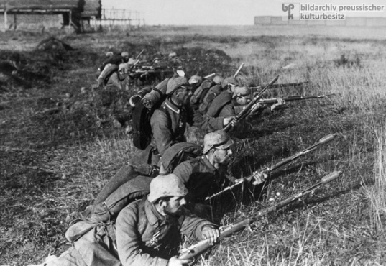

The German forces advancing against Ypres had a numerical advantage over the British Expeditionary Force (BEF), as General Erich von Falkenhayn was able to send the entire German 4th and 6th Armies against the BEF’s seven infantry divisions (one was held in reserve) and three cavalry divisions. For reinforcements, Sir John French, commander of the BEF, had only a few divisions of Indian troops already en route to Flanders; in the days to come, however, these replacement troops would distinguish themselves with excellent performances in both offensive and defensive operations.

After the initial rapid movement of the German offensive, the Battle of Ypres became a messy, desperate struggle for land and position, leaving the countryside and villages around it in a state of bloody devastation. A German artilleryman, Herbert Sulzbach, wrote on 21 OCT of his experience in the battle: “We pull forward, get our first glimpse of this battlefield, and have to get used to the terrible scenes and impressions: corpses, corpses and more corpses, rubble, and the remains of villages.” After the German capture of Langemarck on 22 OCT, fighting at Ypres continued for one more month, before the arrival of winter weather brought the battle to a halt. The Ypres salient, however, would see much more of the same bitter conflict before the war was over, including a major battle in the spring of 1915—also a German offensive—and an attempted Allied breakthrough in the summer of 1917.

- Oct 22 1941 – Holocaust: Odessa Massacre (22-24 OCT) The Odessa massacre refers either to the events of October in which some 25,000 to 34,000 Jews were shot or burned, or to the murder of well over 100,000 Ukrainian Jews in the town and the areas between the Dniester and Bug rivers, during the Romanian and German occupation. The primary perpetrators were Romanian soldiers, Einsatzgruppe SS and local ethnic Germans.

On October 22, 1941, in the building of the NKVD on the Marazlievskaya street where the Romanian military commander's office and the headquarters of the Romanian 10th Infantry Division had settled to occupy the city, a radio-controlled mine exploded. The mine had been planted there by the sappers of the Red Army even before the surrender of the city by Soviet troops. The building collapsed, and under its rubble, 67 people were killed, including 16 officers, among whom was the military commander of the city, Romanian General Ioan Glogojeanu. Responsibility for the explosion was placed on the Jews and Communists.

In response to the explosion at the commandant's office, the Romanian troops and the German "Einsatzgruppe" arrived in Odessa on 23 OCT to kill from 5,000 to 10,000 hostages, many of whom were Jews. Across the Marazlievskaya street, occupiers broke into the apartments of Odessa citizens and shot or hanged all residents found, without exception. They raided the streets and markets of the city and suburbs, and people who knew nothing of the bombing were shot on site against fences or the walls of houses. Nearly 100 men were seized and shot at the Big Fountain, about two hundred people were hanged in the Slobodka neighborhood near the market, 251 residents were executed in Moldavanka, Near and Far Windmills and in Aleksandrovsky Prospekt about 400 townspeople were hanged. The columns of the captured hostages were driven to the area of artillery warehouses on Lustdorf Road, where they were shot or burned alive. After the war, more than 22,000 corpses were found in mass graves.

On 23 OCT, an order was issued threatening all Jews with death on the spot and ordering them to report to the village of Dalnik on 24 OCT. In the afternoon of 24 OCT, about 5,000 Jews were gathered near the outpost of Dalnik. The first 50 people were brought to the anti-tank ditch and shot by the commander of the 10th machine-gun battalion, Lieutenant-Colonel Nicolae Deleanu. To speed up the process of destruction, the Jews were driven into four barracks, in which holes were made for machine guns, and the floor was pre-filled with gasoline. People in two barracks were shot with machine guns on the same day. At 17:00 the barracks were set on fire. The next day, the prisoners were shot, placed in the remaining two barracks, and in one of the barracks grenades were thrown.

Meanwhile, the Jews who were not selected for the first group, and who had already arrived in Dalnik, were told that they were "forgiven". They were sent to various military headquarters and Gendarmerie stations for "registration", where they were detained for different lengths of time. When they were released, they discovered that their houses had been occupied and their property plundered. During the first week of stay of Romanians in Odessa, the city lost about 10% of its inhabitants.

- Oct 22 1942 – WW2: The destroyers USS Mahan (DD 364) and USS Lamson (DD 367) sink the Japanese gunboat Hakkaisan Maru southwest of Tamana.

- Oct 22 1942 – WW2: Allies Confer Secretly About Operation Torch » American Maj. Gen. Mark Clark meets in Algeria with French officials loyal to the Allied cause, as well as Resistance fighters, regarding the launch of Operation Torch, the first Allied amphibious landing of the war. The meeting was interrupted at one point by the arrival of French police loyal to the Vichy government. Clark and company had to hide out in a nearby wine cellar. The conference resumed the next day–and plans for bringing the “Torch” of freedom to French North Africa took final shape.

- Oct 22 1942 – WW2: Battle of Goodenough Island (22–24 Oct) » The battle, also known as Operation Drake, was part of the Pacific campaign. The Allies landed on Goodenough Island, Papua, and clashed with a Japanese Kaigun Rikusentai (Special Naval Landing Force). The Japanese troops had been stranded on the island during the Battle of Milne Bay in late August 1942 when Allied aircraft sank their barges. "Drake Force", consisting of the Australian 2/12th Battalion and attachments, landed on the southern tip of Goodenough Island at Mud Bay and Taleba Bay on 22 OCT, tasked with denying the Japanese use of the island prior to the Buna campaign. By the time the Australians landed 60 of the 353 Japanese troops originally stranded on the island had been rescued by a submarine, which had also left behind food and ammunition. This left 290 Japanese troops, who had had plenty of time to dig in.

A fierce battle developed during daylight on 23 OCT, but on the night of 23-24 the submarine returned, and ferried 250 of the remaining troops across to nearby Fergusson Island, from where they were rescued by a cruiser. On the following day the Australians were able to mop up the small number of Japanese troops who had been left behind, clearing away one obstacle for the attack along the coast. After the battle, Goodenough Island was developed into a major Allied base for operations later in the war. Casualties and losses: U.S. & Australia 13 killed, 19 wounded of a force of 640 – Japan 20 killed, 15 wounded, 1 prisoner of a force of 353 initially, 285 during ground fighting.

- Oct 22 1944 – WW2: Battle of Aachen: The city of Aachen falls to American forces after three weeks of fighting, making it the first German city to fall to the Allies. Casualties and losses: US 5000 - Ger 10,600.

- Oct 22 1948 – Arab*Israeli War: Operation 10 Plagues (Yo’av) - Israeli 15–22 October offensive against Egyptian army in the Negev Desert ends. Its goal was to drive a wedge between the Egyptian forces along the coast and the Beersheba–Hebron–Jerusalem road, and ultimately to conquer the whole Negev.

The Israeli forces consisted of three infantry brigades, the Negev Brigade, the Givati Brigade under the command of Abraham "Kiki" Elkin, and the Yiftach Brigade, an armored battalion from the 8th Armored Brigade and the largest artillery formation that had been available to the IDF at the time. On 18 OCT the Oded Brigade also joined in the operation. In the evening of 15 OCT the Israeli Air Force bombed Gaza, al-Majdal (now Ashkelon), Beersheba and Beit Hanoun. Some targets were bombed again during the following two nights. A battalion of the Yiftach Brigade mined the railroad between El-Arish and Rafah and various roads in the Gaza area, also driving a wedge into the road. Two battalions of the Givati Brigade drove south east of Iraq al-Manshiyya (now Kiryat Gath), thus cutting the road between al-Faluja and Beit Jibrin. Beit Jibrin was captured by the 52 Battalion of Givati and the 8th Brigade on 23 OCT.

In the early morning hours of 21 OCT, following two nights of air raids, the Negev Brigade and 8th Armored Brigade attacked Beersheba from the west. Another force joined them from the north. The Egyptian army garrison consisted of 500 soldiers with some light artillery. They put up some resistance for five hours before surrendering. While a truce was ordered for 15:00 hours on 22 OCT, action in the days immediately following the operation, and associated with it, continued. After the Egyptians retreated southward on 28 OCT from Ashdod and al-Majdal on 6 NOV to Gaza, the coastal strip down to Yad Mordechai was occupied by Israeli forces. On 9 NOV, the Iraq Suwaydan fortress was captured and renamed the Yoav Fortress in honor of the operation.

Towards the end of the operation General Allon sought permission to launch an attack on the Hebron hills and into the Jericho valley. David Ben-Gurion refused, mainly due to a tacit agreement with King Abdullah on the division of the West Bank and the need to avoid British involvement. The United Nations Refugee Relief Project reported that the Gaza Strip's refugee population had jumped from 100,000 to 230,000 as a result of Operation Yoav. This figure does not include those who fled to the Hebron Hills.

- Oct 22 1951 – Cold War: In the Operation Buster-Jangle nuclear tests the first detonation, Able, takes place. Uncle, the last of the seven tests is detonated 29 NOV. Navy and Marine Corps observers and 3rd Marines take part in this Department of Defense operation.

- Oct 22 1957 – Vietnam War Era: American Forces Suffer First Casualties in Vietnam » U.S. military personnel suffer their first casualties in the war when 13 Americans are wounded in three terrorist bombings of Military Assistance Advisory Group and U.S. Information Service installations in Saigon. The rising tide of guerrilla activity in South Vietnam reached an estimated 30 terrorist incidents by the end of the year and at least 75 local officials were assassinated or kidnapped in the last quarter of 1957.

- Oct 22 1962 – U.S.*Cuba: Cuban Missile Crises » In a televised speech of extraordinary gravity, President John F. Kennedy tells America that U.S. spy planes have discovered Soviet missile bases in Cuba. These missile sites—under construction but nearing completion—housed medium-range missiles capable of striking a number of major cities in the United States, including Washington, D.C. Kennedy announced that he was ordering a naval “quarantine” of Cuba to prevent Soviet ships from transporting any more offensive weapons to the island and explained that the United States would not tolerate the existence of the missile sites currently in place. The president made it clear that America would not stop short of military action to end what he called a “clandestine, reckless, and provocative threat to world peace.”

What is known as the Cuban Missile Crisis actually began on October 15, 1962—the day that U.S. intelligence personnel analyzing U-2 spy plane data discovered that the Soviets were building medium-range missile sites in Cuba. The next day, President Kennedy secretly convened an emergency meeting of his senior military, political, and diplomatic advisers to discuss the ominous development. The group became known as ExCom, short for Executive Committee. After rejecting a surgical air strike against the missile sites, ExCom decided on a naval quarantine and a demand that the bases be dismantled and missiles removed. On the night of 22 OCT, Kennedy went on national television to announce his decision. During the next six days, the crisis escalated to a breaking point as the world tottered on the brink of nuclear war between the two superpowers.

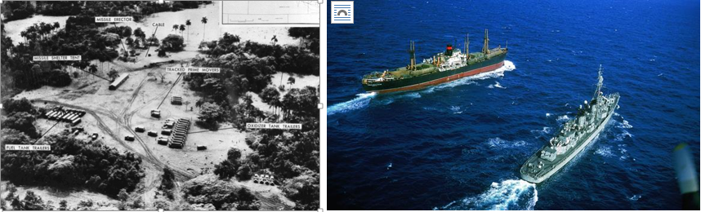

On 23 OCT, the quarantine of Cuba began, but Kennedy decided to give Soviet leader Nikita Khrushchev more time to consider the U.S. action by pulling the quarantine line back 500 miles. By 24 OCT, Soviet ships en route to Cuba capable of carrying military cargoes appeared to have slowed down, altered, or reversed their course as they approached the quarantine, with the exception of one ship—the tanker Bucharest. At the request of more than 40 nonaligned nations, U.N. Secretary-General U Thant sent private appeals to Kennedy and Khrushchev, urging that their governments “refrain from any action that may aggravate the situation and bring with it the risk of war.” At the direction of the Joint Chiefs of Staff, U.S. military forces went to DEFCON 2, the highest military alert ever reached in the postwar era, as military commanders prepared for full-scale war with the Soviet Union.

On 25 OCT, the aircraft carrier USS Essex and the destroyer USS Gearing attempted to intercept the Soviet tanker Bucharest as it crossed over the U.S. quarantine of Cuba. The Soviet ship failed to cooperate, but the U.S. Navy restrained itself from forcibly seizing the ship, deeming it unlikely that the tanker was carrying offensive weapons. On 26 OCT, Kennedy learned that work on the missile bases was proceeding without interruption, and ExCom considered authorizing a U.S. invasion of Cuba. The same day, the Soviets transmitted a proposal for ending the crisis: The missile bases would be removed in exchange for a U.S. pledge not to invade Cuba.

The next day, however, Khrushchev upped the ante by publicly calling for the dismantling of U.S. missile bases in Turkey under pressure from Soviet military commanders. While Kennedy and his crisis advisers debated this dangerous turn in negotiations, a U-2 spy plane was shot down over Cuba, and its pilot, Major Rudolf Anderson, was killed. To the dismay of the Pentagon, Kennedy forbid a military retaliation unless any more surveillance planes were fired upon over Cuba. To defuse the worsening crisis, Kennedy and his advisers agreed to dismantle the U.S. missile sites in Turkey but at a later date, in order to prevent the protest of Turkey, a key NATO member.

On 28 OCT, Khrushchev announced his government’s intent to dismantle and remove all offensive Soviet weapons in Cuba. With the airing of the public message on Radio Moscow, the USSR confirmed its willingness to proceed with the solution secretly proposed by the Americans the day before. In the afternoon, Soviet technicians began dismantling the missile sites, and the world stepped back from the brink of nuclear war. The Cuban Missile Crisis was effectively over. In November, Kennedy called off the blockade, and by the end of the year all the offensive missiles had left Cuba. Soon after, the United States quietly removed its missiles from Turkey.

The Cuban Missile Crisis seemed at the time a clear victory for the United States, but Cuba emerged from the episode with a much greater sense of security. The removal of antiquated Jupiter missiles from Turkey had no detrimental effect on U.S. nuclear strategy, but the Cuban Missile Crisis convinced a humiliated USSR to commence a massive nuclear buildup. In the 1970s, the Soviet Union reached nuclear parity with the United States and built intercontinental ballistic missiles capable of striking any city in the United States. A succession of U.S. administrations honored Kennedy’s pledge not to invade Cuba, and relations with the communist island nation situated just 80 miles from Florida remained a thorn in the side of U.S. foreign policy for more than 50 years. In 2015, officials from both nations announced the formal normalization of relations between the U.S and Cuba, which included the easing of travel restrictions and the opening of embassies and diplomatic missions in both countries.

- Oct 22 1965 – Vietnam War: 173rd Airborne Trooper Saves Comrades » In action this day near Phu Cuong, about 35 miles northwest of Saigon, PFC Milton Lee Olive III of Company B, 2nd Battalion, 503rd Infantry, throws himself on an enemy grenade and saves four soldiers, including his platoon leader, 1st Lt. James Sanford.
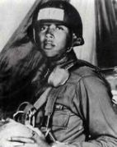

The action came during a patrol that made contact with Communist forces on the southern fringes of the infamous “Iron Triangle,” a traditional Communist stronghold. Private Olive’s body absorbed the full, deadly blast of the grenade and he died saving his comrades. Lieutenant Sanford later said of Olive’s act that “It was the most incredible display of selfless bravery I ever witnessed.” Olive, a native of Chicago, was only 18 years old when he died; he received the Medal of Honor posthumously six months later. The city of Chicago honored its fallen hero by naming a junior college, a lakefront park, and a portion of the McCormick Place convention center after him.

- Oct 22 1972 – Vietnam War: President Thieu Turns Down Peace Proposal » In Saigon, Henry Kissinger meets with South Vietnamese President Thieu to secure his approval of a proposed cease-fire that had been worked out at the secret peace talks with the North Vietnamese in Paris. The proposal presumed a postwar role for the Viet Cong and Thieu rejected the proposed accord point for point and accused the United States of conspiring with China and the Soviet Union to undermine his regime. Kissinger, who had tentatively agreed to initial the draft in Hanoi at the end of the month, cabled President Nixon that Thieu’s terms “verge on insanity” and flew home.

Meanwhile, in the countryside, with a future cease-fire under discussion, both sides in the conflict ordered their forces to seize as much territory as possible and the fighting continued. The Communists hit Bien Hoa airbase with rockets and South Vietnamese commanders in the field reported that the peace talks had no effect on military action. To support the South Vietnamese forces, U.S. B-52 bombers continued to strike Communist positions in an arc north of Saigon, while other U.S. planes flew 220 missions over North Vietnam while other U.S. planes flew 220 missions over North Vietnam

- Oct 22 1972 – Vietnam War: Operation Linebacker I, the bombing of North Vietnam with B-52 bombers, ends.

- Oct 22 1975 – USAF: Gay Sergeant Challenges the Air Force » Air Force Sergeant Leonard Matlovich, a decorated veteran of the Vietnam War, is given a “general” discharge by the air force after publicly declaring his homosexuality. Matlovich, who appeared in his air force uniform on the cover of Time magazine above the headline “I AM A HOMOSEXUAL,” was challenging the ban against homosexuals in the U.S. military.

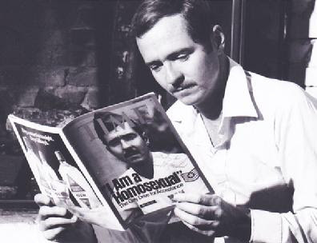

In 1979, after winning a much-publicized case against the air force, his discharge was upgraded to “honorable.” In 1988, Matlovich died at the age of 44 of complications from AIDS. He was buried with full military honors at the Congressional Cemetery in Washington, D.C. His tombstone reads, “A gay Vietnam Veteran. When I was in the military they gave me a medal for killing two men and a discharge for loving one.”

- Oct 22 1999 – Post Holocaust: Maurice Papon who worked for the Vichy France government during World War II. is jailed for 10 years for ordering the arrest and deportation of 1,690 Jews, including 223 children, from the Bordeaux region to the Nazi death camps in Germany However, he served less than four years of his sentence, and was released in September 2002 on grounds of ill-health. He died at age 96 in 2007.

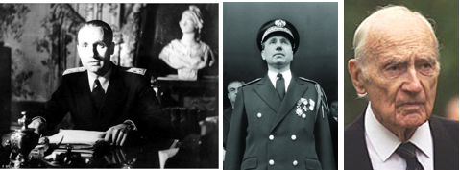

-o-o-O-o-o-

- Oct 23 1694 – Colonial America: American colonial forces, led by Sir William Phipps, fail to seize Quebec.

- Oct 23 1777 – American Revolutionary War: British Fleet Suffers Defeat at Fort Mifflin, PA » A British Royal Navy fleet of ships, trying to open up supply lines along the Delaware River and the occupying British army in Philadelphia, is bombarded by American cannon fire and artillery from Fort Mifflin, Pennsylvania. Six British ships were severely damaged, including the 64-gun battleship HMS Augusta and the 20-gun sloop Merlin, which both suffered direct hits before they were run aground and subsequently destroyed.

- Oct 23 1783 – Post American Revolutionary War: Virginia emancipates slaves who fought for independence during the Revolutionary War.

- Oct 23 1861 – Civil War: President Abraham Lincoln suspends the writ of habeas corpus in Washington, D.C. for all military–related cases.

- Oct 23 1862 - Civil War: CSS Alabama, commanded by Capt. Raphael Semmes, captures and burns the American bark Lafayette south of Halifax, Nova Scotia.

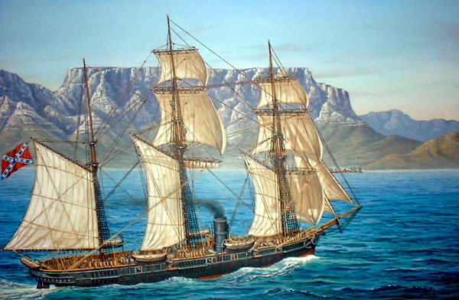

- Oct 23 1864 - Civil War: The blockade-runner Flamingo, which is run aground off Sullivans Island, S.C., is destroyed by shell fire from Fort Strong and Putnam, Battery Chatfield, and ships of Rear Adm. John A. Dahlgren's South Atlantic Blockading Squadron.

- Oct 23 1864 – Civil War: Battle of Westport » Sometimes referred to as the Gettysburg of the West. Confederate General Sterling Price’s raid on Missouri nearly turns into disaster when his army of 8,500 troops is pinned between Major General Samuel R. Curtis’ two Union forces totaling 22,000 troops at Westport, Missouri, near Kansas City. Although outnumbered, Price’s forces managed to slip safely away after the Battle of Westport, which was the biggest conflict west of the Mississippi River. Casualties and losses: US 361 - CSA 500.

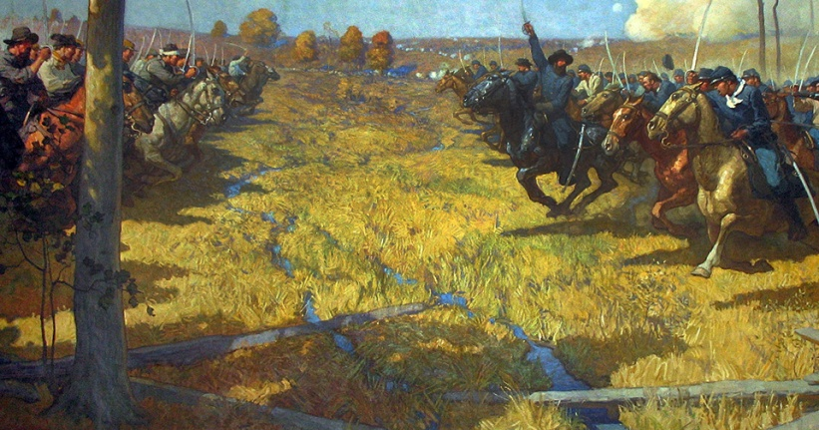

- Oct 23 1917 – WWI: Big Red One » In the morning the first American shell of the war was fired toward German lines by the 1st Infantry division artillery unit "Big Red One". Two days later, the 2nd Battalion of the 16th Infantry suffered the first American casualties of the war. By the end of the war, the division had suffered 4,964 killed in action, 17,201 wounded in action, and 1,056 missing or died of wounds. Five division soldiers received Medals of Honor. The division's dog-mascot was a mixed breed terrier known as Rags. Rags was adopted by the division in 1918 and remained its mascot until his death in 1936. Rags achieved notoriety and celebrity as a war dog, after saving many lives in the crucial Argonne Campaign by delivering a vital message despite being bombed and gassed.

- Oct 23 1918 – WWI: President Woodrow Wilson feels satisfied that the Germans are accepting his armistice terms and agrees to transmit their request for an armistice to the Allies. The Germans have agreed to suspend submarine warfare, cease inhumane practices such as the use of poison gas, and withdraw troops back into Germany.

- Oct 23 1941 – WW2 Era: Soviets Switch Commanders in Drive to Halt Germans » Chief of the Soviet general staff, Georgi K. Zhukov, assumes command of Red Army operations to stop the German advance into the heart of Russia. Stalin’s wise choice in handing so much power and responsibility to this one man was regretted only after the war, when Zhukov’s popularity threatened his own.

- Oct 23 1942 – WW2: The first ships of the Western Task Force invasion fleet destined for Morocco, North Africa, departs from Hampton Roads, Virginia.

- Oct 23 1942 – WW2: Britain Launches 2nd Battle of El Alamein (23 Oct – 4 NOV) » On taking over the Eighth Army, Britain’s General Montgomery had immediately reorganized it to suit his way of fighting, a way very different from the cautious Auchinleck. Now he developed a daring, cunning plan. The conventional view of how to fight in the desert had two key elements – attacking on the southern flank to turn the enemy and focusing on breaking the opposing tanks first. Montgomery threw both these elements out the window in hopes of surprising Rommel. Dummy supplies, tanks, and radio signals filled the southern end of the Allied lines, tricking the Germans into expecting an attack there. While the RAF bombarded Luftwaffe airfields to keep their planes on the ground, Allied infantry dug concealed trenches towards the German lines further north. When the time came, they would pour out of these trenches, face the Germans in brutal close combat, and break a hole in the line through which the armor could pour.

On the night of the 23rd Britain’s General Montgomery made his move. As artillery pounded the German positions, soldiers cleared enemy minefields by the light of the full moon. The infantry sprang from their trenches and attacked the Germans. Battle was begun (Go to https://www.youtube.com/watch?v=cA_Jf2BZCE8 to view video of the offensive). The attack was initially successful, but not as decisive as Montgomery hoped. Some troops became isolated, caught out amid the minefields. Several days of muddled fighting followed, opposing lines becoming tangled in a series of attacks and counter-attacks. Slowly, unsteadily, through the grind of combat, the Allies continued to advance.

On the 28th of October, Australian forces began an advance along the coast at the northern end of the battle. On the 30th, they came out of their trenches for an attack that Rommel thought would exhaust them and allow him to cut off a chunk of the enemy. Victory was in sight, and he prepared to take advantage. It was a trick. At one in the morning on the 2nd of November, Montgomery’s real strike began. Two British infantry brigades and one of armor poured through the lines held by New Zealanders further south. Running full tilt across minefields into the face of the German guns, they took horrific casualties to achieve a critical success. A corridor was punched straight into the Axis lines, and through it poured the British 1st Armoured Division.

Rommel tried to counter-attack with his tanks, but they were halted by bombardments from artillery and aircraft. Orders from Hitler forbade him to retreat, but the enemy was streaming through. To hold the line was suicide, but so was disobeying the Fuhrer’s orders. Seeing no way out, Rommel turned a blind eye as his subordinates began to withdraw. After 12 days of fierce fighting, the whole German army was on the run. Pouring rain on the 7th of November turned the roads into a quagmire, and through the downpour they escaped the British pursuit. In England, the church bells had been silent for years, waiting to ring the alarm if Germany invaded. After El Alamein, Churchill ordered them rung in celebration. The Allies were finally winning in North Africa. They had suffered 13,500 casualties in exchange for 50,000 Germans and Italians dead, wounded or captured. The mighty Rommel was now in retreat. It was far from the end of the Allies’ difficulties, but it was, as Churchill said, “the end of the beginning”.

- Oct 23 1942 – WW2: The Battle for Henderson Field (23-26 OCT) » Also known as the Battle of Guadalcanal or Battle of Lunga Point by the Japanese, took place on and around Guadalcanal in the Solomon Islands. The battle was a land, sea, and air battle of the Pacific campaign of World War II and was fought between the Imperial Japanese Army and Navy and Allied (mainly U.S. Marine and U.S. Army) forces. The battle was the third of the three major land offensives conducted by the Japanese during the Guadalcanal campaign.

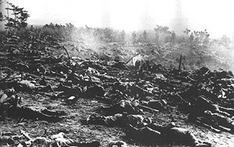
Dead soldiers from the Japanese 16th and 29th Infantry Regiments litter the battlefield after the failed
assaults on 25–26 October.

In the battle, U.S. Marine and Army forces, under the overall command of Major General Alexander Vandegrift, repulsed an attack by the Japanese 17th Army, under the command of Japanese Lieutenant General Harukichi Hyakutake. The U.S. forces were defending the Lunga perimeter, which guarded Henderson Field on Guadalcanal that had been captured from the Japanese by the Allies in landings on Guadalcanal on 7 August 1942. Hyakutake's force was sent to Guadalcanal in response to the Allied landings with the mission of recapturing the airfield and driving the Allied forces off the island. Hyakutake's soldiers conducted numerous assaults over three days at various locations around the Lunga perimeter, all repulsed with heavy Japanese losses. At the same time, Allied aircraft operating from Henderson Field successfully defended U.S. positions on Guadalcanal from attacks by Japanese naval air and sea forces. The battle was the last serious ground offensive conducted by Japanese forces on Guadalcanal. After an attempt to deliver further reinforcements failed during the Naval Battle of Guadalcanal in November 1942, Japan conceded defeat in the struggle for the island and evacuated many of its remaining forces by the first week of February 1943. Casualties and losses: U.S. 61–86 killed, 1 tugboat and 1 patrol boat sunk, 3 aircraft destroyed – Japan 2,200–3,000 killed, one cruiser sunk, 14 aircraft destroyed[

- Oct 23 1942 – WW2: The Western Task Force, destined for North Africa, departs from Hampton Roads, Virginia with 100 naval vessels. The first ever transoceanic amphibious operation.

- Oct 23 1942 - WW2: USS Kingfish (SS 234) sinks Japanese gunboat at the entrance to Kii Suido, Honshu, Japan.

- Oct 23 1942 – U.S. Army: All 12 passengers and crewmen aboard an American Airlines flight 28 DC-3 airliner are killed when it is struck by a U.S. Army Air Forces B-34 bomber near Palm Springs, California. The army pilot's reckless flying severed the airliner's tail. Both army pilots survived. Amongst the victims was composer Ralph Rainger ("Thanks for the Memory")

- Oct 23 1944 – WW2: Battle of Leyte Gulf (23-27 OCT) » Considered the largest naval battle of World War II. It was conducted in the waters of the Philippine Islands in five engagements by elements of the Imperial Japanese Navy's Combined Fleet and the United States Navy's Pacific Fleet. It was an American victory. Ship Losses totaled:
- IJN: 1 fleet carrier, 3 light carriers, 2 old battleships, 3 heavy cruisers, 3 light cruisers, 9 destroyers, 1 oiler
- USN: 1 escort carriers, 3 destroyers

Japanese ships sunk
- Destroyer Wakaba sunk by air attack 24 Oct.
- Battleships Fuso and Yamashiro sunk by gunfire 25 Oct.
- Light carriers Chitose Chiyoda and sunk by air attack, gunfire and torpedoes 25 Oct
- Light cruiser Tama sunk by submarine 25 Oct.
- Light cruiser Abukuma and Noshiro sunk by air attack 26 Oct.
- Heavy cruisers Mogami, Takao and Chokai scuttled 25 Oct.
- Heavy cruisers Suzuya sunk by air attack 25 Oct & Chikuma sunk/scuttled 25 Oct.
- Destroyers Michishio, Yamagumo, and Asagumo sunk by torpedo and gunfire 25 Oct.
- Destroyers Hatsuzuki sunk by gunfire 25 Oct and Akizuki sunk by air attack 25 Oct.
- Destroyer Hayashimo and Nowaki sunk by air attack 26 Oct.
- Destroyers Fujinami and Shiranuhi sunk by air attack 27 Oct
- Oiler Jinei Maru (sunk)

American ships sunk
- Escort carrier St. Lo sunk 1125 hrs.
- Fletcher class Destroyers Hoel (sunk 0855 hrs.) and Johnston (sunk 1010 hrs.)
- John C. Butler class destroyer escort Samuel B. Roberts (sunk 1005 hrs.)

- Oct 23 1944 – WW2: Hungary Liberated by Russia » After the Great Depression every country did whatever they could to pull themselves out of debt and to pave the way for a better future. Hungary had established increased trade with the Fascists in Italy and the Nazis in Germany. After being pressured to join the Axis powers by Germany, Hungary tried to avoid direct involvement in the war but found it to be inevitable. While waging war against the Soviets, Hungary attempted to engage in peace negotiations with the U.S. behind Hitler’s back. When Hitler found out, he attacked Hungary with all of his fury, and occupied it until the Soviet troops liberated the country.

The Soviet’s Red Army entered German-occupied Hungary for the first time in World War II on this date. The Soviets maintained control in Hungary long after the war, until the collapse of the Soviet Union. The only time they lost control was during the Hungarian Revolution of 1956, and then for a very short period of time. When the third Hungarian Republic was established in the 1990’s, many state subsidies were removed causing a severe recession and very difficult living standards. After electing a Socialist party in 1994 and then joining the European Union in 2004 Hungary became more financially stable.

- Oct 23, 1944 – WW2: USS Darter (SS-227) sank Admiral Takeo Kurita’s flagship, the heavy cruiser Atago, with four torpedoes killing 360 of her 889 man crew and then seriously damaged another heavy cruiser, the Takao with four torpedo hits the same day. Takao was escorted to Singapore by two destroyers, but after her arrival would never sail again

- Oct 23 1954 – Germany: In Paris, an agreement is signed providing for West German sovereignty and permitting West Germany to rearm and enter NATO and the Western European Union.

- Oct 23 1956 – Russia*Hungary: Hungarian Protest Turns Violent » Thousands of Hungarians erupt in protest against the Soviet presence in their nation and are met with armed resistance. Organized demonstrations by Hungarian citizens had been ongoing since June 1956, when signs of political reform in Poland raised the possibility for such changes taking place in their own nation. On this day, however, the protests erupted into violence as students, workers, and even some soldiers demanded more democracy and freedom from what they viewed as an oppressive Soviet presence in Hungary.

- Oct 23 1965 – Vietnam War: 1st Cavalry Division Launches Operation Silver Bayonet » In action following the clash at the Plei Me Special Forces camp 30 miles southwest of Pleiku earlier in the month, U.S. troops, in conjunction with South Vietnamese forces, sought to destroy North Vietnamese forces operating in Pleku Province in II Corps Tactical Zone (the Central Highlands).

- Oct 23 1972 – Vietnam War: U.S. Negotiators Ask for Further Talks in Paris » Citing difficulties with South Vietnamese President Thieu, U.S. negotiators cable Hanoi requesting further negotiations in Paris over the proposed draft peace accord. Thieu felt that he was being sold out by the United States to secure a peace agreement at any terms.

- Oct 23 1972 – Vietnam War: Operation Linebacker I - U.S. Seventh Air Force and U.S. Navy TF 77 air interdiction campaign conducted against the Democratic Republic of Vietnam (North Vietnam) since 9 May is stopped by President Nixon for the Paris Peace Talks. Bombing subsequently resumed as Linebreaker II from 18 to 29 DEC.

- Oct 23 1973 – Israel: A U.N. sanctioned cease-fire officially ends the Yom Kippur war between Israel and Syria.

- Oct 23 1983 – War On Terrorism: U.S. and French Troops Attacked in Beirut » A suicide bomber drove a 19-ton Mercedes-Benz truck packed with an estimated 21,000 pounds of TNT explosives through a five foot concertina wire fence and into a four-story barracks housing U.S. Marines at the Beirut International Airport, Lebanon. When the dust settled 220 Marines with the 2st Battalion, 8th Marines – Battalion Landing Team had perished along with 21 other service members marking the deadliest day for the Corps since the Battle of Iwo Jima in FEB 1945.

That same morning, 58 French soldiers were killed in their barracks two miles away in a separate suicide terrorist attack. The U.S. Marines were part of a multinational force sent to Lebanon in August 1982 to oversee the Palestinian withdrawal from Lebanon. From its inception, the mission was plagued with problems–and a mounting body count.

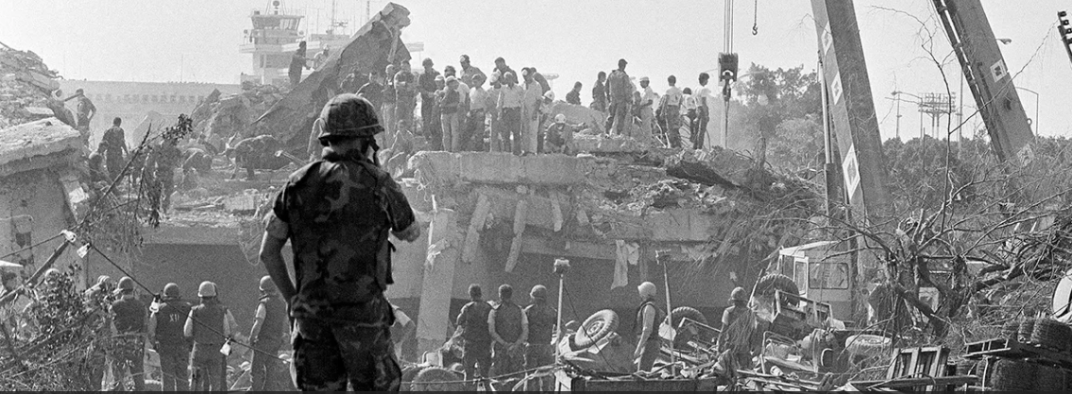

In 1975, a bloody civil war erupted in Lebanon, with Palestinian and leftist Muslim guerrillas battling militias of the Christian Phalange Party, the Maronite Christian community, and other groups. During the next few years, Syrian, Israeli, and United Nations interventions failed to resolve the factional fighting, and on August 20, 1982, a multinational force including 800 U.S. Marines was ordered to Beirut to help coordinate the Palestinian withdrawal.

The Marines left Lebanese territory on 10 SEP but returned in strengthened numbers on 29 SEP, following the massacre of Palestinian refugees by a Christian militia. The next day, the first U.S. Marine to die during the mission was killed while defusing a bomb. Other Marines fell prey to snipers. On April 18, 1983, a suicide bomber driving a van devastated the U.S. embassy in Beirut, killing 63 people, including 17 Americans. Then, on 23 OCT, a Lebanese terrorist plowed his bomb-laden truck through three guard posts, a barbed-wire fence, and into the lobby of the Marines Corps headquarters in Beirut, where he detonated a massive bomb, killing 241 marine, navy, and army personnel. The bomb, which was made of a sophisticated explosive enhanced by gas, had an explosive power equivalent to 18,000 pounds of dynamite. The identities of the embassy and barracks bombers were not determined, but they were suspected to be Shiite terrorists associated with Iran.

After the barracks bombing, many questioned whether President Ronald Reagan had a solid policy aim in Lebanon. Serious questions also arose over the quality of security in the American sector of war-torn Beirut. The U.S. peacekeeping force occupied an exposed area near the airport, but for political reasons the marine commander had not been allowed to maintain a completely secure perimeter before the attack. In a national address on 23 OCT, President Reagan vowed to keep the marines in Lebanon, but just four months later he announced the end of the American role in the peacekeeping force. On February 26, 1984, the main force of marines left Lebanon, leaving just a small contingent to guard the U.S. embassy in Beirut.

- Oct 23 1983 – Grenada: The U.S. Navy begins preparation for Operation Urgent Fury (Grenada, West Indies), which occurs only two days later.

- Oct 23 1983 – War On Terrorism: Hostage Crisis in Moscow Theater » About 50 Chechen rebels storm a Moscow theater, taking up to 700 people hostage during a sold-out performance of a popular musical.

The second act of the musical “Nord Ost” was just beginning at the Moscow Ball-Bearing Plant’s Palace of Culture when an armed man walked onstage and fired a machine gun into the air. The terrorists—including a number of women with explosives strapped to their bodies—identified themselves as members of the Chechen Army. They had one demand: that Russian military forces begin an immediate and complete withdrawal from Chechnya, the war-torn region located north of the Caucasus Mountains.

Chechnya, with its predominately Muslim population, had long struggled to assert its independence. A disastrous two-year war ended in 1996, but Russian forces returned to the region just three years later after Russian authorities blamed Chechens for a series of bombings in Russia. In 2000, President Vladimir Putin was elected partly because of his hard-line position towards Chechnya and his public vow not to negotiate with terrorists.

After a 57-hour-standoff at the Palace of Culture, during which two hostages were killed, Russian Special Forces surrounded and raided the theater on the morning of October 26. Later it was revealed that they had pumped a powerful narcotic gas into the building, knocking nearly all of the terrorists and hostages unconscious before breaking into the walls and roof and entering through underground sewage tunnels. Most of the guerrillas and 120 hostages were killed during the raid. Security forces were later forced to defend the decision to use the dangerous gas, saying that only a complete surprise attack could have disarmed the terrorists before they had time to detonate their explosives.

After the theater crisis, Putin’s government clamped down even harder on Chechnya, drawing accusations of kidnapping, torture and other atrocities. In response, Chechen rebels continued their terrorist attacks on Russian soil, including an alleged suicide bombing in a Moscow subway in February 2004 and another major hostage crisis at a Beslan school that September.

-o-o-O-o-o-

- Oct 24 1775 – American Revolution Era: British Naval Fleet Attacks Norfolk, Virginia » Virginia’s last royal governor, Lord John Murray Dunmore, orders a British naval fleet of six ships to sail up the James River and into Hampton Creek to attack Patriot troops and destroy the town of Norfolk, Virginia. British Captain Matthew Squire led the six ships into Hampton Creek and began bombarding the town with artillery and cannon fire, while a second contingent of British troops sailed ashore to begin engaging the Patriots. The Patriots and militia pushed the British back to their ships, where the riflemen picked off British troops from the decks of their vessels. Facing a humiliating defeat at the hands of an outnumbered local militia, Captain Squire ordered a full British retreat.

- Oct 24 1861 – Civil War: West Virginia Secedes from Virginia » West Virginia is one of two American states formed during the American Civil War, along with Nevada, and is the only state to form by seceding from a Confederate state. It was originally part of the British Virginia Colony (1607–1776) and the western part of the state of Virginia (1776–1863), whose population became sharply divided over the issue of secession from the Union and in the separation from Virginia, formalized by admittance to the Union as a new state in 1863. West Virginia was one of the Civil War Border states.

- Oct 24 1862 – Civil War: A landing party from stern wheel casemate gunboat Baron de Kalb, commanded by Capt. J.A. Winslow, lands at Hopefield, Ark., and engages a small Confederate scouting party. On mounted horses, the sailors then engage in a nine mile running fight, ending with the capture of the Confederate party.

- Oct 24 1862 – Civil War: Gen. Rosecrans Replaces Buell » Union General Don Carlos Buell is replaced because of his ineffective pursuit of the Confederates after the Battle of Perryville, Kentucky, on October 8. He was replaced by William Rosecrans, who had distinguished himself in western Virginia in 1861 and provided effective leadership at the battle of Corinth, Mississippi, just prior to Perryville.

- Oct 24 1863 – Civil War: General Ulysses S. Grant arrives in Chattanooga, Tennessee to find the Union Army there starving.

- Oct 24 1916 – WW1 Era: French (Moroccan) Troops Recapture Fort Douaumont » Fort Douaumont was the largest and highest fort on the ring of 19 large defensive works which had protected the city of Verdun, France since the 1890s. By 1915, the French General Staff had concluded that even the best-protected forts of Verdun could not resist bombardments from the German 420 mm (16.5 in) Gamma guns. These new super-heavy howitzers had easily taken several large Belgian forts out of action in August 1914. Fort Douaumont and other Verdun forts were judged ineffective and had been partly disarmed and left virtually undefended since 1915. On 25 February 1916, Fort Douaumont was entered and occupied without a fight by a small German raiding party comprising only 19 officers and 79 men. The easy fall of Fort Douaumont, only three days after the beginning of the Battle of Verdun, shocked the French Army. It set the stage for the rest of a battle which lasted nine months, at enormous human cost.

A French offensive involving three infantry divisions began on 24 October 1916, to recapture the fort. This took place on the same day and was carried out by the elite Régiment d'infanterie-chars de marine (Regiment of Colonial Infantry of Morocco). Douaumont had been pounded for days by two super heavy 400 mm (16 in) long-range French railway guns named "Alsace" and "Lorraine", emplaced at Baleycourt, south-west of Verdun. Douaumont had become untenable under their fire and was in the process of being evacuated when it was recaptured. Millions of smaller shells had been fired at the fort since its capture by the Germans to little avail and tens of thousands of men had died in attempts to recapture it. This event brought closure to the battle in 1916.

- Oct 24 1917 – WW1: Battle of Caporetto (24 Oct – 19 Nov) » A combined German and Austro-Hungarian force scores one of the most crushing victories of World War I, decimating the Italian line along the northern stretch of the Isonzo River in the Battle of Caporetto, also known as the Twelfth Battle of the Isonzo, or the Battle of Karfreit (to the Germans).

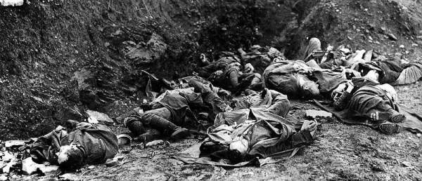

By the autumn of 1917, Italian Commander in Chief Luigi Cadorna’s strategy of successive offensives near the Isonzo River in northern Italy—11 Italian attacks since May 1915 preceded the Austrian assault at Caporetto—had cost the Italians heavy casualties for an advance of less than seven miles, only one third of the way towards their preliminary objective, the city of Trieste on the Adriatic Sea. Despite this, the wave of Italian attacks had also taken a serious toll on Austro-Hungarian resources in the region. Indeed, in the wake of the Eleventh Battle of the Isonzo in August 1917, Austria’s positions around the city of Gorizia were dangerously close to collapse. As a result, the German Supreme Command, led by Paul von Hindenburg and Erich Ludendorff, determined with their Austrian counterpart, Arz von Straussenberg, to launch a combined operation against the Italians, intended for mid-September.

In preparation for the offensive, Germany transported seven divisions of troops to reinforce the Austrians on the upper banks of the Isonzo. Cadorna, learning by aerial reconnaissance of the Austro-German movements, pushed back his own army’s scheduled September offensive to prepare a defensive position for the scheduled attacks that month. Unfavorable weather, however, pushed back the plans, and by the time Germany and Austria-Hungary were ready to attack, they were able to catch the Italians by surprise. On 24 OCT, after a brief, effective artillery bombardment, the German and Austrian infantry moved ahead against the damaged Italian lines, using grenades and flamethrowers to exploit their advantage and achieve a quick and decisive breakthrough. By the end of the day, they had advanced an impressive 25 kilometers.

Though the Italians managed to harden their defensives over the coming weeks, by mid-November the Germans and Austrians had driven them back some 60 miles to the River Piave, just 30 kilometers north of Venice. Italian casualties at Caporetto totaled almost 700,000—40,000 killed or wounded, 280,000 captured by the enemy and another 350,000 deserted. Austria-Hungy and Germany suffered 70,000 dead or wounded. In the wake of the battle, violent anti-war protests reached a peak in Italy, as Cadorna was forced to resign his command. His successor, General Armando Diaz, would oversee a new Italian strategy—defensive, as opposed to offensive—for the remainder of the war, including a greater reliance on the resources of the stronger Allied powers.

- Oct 24 1918 – WW1: Battle of Vittorio Veneto (24 Oct – 4 Nov) » The battle was fought near Vittorio Veneto on the Italian Front with an armistice taking effect 24 hours later. The Italian victory marked the end of the war on the Italian Front, secured the dissolution of the Austro-Hungarian Empire and contributed to the end of the First World War just one week later. The battle led to the capture of 5,000+ artillery pieces and over 350,000 Austro-Hungarian troops, including 120,000 Germans, 83,000 Czechs and Slovaks, 60,000 South Slavs, 40,000 Poles, several tens of thousands of Romanians and Ukrainians, and 7,000 Italians and Friulians. The Italians suffered during the 10 days' struggle 37,461 casualties (dead and wounded) – 24,507 of them on Monte Grappa. British casualties were 2,139, while the French lost 778 men.

- Oct 24 1921 – Post WW1: Unknown Soldier is Selected » In the French town of Chalons-sur-Marne, an American officer selects the body of the first “Unknown Soldier” to be honored among the approximately 77,000 United States servicemen killed on the Western Front during World War I.

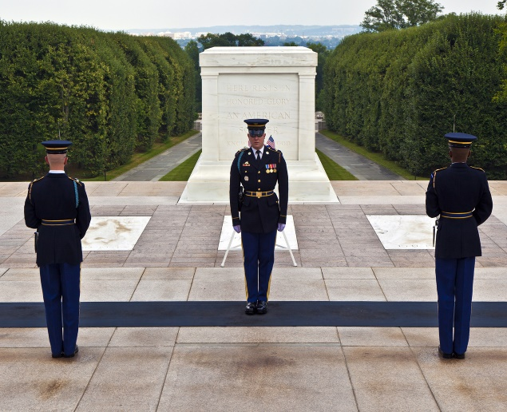

According to the official records of the Army Graves Registration Service deposited in the U.S. National Archives in Washington, four bodies were transported to Chalons from the cemeteries of Aisne-Marne, Somme, Meuse-Argonne and Saint-Mihiel. All were great battlegrounds, and the latter two regions were the sites of two offensive operations in which American troops took a leading role in the decisive summer and fall of 1918. As the service records stated, the identity of the bodies was completely unknown: “The original records showing the internment of these bodies were searched and the four bodies selected represented the remains of soldiers of which there was absolutely no indication as to name, rank, organization or date of death.”

The four bodies arrived at the Hotel de Ville in Chalons-sur-Marne on October 23, 1921. At 10 o’clock the next morning, French and American officials entered a hall where the four caskets were displayed, each draped with an American flag. Sergeant Edward Younger, the man given the task of making the selection, carried a spray of white roses with which to mark the chosen casket. According to the official account, Younger “entered the chamber in which the bodies of the four Unknown Soldiers lay, circled the caskets three times, and then silently placed the flowers on the third casket from the left. He faced the body, stood at attention and saluted.”

Bearing the inscription “An Unknown American who gave his life in the World War,” the chosen casket traveled to Paris and then to Le Havre, France, where it would board the cruiser Olympia for the voyage across the Atlantic. Once back in the United States, the Unknown Soldier was buried in Arlington National Cemetery, near Washington, D.C.

- Oct 24 1922 – Post WW1: March on Rome » The insurrection by which Benito Mussolini came to power in Italy in late October 1922. The March marked the beginning of fascist rule and meant the doom of the preceding parliamentary regimes of socialists and liberals.

Widespread social discontent, aggravated by middle-class fear of a socialist revolution and by disappointment over Italy’s meagre gains from the peace settlement after World War I, created an atmosphere favorable for Mussolini’s rise to power. On 24 OCT the fascist party leaders planned an insurrection to take place on 28 OCT, consisting of a march on Rome by the fascist armed squads known as Blackshirts and the capture of strategic local places throughout Italy. Waiting in Milan for the outcome of events, Mussolini left the work of organization to his subordinates.

On 28 OCT, to meet the threat posed by the bands of fascist troops now gathering outside Rome, the government of Prime Minister Luigi Facta, which had resigned but continued to hold power, ordered a state of siege for Rome. King Victor Emmanuel III, however, refused to sign the order. This meant that the army, which might have stopped Mussolini, was not called on to oppose the fascists. The reasons for Victor Emmanuel’s refusal have been debated; it has been suggested that he feared he would lose his throne if he refused to cooperate with the fascists, that he wanted to avoid civil war, and that he hoped to neutralize the fascists by associating them with the national government.

Mussolini, now confident of his control over events, was determined to accept nothing less than control of the government, and on 29 OCT the king asked him to form a cabinet. Traveling from Milan by train, Mussolini arrived in Rome on 30 OCT, before the actual entry of the fascist forces. As prime minister, he organized a triumphant parade for his followers to show the fascist party’s support for his rule. The March on Rome was not the conquest of power that Mussolini later called it but rather a transfer of power within the framework of the constitution, a transfer made possible by the surrender of public authorities in the face of fascist intimidation.

- Oct 24 1942 – WW2: Second Battle of El Alamein (24 Oct - 11 NOV) » The battle took place near the Egyptian railway halt of El Alamein. The First Battle of El Alamein and the Battle of Alam el Halfa had prevented the Axis from advancing further into Egypt. In August 1942, General Claude Auchinleck had been sacked as Commander-in-Chief Middle East Command and his successor, Lieutenant-General William Gott was killed on his way to replace him as commander of the Eighth Army. Lieutenant-General Bernard Montgomery was appointed and led the Eighth Army allied offensive. Montgomery ultimately defeated Gen. Erwin Rommel’s panzer troops in a four stage operation.

British figures, based on Ultra intercepts, gave German casualties as 1,149 killed, 3,886 wounded and 8,050 men captured. Italian losses were 971 dead, 933 wounded and 15,552 men captured. By 11 NOV, the number of Axis prisoners had risen to 30,000 men. In a note to The Rommel Papers, Fritz Bayerlein (quoting figures obtained from Offizieller Bericht des Oberkommandos Afrika) instead estimated German losses in the battle as 1,100 killed, 3,900 wounded and 7,900 prisoners and Italian losses as 1,200 killed, 1,600 wounded and 20,000 prisoners. The Eighth Army had 13,560 casualties, of whom 2,350 men had been killed, 8,950 wounded and 2,260 were missing; 58 percent of the casualties were British, 22 percent Australian, 10 percent New Zealanders, 6 percent South African, 1 percent Indian and 3 percent Allied forces. The Eighth Army lost from 332 to 500 tanks, although by the end of the battle, 300 had been repaired. The artillery lost 111 guns and the DAF lost 77 British and 20 American aircraft.

The Allied victory was the beginning of the end of the Western Desert Campaign, eliminating the Axis threat to Egypt, the Suez Canal and the Middle Eastern and Persian oil fields. The battle revived the morale of the Allies, being the first big success against the Axis since Operation Crusader in late 1941. The battle coincided with the Allied invasion of French North Africa in Operation Torch on 8 NOV, the Battle of Stalingrad and the Guadalcanal Campaign.

- Oct 24 1944 – WW2: USS Princeton (CVL-23) Scuttled » The Battle of Leyte Gulf continues, with Task Force 38 aircraft attacking the Japanese in the Sibuyan and Sulu Seas. U.S. Navy carrier planes sink the Japanese battleship Musashi and damage numerous other enemy ships, among them battleships Yamato, Nagato, Fuso and Yamashiro. Japanese air attacks hit the small USS Princeton (CVL 23), which eventually has to be scuttled. The desperate kamikaze tactic makes its appearance, causing damage and casualties on U.S. ships off the Leyte invasion beaches.

- Oct 24 1944 – WW2: USS Shark (SS 314) is lost in the vicinity of Luzon Strait while participating in a coordinated attack by Task Group 17.15 with USS Seadragon (SS 194) and USS Blackfish (SS 221). Also, USS Richard M. Rowell (DD 403) sinks Japanese submarine I-54, 70 miles east of Surigao, and USS Tang (SS 306) is lost when she runs into her own torpedoes.

- Oct 24 1944 – WW2: USS Woolsey (DD 437) and British destroyer HMS Fortune sink two German explosive boats 16 miles off Cap Ferrat, France. Woolsey and minesweeper USS Sway (AM 120) then recover the prisoners.

- Oct 24 1944 – WW2: The USS Tang (SS–306) under Richard O'Kane (the top American submarine captain of World War II) is sunk by the ship's own malfunctioning torpedo during a surface night attack 24–25 OCT. 78 died, 9 POWs survived

- Oct 24 1944 – WW2: USS Darter (SS–227) ran aground on Bombay Shoal, Palawan Passage; later scuttled by USS Nautilus (SS–168) and sunk by Japanese depth charges from Harukaze, South China Sea west of Luzon. 87 killed. USS Dace (SS–247).

- Oct 24 1945 – Post WW2: The United Nations is Born » The United Nations Charter, which was adopted and signed on June 26, 1945, comes into effect and is ready to be enforced.

The United Nations was born of perceived necessity, as a means of better arbitrating international conflict and negotiating peace than was provided for by the old League of Nations. The growing Second World War became the real impetus for the United States, Britain, and the Soviet Union to begin formulating the original U.N. Declaration, signed by 26 nations in January 1942, as a formal act of opposition to Germany, Italy, and Japan, the Axis Powers.

The principles of the U.N. Charter were first formulated at the San Francisco Conference, which convened on April 25, 1945. It was presided over by President Franklin Roosevelt, British Prime Minister Winston Churchill, and Soviet Premier Joseph Stalin, and attended by representatives of 50 nations, including 9 continental European states, 21 North, Central, and South American republics, 7 Middle Eastern states, 5 British Commonwealth nations, 2 Soviet republics (in addition to the USSR itself), 2 East Asian nations, and 3 African states. The conference laid out a structure for a new international organization that was to “save succeeding generations from the scourge of war,…to reaffirm faith in fundamental human rights,…to establish conditions under which justice and respect for the obligations arising from treaties and other sources of international law can be maintained, and to promote social progress and better standards of life in larger freedom.”

Two other important objectives described in the Charter were respecting the principles of equal rights and self-determination of all peoples (originally directed at smaller nations now vulnerable to being swallowed up by the Communist behemoths emerging from the war) and international cooperation in solving economic, social, cultural, and humanitarian problems around the world.

Now that the war was over, negotiating and maintaining the peace was the practical responsibility of the new U.N. Security Council, made up of the United States, Great Britain, France, the Soviet Union, and China. Each would have veto power over the other. Winston Churchill called for the United Nations to employ its charter in the service of creating a new, united Europe-united in its opposition to communist expansion-East and West. Given the composition of the Security Council, this would prove easier said than done.

- Oct 24 1945 – Post WW2: Vidkun Quisling, Norway’s wartime minister president, is executed by firing squad for collaboration with the Nazis.

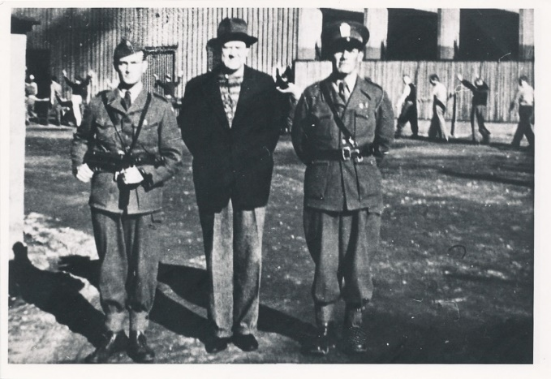

- Oct 24 1951 – Post WW2: Truman Declares War with Germany Officially Over » President Harry Truman finally proclaims that the nation’s war with Germany, begun in 1941, is officially over. Fighting had ended in the spring of 1945.

Most Americans assumed that the war with Germany had ended with the cessation of hostilities six years earlier. In fact, a treaty with Germany had not been signed. Complicating the treaty process was the status of territory within what was formerly the German state. Following the Second World War, the major Western powers (U.S., Britain and France) and the Soviets agreed to divide the country, including the capital city of Berlin, into democratic and communist-controlled sectors. Both East and West Berlin ended up within the Soviet-controlled territory of East Germany and the capital became the epicenter of increasing tensions between the West and Soviet Russia. Each side claimed the other had violated post-war treaties regarding their respective spheres of influence in post-war Europe. The conflict over Berlin came to a head in June 1948 when Stalin ordered a blockade of the city. Truman did not want to abandon Berlin to the Soviets and ordered an airlift to supply the western sectors with food and fuel. The treaty process was put on hold until the Western powers could agree on what to do about Berlin. A Soviet atomic weapons test on October 3, 1951, increased the tension.

In his proclamation on this day, Truman stated that it had always been America’s hope to create a treaty of peace with the government of a united and free Germany, but that Soviet policy had “made it impossible.” The official end to the war came 10 years after Congress had declared open war with Nazi Germany on December 11, 1941.

- Oct 24 1954 – Vietnam War Era: U.S. President Pledges Support to South Vietnam » Eisenhower wrote to South Vietnamese President Ngo Dinh Diem and promised direct assistance to his government. Eisenhower made it clear to Diem that U.S. aid to his government during Vietnam’s “hour of trial” was contingent upon his assurances of the “standards of performance [he] would be able to maintain in the event such aid were supplied.” Eisenhower called for land reform and a reduction of government corruption. Diem agreed to the “needed reforms” stipulated as a precondition for receiving aid, but he never actually followed through on his promises. Ultimately his refusal to make any substantial changes to meet the needs of the people led to extreme civil unrest and eventually a coup by dissident South Vietnamese generals in which Diem and his brother were murdered.

- Oct 24 1958 – U.S. Navy: USS Kleinsmith (APD 134) rescues 56 U.S. citizens and three foreign nationals at Nicaro, Cuba, where they are endangered by military operations between the Cuban Army and the Castro rebels.

- Oct 24 1960 – Cold War: The Nedelin Catastrophe » Nedelin disaster was a launch pad accident that occurred at Baikonur test range during the development of the Soviet R-16 ICBM. As a prototype of the missile was being prepared for a test flight, an explosion occurred when the second stage engine ignited accidentally, killing an unknown number of military and technical personnel working on the preparations. Despite the magnitude of the disaster, news of it was suppressed for many years and the Soviet government did not acknowledge the event until 1989. The disaster is named after Chief marshal of Artillery Mitrofan Ivanovich Nedelin, who was killed in the explosion. As commanding officer of the Soviet Union's Strategic Rocket Forces, Nedelin was head of the R-16 development program.

- Oct 24 1962 – Cold War: Cuban missile crisis: Soviet ships approach but stop short of the US blockade of Cuba

- Oct 24 1966 – Vietnam War: Manila Conference Attendees Issue "Declaration of Peace" » In Manila, President Johnson meets with other Allied leaders and they pledge to withdraw troops from Vietnam within six months if North Vietnam “withdraws its forces to the North and ceases infiltration of South Vietnam.”

- Oct 24 1977 - Veterans Day: Observed on the fourth Monday in October for the seventh and last time. (The holiday is once again observed on November 11 beginning the following year.)

-o-o-O-o-o-

- Oct 25 1774 – American Revolution Era: Congress Petitions English King to Address Grievances » The First Continental Congress sends a respectful petition to King George III to inform his majesty that if it had not been for the acts of oppression forced upon the colonies by the British Parliament, the American people would be standing behind British rule.

Despite the anger that the American public felt towards the United Kingdom after the British Parliament established the Coercive Acts—called the Intolerable Acts by the colonists—Congress was still willing to assert its loyalty to the king. In return for this loyalty, Congress asked the king to address and resolve the specific grievances of the colonies. The petition, written by Continental Congressman John Dickinson, laid out what Congress felt was undo oppression of the colonies by the British Parliament. Their grievances mainly had to do with the Coercive Acts, a series of four acts that were established to punish colonists and to restore order in Massachusetts following the Boston Tea Party.

The first of the Coercive Acts was the Boston Port Act, which closed the port of Boston to all colonists until damages from the Boston Tea Party were paid. The second, the Massachusetts Government Act, gave the British government total control of town meetings, taking all decisions out of the hands of the colonists. The third, the Administration of Justice Act, made British officials immune to criminal prosecution in America and the fourth, the Quartering Act, required colonists to house and quarter British troops on demand, including in private homes as a last resort.

The king did not respond to the petition to Congress’ satisfaction and eight months later on July 6, 1775, the Second Continental Congress adopted a resolution entitled “Declaration of the Causes and Necessity of Taking Up Arms.” Written by John Dickinson and Thomas Jefferson, the resolution laid out the reasons for taking up arms and starting a violent revolution against British rule of the colonies.

- Oct 25 1812 – War of 1812: USS United States Defeated the HMS Macedonian » At dawn five hundred miles south of the Azores, crewmen of the "United States" reported seeing a sail 12 miles to windward. Capt. Decatur identified the ship as the HMS Macedonia and cleared his ship for action. Capt. Decatur intended to engage the Macedonian from a long range, where his 24-pounders would have the advantage over the 18 pounders of the British, and then move in for the kill.

The actual battle developed according to Decatur's plan. United States began the action at 0920 by firing an inaccurate broadside. This was answered immediately by the British vessel, bringing down a small spar of United States. Decatur's next broadside had better luck, as it destroyed Macedonian's mizzen top mast, letting her driver gaff fall and so giving the maneuvering advantage to the American frigate. United States next took up position off Macedonian's quarter and proceeded to riddle the hapless frigate methodically with shot. She hailed Macedonian demanding the name of her antagonist and whether or not she surrendered. By noon, Macedonian was a dismasted hulk. When United States closed for another broadside, Carden was forced to strike her colors and surrender. She had had over 100 round shot lodged in her hull and suffered over one hundred casualties, one third of her crew, while United States only suffered 12. Because of the greater range of the guns aboard United States, she got off seventy broadsides to Macedonian's thirty, and emerged from the battle relatively unscathed.

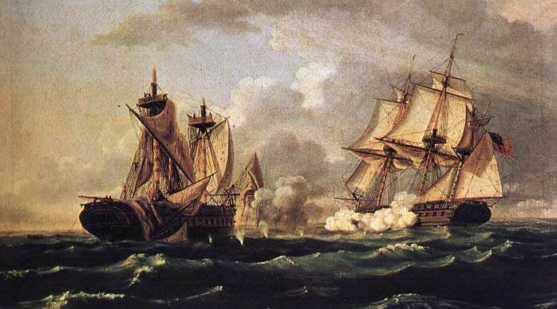
HMS Macedonian versus USS United States By Thomas Birch

The two ships lay alongside each other for over two weeks while Macedonian was repaired sufficiently to sail. United States and her prize arrived at Newport, Rhode Island, on 4 DEC amid tumultuous national jubilation over the spectacular victory. Wherever they went, Captain Decatur and his crew were lionized and received special praise from both Congress and President James Madison. Macedonian was subsequently purchased by the United States Navy, and was renamed USS Macedonian. It had a long and honorable career under the American flag

After repairs, United States sailed from New York on 24 May 1813, accompanied by USS Macedonian and the sloop Hornet. On 1 JUN, the three vessels were driven into New London, Connecticut, by the 74-gun ship HMS Valiant and the 40-gun frigate HMS Acasta, and United States and Macedonian were kept blockaded there until the end of the war. However, Decatur was transferred to the frigate President in the spring of 1814, and he took the officers and crew of United States with him to his new command. Hornet managed to slip through the blockade on 14 November 1814 and escaped to sea, but Decatur and the President were not as fortunate as they were captured by the blockading force on 14 January 1815.

- Oct 25 1813 – War of 1812: USS Congress, commanded by Capt. John Smith, captures and burns the British merchant ship Rose in the Atlantic off the coast of Brazil.

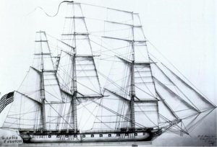
USS Congress

- Oct 25 1854 – Crimean War: Charge of the Light Brigade » Lord James Cardigan leads a charge of the Light Brigade cavalry against well-defended Russian artillery.\. The British were winning the Battle of Balaclava when Cardigan received his order to attack the Russians. His cavalry gallantly charged down the valley and were decimated by the heavy Russian guns, suffering 40 percent casualties. It was later revealed that the order was the result of confusion and was not given intentionally. Lord Cardigan, who survived the battle, was hailed as a national hero in Britain.

- Oct 25 1861 – Civil War: First Battle of Springfield » The battle, also known Zagonyi's Charge, was fought in Springfield, Missouri. It was the only Union victory in southwestern Missouri in 1861.

Having accomplished little since taking command of the Western Department with headquarters in St. Louis, Union Maj. Gen. John C. Frémont formulated a plan to clear Maj. Gen. Sterling Price's Confederates from the state and then, if possible, carry the war into Arkansas and Louisiana. Leaving St. Louis on October 7, 1861, Frémont's combined force eventually numbered more than 20,000. His accompanying cavalry force, numbering 5,000 men and other mounted troops, included Maj. Frank J. White's Prairie Scouts and Frémont's Body Guards under Maj. Charles Zagonyi. Maj. White became ill and turned his command over to Zagonyi. These two units operated in front of Frémont’s army to gather intelligence.

As Frémont neared Springfield, the local state guard commander, Col. Julian Frazier, sent out requests to nearby localities for additional troops. Frémont camped on the Pomme de Terre River, about 50 miles from Springfield. Zagonyi's column, though, continued on to Springfield, and Frazier's force of 1,000 to 1,500 prepared to meet it. Frazier set up an ambush along the road that Zagonyi traveled, but the Union force charged the Confederates, sending them fleeing. Zagonyi's men continued into town, hailed Federal sympathizers and released Union prisoners. Leery of a Confederate counterattack, Zagonyi departed Springfield before night, but Frémont's army returned, in force, a few days later and set up camp in the town.

In mid-November, after Frémont was sacked and replaced by Maj. Gen. David Hunter, the Federals evacuated Springfield and withdrew to Sedalia and Rolla. Federal troops reoccupied Springfield in early 1862 and it was a Union stronghold from then on.

- Oct 25 1861 – Civil War: Keel of the Monitor Laid » Signaling an important shift in the history of naval warfare, the keel of the Union ironclad Monitor is laid at Greenpoint, New York. Union Secretary of the Navy Gideon Welles appointed an Ironclad Board when he heard rumors that the Confederates were trying to build an iron-hulled ship, as such a vessel could wreak havoc on the Union’s wooden armada. In September 1861, the board granted approval for engineer John Ericsson, a native of Sweden, to begin constructing the U.S. Navy’s first ironclad.

- Oct 25 1864 – Civil War: Battle of Marais Des Cygnes » The conflict took place in Linn County, Kansas during Confederate Major General Sterling Price's Missouri Raid. Also called the Battle of Osage, or the Battle of Trading Post it was the first of three interconnected actions on this same day, all involving elements of Major General Price's Confederate Army of Missouri, and the Union's Provisional Cavalry Division commanded by Major General Alfred Pleasonton.

On 24 OCT, Price and his cavalry set up camp next the Marais des Cygnes River near Trading Post. The weather that night was terrible with rain and cold temperatures. Pleasonton's cavalry was closing in on Price, and knew that he had set up camp in the area. Pleasonton sent out two brigades to overtake Price. The First Brigade, under the command of Colonel John Philips consisted of three regiments of Missouri State Militia and totaled 1,500 men. The Second Brigade under Lt. Colonel Frederick Benteen included regiments from Iowa, Missouri and two companies from the 7th Indiana. During the next foggy morning, around 4am, Pleasonton's army fired artillery, and after these were fired, Pleasonton's men attacked the camp.

This caused Price to order his troops to cross the river immediately, leaving Brigadier General James Fagan to take on the Union troops while Price evacuated the supply train. According to one account, the Confederates abandoned their camp so rapidly that attacking Union cavalrymen came upon campfires with meat still cooking on spits above them. Another account of the battle stated that the rifle fire from both sides was mostly ineffective because of the fog. Confederate fire was also effected by the height that they were shooting from, being positioned on a high-ridge about two-hundred feet above the Union troops. Casualties are unknown, but it is known that there were not very many. Despite the fact the Union troops were not able to prevent Price from crossing the river and escaping momentarily, Union troops captured about 100 Confederate men, and two cannon. After this battle, the Union troops continued to pursue Price's army, but they were delayed due to the rain and the swollen condition of the river.

After the Union victory at Marais des Cygnes, the Union forces continued to follow Price on his attempt to retreat to Confederate territory. About six miles south of the battle site on the Marais des Cygnes, Phillips and Benteen and their cavalry brigades caught up to Price's wagon train as it struggled to cross Mine Creek. The resulting Battle of Mine Creek, would turn out to be one of the largest, if not the largest cavalry engagements of the entire Civil War, and resulted in the capture of two Confederate Generals, the death of another Confederate General, and the capture of hundreds of Confederate troops. The Union troops also caused the Confederates to leave behind much of the supply train that they were moving. After the altercation at Mine Creek, Price and his officers attempted to rally their troops where a river was blocking their escape plan. Here, at Marimton River, Union troops under the command of Brigadier General John McNeil attacked Price and the Confederate troops. Many of the Union troops were unarmed, and McNeil was unsure of the exact size of Price's troops, and after a few hours of skirmishing, McNeil decided they couldn't effectively pursue the remaining Confederate troops, and ceased the attack.

This ended the Union pursuit of Price's army, he found his way back to Arkansas. His orders and plans to overtake Missouri for the Confederacy had ended. He had not only failed his mission, but it resulted in a large loss of men. This raid lasted about one month, but never truly had a chance.

- Oct 25 1916 – WW1: MCRD at Norfolk, Virginia was moved and established at Parris Island, SC.

- Oct 25 1916 – WW1 Era: French Troops Recapture Fort Douaumont at Verdun » French troops rejoice after recapturing Fort Douaumont, the preeminent fortress guarding the city of Verdun, under siege by the German army since the previous February.

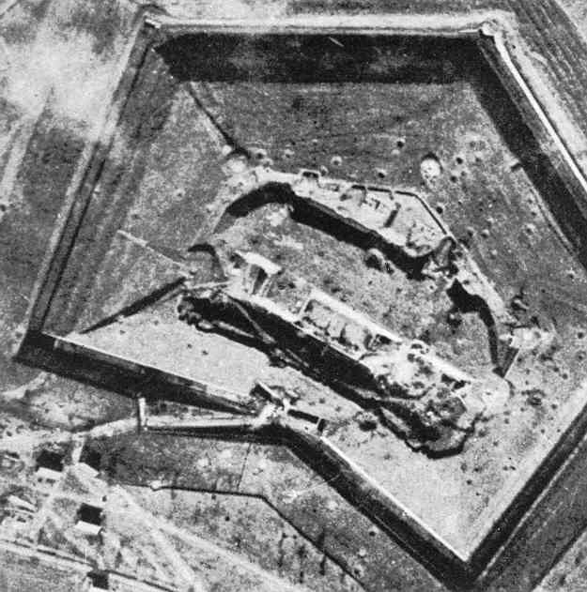

In February 1916, the walls of Verdun were defended by some 500,000 men stationed in two principal fortresses, Fort Douaumont and Fort Vaux. The Germans, commanded by Chief of Staff Erich von Falkenhayn, sent 1 million men against the city, hoping for a decisive victory on the Western Front that would push the Allies towards an armistice. The first shot was fired on the morning of 21 FEBand the Germans proceeded quickly from there, overrunning two lines of French trenches and pushing the defenders back to the walls of the city itself. Fort Douaumont was a massive structure, protected by two layers of concrete over a meter thick, and surrounded by a seven-meter-deep moat and 30 meters of barbed wire. Its fall to the Germans on 25 FEB became an early turning point in the struggle at Verdun. From then on, Verdun became a symbolic cause the French command could not abandon: public sentiment demanded the recapture of the fortress.

If the German army sought to “bleed the French white,” in Falkenhayn’s words, the French army, under Phillipe Petain, was equally determined that the enemy would not pass at Verdun. The battle soon settled into a bloody stalemate, and over the next 10 months, the city would see some of the fiercest and costliest fighting of World War I, with a total of over 700,000 casualties. By the summer of 1916, German resources had been stretched thinner by having to confront both a British-led offensive on the Somme River and Russia’s Brusilov Offensive on the Eastern Front. In July, the kaiser, frustrated by the state of things at Verdun, removed Falkenhayn and sent him to command the 9th Army in Transylvania; Paul von Hindenburg took his place. Petain had been replaced in April by Robert Nivelle, who implemented a counter-attacking strategy that enabled the French to recapture of much of their lost territory by the late fall.

Chief among these French gains was the recapture of Fort Douaumont on October 24, 1916. Under a cover of fog, French forces attacked the German-occupied fort from atop nearby Souville Hill, swarming down and taking some 6,000 German prisoners by the end of that day. “Douaumont is ours,” wrote a French staff officer who participated in the action that day. “The formidable Douaumont, which dominates with its mass, its observation points, the two shores of the Meuse, is again French.” Fort Vaux likewise fell back into French hands barely a week later. Though German commanders such as Erich Ludendorff played down the impact of such “local” French victories, the German momentum at Verdun was indeed winding down. On December 18, 1916, Hindenburg finally called a halt to his army’s attacks at Verdun, after the French captured 11,000 German soldiers over the last three days of battle.

- Oct 25 1916 – WW1 Era: German pilot Rudolf von Eschwege shoots down his first enemy plane, a Nieuport 12 of the Royal Naval Air Service over Bulgaria.

- Oct 25 1932 – Italy: Benito Mussolini promises to remain dictator for 30 years.

- Oct 25 1936 – WW2 Era: Rome-Berlin Axis » Coalition formed between Italy and Germany. It was an agreement formulated by Italy’s foreign minister Galeazzo Ciano informally linking the two fascist countries. It was formalized by the Pact of Steel in 1939. The term Axis Powers came to include Japan as well.

Italy's invasion of Ethiopia in 1935 irrevocably changed the European geopolitical framework. After 1935, Mussolini came increasingly under Hitler's influence. Hitler would also begin to free Germany from the restrictions imposed by the Treaty of Versailles and Anglo-French encirclement. The advance of Italo-German interests during from 1935 to the beginning of the Second World War also created an aura of totalitarian success and collaboration. The Spanish Civil War (1936-1939), Rhineland (1936), Austria (1937), Czechoslovakia (1938), and Albania (1939) lent credence to this perception. This period was also critical to Germany and Italy's efforts in building a coalition.

A most important step in the military features of the German plan was the signing of a treaty with protocols with Italy who had sided politically with Great Britain and France. As late as 1934 she was hostile to German expansion in Austria. A change occurred in 1935, caused by Italy engaging in a war to conquer Ethiopia. Unexpectedly, the British at once showed great displeasure. For Italy, the alliance with Germany promised support in case of a major war, and an end to her then political isolation. For Germany it meant that her south boundary was protected. It thereby released German troops for use in other theaters of operation.

- Oct 25 1940 – U.S. Army: Benjamin O. Davis, Sr. is named the first African American general in the United States Army.

- Oct 25 1941 – WW2 Era: German troops capture Kharkov and launch a new drive toward Moscow.

- Oct 25 1941 – WW2 Era: Between 25 OCT and 8 NOV a U.S. Navy taskforce of one CV, one BB, & 11 other warships screen convoys to & from the Mid-Ocean Meeting Point (MOMP).

- Oct 25 1944 – WW2: Battle of Leyte Gulf » The largest naval battle in history, takes place in and around the Philippines between the Imperial Japanese Navy and the U.S. Third and U.S. Seventh Fleets. From this point on, the depleted Japanese Navy increasingly resorts to the suicidal attacks of Kamikaze fighters which they did for the first time during this battle.

- Oct 25 1944 – WW2: First Kamikaze Attack of the War Begins » During the Battle of the Leyte Gulf, the Japanese deploy kamikaze (“divine wind”) suicide bombers against American warships for the first time. It will prove costly–to both sides.

This decision to employ suicide bombers against the American fleet at Leyte, an island of the Philippines, was based on the failure of conventional naval and aerial engagements to stop the American offensive. Declared Japanese naval Capt. Motoharu Okamura: “I firmly believe that the only way to swing the war in our favor is to resort to crash-dive attacks with our planes…. There will be more than enough volunteers for this chance to save our country.”

The first kamikaze force was in fact composed of 24 volunteer pilots from Japan’s 201st Navy Air Group. The targets were U.S. escort carriers; one, the St. Lo, was struck by a A6M Zero fighter and sunk in less than an hour, killing 100 Americans. More than 5,000 kamikaze pilots died in the gulf battle-taking down 34 ships. For their kamikaze raids, the Japanese employed both conventional aircraft and specially designed planes, called Ohka (“cherry blossom”) by the Japanese, but Baka (“fool”) by the Americans, who saw them as acts of desperation. The Baka was a rocket-powered plane that was carried toward its target attached to the belly of a bomber.

All told, more than 1,321 Japanese aircraft crash-dived their planes into Allied warships during the war, desperate efforts to reverse the growing Allied advantage in the Pacific. While approximately 3,000 Americans and Brits died because of these attacks, the damage done did not prevent the Allied capture of the Philippines, Iwo Jima, and Okinawa.

- Oct 25 1944 – WW2: Battle in Straits of Surigao » U.S. and Australian warships maul the advancing enemy with torpedoes and heavy guns during the Battle of Surigao Strait in the midst of the Battle of Leyte Gulf. The Japanese lose battleships Fuso and Yamashiro, plus three destroyers. The Battle of Surigao Strait marks the end of an era in naval warfare -- it was the last engagement of a battle line.

- Oct 25 1944 – WW2: Battle at Samar Island » During the Battle off Samar in the midst of the Battle of Leyte Gulf, four Japanese battleships, eight cruisers and 11 destroyers surprise U.S. Navy Task Unit 77.4.3 consisting of six escort carriers, three destroyers, and four destroyer escorts. Despite their great inferiority in numbers, speed and fire power, U.S. airmen and surface sailors fight heroically to defend their carriers.

- Oct 25 1944 – WW2: Battle at Cape Engano » During this engagement 3rd Fleet carrier aircraft, surface ships and submarines strike the Japanese Northern Force off northeastern Luzon. The Japanese lose aircraft carriers Zuikaku, Zuiho, Chitose and Chiyoda, as well as a light cruiser and two destroyers.

- Oct 25 1945 – WW2: Japanese surrender Taiwan to General Chiang Kai-shek.

- Oct 25 1950 – Korean War: Chinese Communist Forces (CCF) launched their first-phase offensive across the Yalu River into North Korea. Although a reconnaissance platoon for a South Korean division reached the Yalu River at Chosan, they were the only elements of the U.N. force to reach the river before the Chinese offensive pushes the whole army down into South Korea. CCF offensive operations begin north of Unsan with fighting between CCF and ROK forces; first Chinese soldier is captured. The next day 1st Marine Division, X Corps, lands at Wonsan, and on 29 OCT U.S. 7th Division lands at Iwon.

- Oct 25 1951 – Korea War: Armistice talks resume, now at Panmunjom.

- Oct 25 1955 – Austria: Austria resumed its sovereignty after departure of last Allied occupation forces, for 1st time since German occupation of 1938.

- Oct 25 1958 – Lebanon: The last U.S. troops leave Beirut.

- Oct 25 1962 – Cuban Missile Crisis: US Ambassador Adlai Stevenson shows photos at the UN proving Soviet missiles are installed in Cuba. Stevenson demands USSR UN rep Zorin answer regarding Cuban missile bases saying "I am prepared to wait for my answer until hell freezes over" President Kennedy orders the U.S. military to DEFCON 2.

- Oct 25 1971 – Cold War: The U.N. Seats the People’s Republic of China and Expels Taiwan » In a dramatic reversal of its long-standing commitment to the Nationalist Chinese government of Taiwan, and a policy of non-recognition of the communist People’s Republic of China (PRC), America’s U.N. representatives vote to seat the PRC as a permanent member. Over American objections, Taiwan was expelled.

The reasons for the apparently drastic change in U.S. policy were not hard to discern. The United States had come to value closer relations with the PRC more than its historical commitment to Taiwan. U.S. interest in having the PRC’s help in resolving the sticky Vietnam situation; the goal of using U.S. influence with the PRC as diplomatic leverage against the Soviets; and the desire for lucrative economic relations with the PRC, were all factors in the U.S. decision. Relations with the PRC thereupon soared, highlighted by President Richard Nixon’s visit to China in 1972. Not surprisingly, diplomatic relations with Taiwan noticeably cooled, though the United States still publicly avowed that it would defend Taiwan if it were attacked.

- Oct 25 1972 – Vietnam War: Nixon Suspends Bombing of North Vietnam » The White House (Nixon) orders a suspension of bombing above the 20th parallel as a signal of U.S. approval of recent North Vietnamese concessions at the secret peace talks in Paris.

- Oct 25 1973 – Cold War: Nixon Vetoes War Powers Resolution » The Resolution would have limited presidential power to commit armed forces abroad without Congressional approval. The bill, introduced by Senator Jacob K. Javits of New York, required the president to report to Congress within 48 hours after commitment of armed forces to foreign combat and limited to 60 days the time they could stay there without Congressional approval. The legislation was an attempt by Congress to regain control of the power to make war. Nixon claimed that the bill imposed “unconstitutional and dangerous restrictions” on presidential authority. Nevertheless, Congress passed the law over Nixon’s veto on November 7, 1973.

- Oct 25 1973 – Post Vietnam War: U.S. intelligence officials report that since the cease-fire, North Vietnamese military presence in South Vietnam had been built up by 70,000 troops, 400 tanks, at least 200 artillery pieces, 15 anti-aircraft artillery, and 12 airfields. Intelligence reports also indicated that an all-weather road from North Vietnam to Tay Ninh province to the north of Saigon had been almost completed. The cease-fire had gone into effect on 27 JAN at midnight as part of the Paris Peace Accords. The provisions of the cease-fire left over 100,000 Communist troops in South Vietnam. The build-up of these forces did not bode well for the South Vietnamese because the fighting had continued after only a momentary lull when the cease-fire was instituted. Congress was cutting U.S. military aid to South Vietnam while the North Vietnamese forces in the south grew stronger.

- Oct 25 1983 – Grenada: United States Invades Grenada (25-29 OCT) » President Ronald Reagan, citing the threat posed to American nationals on the Caribbean nation of Grenada by that nation’s Marxist regime, orders the Marines to invade and secure their safety. There were nearly 1,000 Americans in Grenada at the time, many of them students at the island’s medical school. In little more than a week, Grenada’s government was overthrown.

The situation on Grenada had been of concern to American officials since 1979, when the leftist Maurice Bishop seized power and began to develop close relations with Cuba. In 1983, another Marxist, Bernard Coard, had Bishop assassinated and took control of the government. Protesters clashed with the new government and violence escalated. Citing the danger to the U.S. citizens in Grenada, Reagan ordered nearly 2,000 U.S. troops into the island with Operation Urgent Fury, where they soon found themselves facing opposition from Grenadan armed forces and groups of Cuban military engineers, in Grenada to repair and expand the island’s airport. Matters were not helped by the fact that U.S. forces had to rely on minimal intelligence about the situation. (The maps used by many of them were, in fact, old tourist maps of the island.) Reagan ordered Operation Urgent Fury in 1,800 U.S. troops and 300. Caribbean troops land six days after Prime Minister Maurice Bishop and several of his supporters are executed in a coup d'état. By the time the fighting was done, nearly 6,000 U.S. troops were in Grenada.

Nearly 20 of these troops were killed and over a hundred wounded; over 60 Grenadan and Cuban troops were killed. Coard’s government collapsed and was replaced by one acceptable to the United States. The next day, hostilities are declared to be at an end. Grenadians put their country back in order--schools and businesses reopen for the first time in at least two weeks. Evidence is found of a strong Cuban and Soviet presence–large stores of arms and documents suggesting close links to Cuba.

A number of Americans were skeptical of Reagan’s defense of the invasion, noting that it took place just days after a disastrous explosion in a U.S. military installation in Lebanon killed over 240 U.S. troops, calling into question the use of military force to achieve U.S. goals. Nevertheless, the Reagan administration claimed a great victory, calling it the first “rollback” of communist influence since the beginning of the Cold War.

- Oct 25 1986 – U.S. Navy: USS Theodore Roosevelt (CVN 71) is commissioned at Newport News, Va.

-o-o-O-o-o-

- Oct 26 1774 – American Revolution Era: The first Continental Congress, which protested British measures and called for civil disobedience, concludes in Philadelphia.

- Oct 26 1774 – American Revolution Era: Minutemen Organized in U.S. Colonies » Minutemen were civilian colonists who independently organized to form militia companies self-trained in weaponry, tactics, and military strategies from the American colonial partisan militia during the American Revolutionary War. They were known for being ready at a minute's notice, hence the name. Minutemen provided a highly mobile, rapidly deployed force that enabled the colonies to respond immediately to war threats. The minutemen were among the first to fight in the American Revolution. Their teams constituted about a quarter of the entire militia. They were generally younger and more mobile. The need for efficient minuteman companies was illustrated by the Powder Alarm of 1774. Militia companies were called out to resist British troops, who were sent to capture ammunition stores. By the time the militia was ready, the British regulars had already captured the arms at Cambridge and Charlestown and had returned to Boston.

- Oct 26 1775 – American Revolution Era: King George III goes before Parliament to declare the American colonies in rebellion, and authorized a military response to quell the American Revolution.

- Oct 26 1776 – American Revolutionary War: Benjamin Franklin Sets Sail for France » Exactly one month to the day after being named an agent of a diplomatic commission by the Continental Congress, Benjamin Franklin sets sail from Philadelphia for France, with which he was to negotiate and secure a formal alliance and treaty. In France, the accomplished Franklin was feted throughout scientific and literary circles and he quickly became a fixture in high society. While his personal achievements were celebrated, Franklin’s diplomatic success in France was slow in coming. Although it had been secretly aiding the Patriot cause since the outbreak of the American Revolution, France felt it could not openly declare a formal allegiance with the United States until they were assured of an American victory over the British.

For the next year, Franklin made friends with influential officials throughout France, while continuing to push for a formal alliance. France continued to secretly support the Patriot cause with shipments of war supplies, but it was not until the American victory over the British at the Battle of Saratoga in October 1777 that France felt an American victory in the war was possible. A few short months after the Battle of Saratoga, representatives of the United States and France, including Benjamin Franklin, officially declared an alliance by signing the Treaty of Amity and Commerce and the Treaty of Alliance on February 6, 1778. The French aid that these agreements guaranteed was crucial to the eventual American victory over the British in the War for Independence.

- Oct 26 1812 – War of 1812: The frigate USS Constitution captures the frigate HMS Guerriere, off Halifax, Nova Scotia after an intense battle.

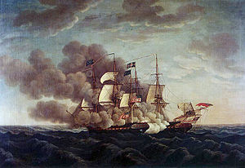

- Oct 26 1813 – War of 1812: Battle of Chateauguay » A Canadian force consisting of 1,530 regulars, volunteers, militia and Native Americans from Lower Canada, commanded by Charles de Salaberry, repelled an American force of about 2,600 regulars which was attempting to invade Lower Canada and ultimately attack Montreal. The battle was one of the two battles (the other being the Battle of Crysler's Farm) which caused the Americans to abandon the Saint Lawrence Campaign, their major strategic effort in the autumn of 1813. Casualties and losses: Lower Canada and Mohawk Nation 22 killed, wounded or missing - US 85 killed, wounded or missing.

- Oct 26 1818 – Old West: Capt. James Biddle, as commanding officer of USS Ontario, takes possession of Oregon Territory for United States.

- Oct 26 1864 – Civil War: Bloody “Bill" Anderson Killed » The notorious Confederate guerrilla leader William “Bloody Bill” Anderson is killed in Missouri in a Union ambush outside of Albany Missouri.

Born in the late 1830s, Anderson grew up in Missouri and moved to Kansas in the late 1850s. Arriving to settle on his father’s land claim east of Council Grove, Anderson was soon enmeshed in the bitter fight over slavery that gave the area the nickname “Bleeding Kansas.” Before the Civil War, he trafficked stolen horses and escorted wagon trains along the Santa Fe Trail. When the war broke out, Anderson joined an antislavery, pro-Union band of guerillas known as “Jayhawkers.” He soon switched sides and joined a band of pro-Confederate “Bushwhackers.” In the partisan warfare of Kansas and Missouri, these groups were often more interested in robbery, looting, and personal gain than advancement of a political cause.

After his father was killed in a dispute in 1862, Anderson and his brother Jim gunned down the killer and then moved back to western Missouri. Anderson became the head of a band of guerillas, and his activities cast a shadow of suspicion over the rest of his family. The Union commander along the border, General Thomas Ewing, arrested several wives and sisters of another notorious band, led by William Quantrill that was terrorizing and murdering Union sympathizers. While Anderson commanded his own band, he often collaborated with Quantrill’s larger force. As a result, the group Ewing arrested also included three of Anderson’s sisters, who were imprisoned in a temporary Union jail in Kansas City, Missouri. On August 14, 1863, the structure collapsed, killing one of Anderson’s sisters along with several other women. Quantrill assembled more than 400 men to exact revenge against the abolitionist community of Lawrence, Kansas. On August 21, the band killed at least 150 residents and burned much of the town. Anderson was credited with 14 murders that day.

Anderson went to Texas that winter, married, and returned to Missouri in 1864 with a band of about 50 fighters. He embarked on a summer of violence, leading his group on a campaign that killed hundreds and caused extensive damage. The climax came on 27 SEP, when Anderson’s gang joined with several others to pillage the town of Centralia, Missouri. When more than 100 Union soldiers pursued them, the guerillas ambushed and massacred the entire detachment. Just a month later, on 26 OCT, Anderson’s band was caught in a Union ambush outside of Albany, Missouri, and Anderson was killed. The body of the “blood-drenched savage,” as he became known in the area, was placed on public display. Anderson kept a rope to record his killings, and there were reportedly 54 knots in it at the time of his death.

- Oct 26 1881 – The Old West: OK Corral » The Earp brothers face off against the Clanton-McLaury gang in a legendary shootout at the OK Corral in Tombstone, Arizona.

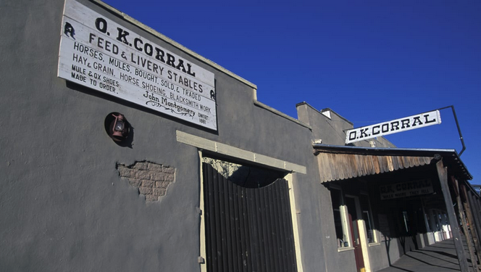

After silver was discovered nearby in 1877, Tombstone quickly grew into one of the richest mining towns in the Southwest. Wyatt Earp, a former Kansas police officer working as a bank security guard, and his brothers, Morgan and Virgil, the town marshal, represented “law and order” in Tombstone, though they also had reputations as being power-hungry and ruthless. The Clantons and McLaurys were cowboys who lived on a ranch outside of town and sidelined as cattle rustlers, thieves and murderers. In October 1881, the struggle between these two groups for control of Tombstone and Cochise County ended in a blaze of gunfire at the OK Corral.

On the morning of 25 OCT, Ike Clanton and Tom McLaury came into Tombstone for supplies. Over the next 24 hours, the two men had several violent run-ins with the Earps and their friend Doc Holliday. Around 1:30 p.m. on 26 OCT, Ike’s brother Billy rode into town to join them, along with Frank McLaury and Billy Claiborne. The first person they met in the local saloon was Holliday, who was delighted to inform them that their brothers had both been pistol-whipped by the Earps. Frank and Billy immediately left the saloon, vowing revenge.

Around 3 p.m., the Earps and Holliday spotted the five members of the Clanton-McLaury gang in a vacant lot behind the OK Corral, at the end of Fremont Street. The famous gunfight that ensued lasted all of 30 seconds, and around 30 shots were fired. Though it’s still debated who fired the first shot, most reports say that the shootout began when Virgil Earp pulled out his revolver and shot Billy Clanton point-blank in the chest, while Doc Holliday fired a shotgun blast at Tom McLaury’s chest. Though Wyatt Earp wounded Frank McLaury with a shot in the stomach, Frank managed to get off a few shots before collapsing, as did Billy Clanton. When the dust cleared, Billy Clanton and the McLaury brothers were dead, and Virgil and Morgan Earp and Doc Holliday were wounded. Ike Clanton and Claiborne had run for the hills.

Sheriff John Behan of Cochise County, who witnessed the shootout, charged the Earps and Holliday with murder. A month later, however, a Tombstone judge found the men not guilty, ruling that they were “fully justified in committing these homicides.”

- Oct 26 1898 – U.S. Marine Corps: Marine Barracks were established at Naval Station San Juan Puerto Rico.

- Oct 26 1917 – WWI: Brazil Declares War on Germany » Brazil declares its decision to enter the First World War on the side of the Allied powers. As a major player in the Atlantic trading market, Brazil—an immense country occupying nearly one-half of the entire South American continent—had been increasingly threatened by Germany’s policy of unrestricted submarine warfare over the course of the first two years of WWI. In February 1917, when Germany resumed that policy after temporarily suspending it due to pressure from neutral nations such as the United States, President Woodrow Wilson responded by immediately breaking diplomatic relations with Germany; the U.S. formally entered the war alongside the Allied powers on April 6, 1917.

One day before the U.S. declaration of war, a German U-boat sank the Brazilian merchant ship Parana as it sailed off the coast of France. On 4 JUN, Dominico da Gama, the Brazilian ambassador to the U.S., wrote to Secretary of State Robert Lansing declaring that Brazil was revoking its previous neutrality and severing its own diplomatic relations with Germany. “Brazil ever was and is now free from warlike ambitions,” da Gama stated, “and, while it always refrained from showing any partiality in the European conflict, it could no longer stand unconcerned when the struggle involved the United States, actuated by no interest whatever but solely for the sake of international judicial order, and when Germany included us and the other neutral powers in the most violent acts of war.”

Over the next few months, Brazil’s government actively sought to amend its constitution to enable it to declare war. This having been accomplished, the declaration was made on October 26, 1917. In an open letter sent to the Vatican but clearly intended to be read in countries around the world, the Brazilian foreign minister, Dr. Nilo Pecanha, justified his country’s decision to enter the epic struggle of World War I on the side of the Allies by pointing to Germany’s attacks on international trade and invoking the higher purpose of creating a more peaceful, democratic post-war world: “Through the sufferings and the disillusions to which the war has given rise a new and better world will be born, as it were, of liberty, and in this way a lasting peace may be established without political or economic restrictions, and all countries be allowed a place in the sun with equal rights and an interchange of ideas and values in merchandise on an ample basis of justice and equity.”

Though Brazil’s actual contribution to the Allied war effort was limited to one medical unit and some airmen, its participation was rewarded with a seat at the post-war bargaining table. The fact that Brazil—according to the size of its population—had three official delegates at the Paris Peace Conference in 1919 angered Portugal, who had sent 60,000 soldiers to the Western Front and yet had only one delegate. Britain supported Portugal in the disagreement, while the U.S. backed Brazil; no change was made. This conflict illustrated how important it was considered for the nations of the world to have representation in Versailles, as it was there that the boundaries of the new, post-World War I world would be determined. On June 28, 1919, Brazil was one of 27 nations to sign the 200-page Versailles Treaty, alongside a number of other Latin American nations who had also declared their support for the Allies, including Bolivia, Cuba, Ecuador, Guatemala, Haiti, Honduras, Nicaragua, Panama, Peru and Uruguay.

- Oct 26 1918 – WWI: Germany’s supreme commander, General Erich Ludendorff, is forced to resign by Emperor William II on Prince Maximilian's advice in an effort to establish an armistice agreement. Ludendorff had been protesting the terms to which the German Government had agreed in negotiating the armistice. This sets the stage for his later support for Adolf Hitler and the Nazis, who claim that Germany did not lose the war on the battlefield but were “stabbed in the back” by politicians.

- Oct 26 1936 – U.S. Navy: Lt. B.L. Braun, pilot, completes test bombing against the submarine USS R -8 (SS 85) off the Virginia capes, sinking the old submarine and proving the value of properly armed aircraft in antisubmarine warfare.

- Oct 26 1940 – U.S. Air Force: The P-51 Mustang makes its maiden flight.
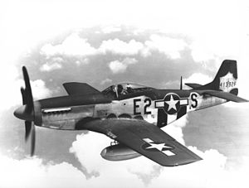

- Oct 26 1942 – WW2: Battle of Santa Cruz (25-27 Oct) » The last U.S. carrier manufactured before America’s entry into World War II, the Hornet, is damaged so extensively by Japanese war planes in the Battle of Santa Cruz that it must be abandoned.

The battle for Guadalcanal was the first American offensive against the Japanese, an attempt to prevent the Axis power from taking yet another island in the Solomon chain and gaining more ground in its race for Australia. On this day, in the vicinity of the Santa Cruz Islands, two American naval task forces had to stop a superior Japanese fleet, which was on its way to Guadalcanal with reinforcements. As was the case in the Battle of the Coral Sea in May 1942, the engagement at Santa Cruz was fought exclusively by aircraft taking off from carriers of the respective forces; the ships themselves were not in range to fire at one another.

Japanese aerial fire damaged the USS Enterprise, the battleship South Dakota, and finally the Hornet. In fact, the explosions wrought by the Japanese bombs that rained down on the Hornet were so great that two of the Japanese bombers were themselves crippled by the blasts, and the pilots chose to dive-bomb their planes into the deck of the American carrier, which was finally abandoned and left to burn. The Hornet, which weighed 20,000 tons, had seen battle during the Doolittle Raid on Tokyo (its commander at the time, Marc Mitscher, was promoted to admiral and would be a significant player in the victory over Japan) and the battle of Midway.

While the United States losses at Santa Cruz were heavy, the cost in aircraft to the Japanese was so extensive—more than 100, including 25 of the 27 bombers that attacked the Hornet—that they were unable finally to reinforce their troops at Guadalcanal, paving the way for an American victory. Casualties and losses: U.S. 1 fleet carrier sunk and 1 damaged, 1 battleship lightly damaged, 0 of 6 cruisers damaged, 1 of 12 destroyers sunk and 2 damaged, 86 of 136 aircraft destroyed, and 266 killed – Japan 1 of 3 fleet and 1 light carrier heavily damaged, 0 of 4 battleships damaged, 1 of 18 cruisers damaged, 0 of 25 destroyers damaged, 99 of 199 aircraft destroyed, and 400-500 killed.

Footnote: The Hornet lost at Santa Cruz was the CV-8; another Hornet, the CV-12, launched August 30, 1943, led a virtually charmed life, spending 52 days under Japanese attack in many battles in the Pacific, with nary a scratch to show for it. That is, until June 1945, when it was finally damaged—by a typhoon.

- Oct 26 1943 – WW2: First flight of the German Dornier Do 335 "Pfeil" heavy fighter.

- Oct 26 1943 – WW2: USS Finback (SS 230) sinks the Japanese auxiliary submarine chaser (No.109) off the eastern Celebes.

- Oct 26 1944 – WW2: The Battle of Leyte Gulf - The Battle of Leyte Gulf ends with an overwhelming U.S. victory as combined American and Australian forces cripple the Imperial Japanese Navy. Fought over four days in waters near the Philippine islands of Leyte, Samar, and Luzon, it is the first battle in which Japanese aircraft carry out organized kamikaze attacks and will come to be regarded as the largest naval battle of World War II.

- Oct 26 1950 – Korean War: A reconnaissance platoon for a South Korean division reaches the Yalu River. They are the only elements of the U.N. force to reach the river before the Chinese offensive pushes the whole army down into South Korea.

- Oct 26 1955 – Vietnam War Era: Diem Declares Himself Premier of Republic of Vietnam » Ngo Dinh Diem declares that pursuant to the wishes of the South Vietnamese people, as evidenced in a national referendum a few days before, the Republic of Vietnam is now in existence and that he will serve as the nation’s first president. The event marked a crucial step in the deepening U.S. involvement in Vietnam, and gave evidence of some troubling aspects that would characterize Diem’s eight years in power.

- Oct 26 1957 – Russia: The Russian government announces that Marshal Georgy Zhukov, the nation’s most prominent military hero, has been relieved of his duties as Minister of Defense. Khrushchev accuses Zhukov as promoting his own “cult of personality” and sees him as a threat to his own popularity.

- Oct 26 1966 – U.S. Navy: Fire Breaks Out on U.S. Aircraft Carrier » A fire breaks out on board the 42,000-ton U.S. aircraft carrier Oriskany in the Gulf of Tonkin. The accident occurred when a locker filled with night illumination magnesium flares burst into flame. The fire spread quickly through most of the ship, resulting in 35 officers and eight enlisted men killed and a further 16 injured. The loss of life would have been much higher except for the valor of crewmen who pushed 300 500-pound, 1,000-pound, and 2,000-pound bombs that lay within reach of the flames on the hangar deck overboard. The fire destroyed four fighter-bombers and two helicopters, but it was brought under control after three hours. The fallen were returned to the United States for burial.

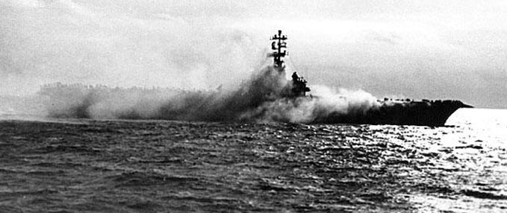

- Oct 26 1968 – Vietnam War: Big Battle Begins in Tay Ninh Province » The 1st Infantry Division troops are attacked in Binh Long Province (III Corps), 60 miles north of Saigon near the Cambodian border. Communist forces launched a mortar, rocket, and ground attack against Fire Support Base (FSB) Julie, eight miles west of An Loc. Soldiers from 1st Battalion, 2nd Infantry, manned the FSB. U.S. B-52s conducted 22 strikes over the area in an effort to disperse a reported massing of North Vietnamese forces. The defenders were successful in fending off the Communist attack but eight soldiers were killed and 33 were wounded.

- Oct 26 1979 – Korea: The President of South Korea, Park Chung-hee, is assassinated by Kim Jae-kyu, head of the country’s Central intelligence Agency; Choi Kyu-ha is named acting president.

- Oct 26 1981 – Middle East: Two F-14 Tomcats of VF-41 shoot down two Libyan (Su 22) Sukhoi aircraft over international waters. Flying off USS Nimitz (CVA(N) 68), the Tomcats are on a reconnaissance mission for a missile-firing exercise being conducted by U.S. ships from two carrier battle groups when they are fired on by the Libyan planes.

- Oct 26 1994 – Israel: Israel and Jordan sign a peace treaty

- Oct 26 2001 – War On Terrorism: Patriot Act is Signed » President George W. Bush signs the Act, an anti-terrorism law drawn up in response to the attacks on the Pentagon and World Trade Center on September 11, 2001. The USA PATRIOT Act, as it is officially known, is an acronym for “Uniting and Strengthening America by Providing Appropriate Tools Required to Intercept and Obstruct Terrorism.” Bush hoped the bipartisan legislation would empower law enforcement and intelligence agencies to prevent future terrorist attacks on American soil.

The law was intended, in Bush’s words, to “enhance the penalties that will fall on terrorists or anyone who helps them.” The act increased intelligence agencies’ ability to share information and lifted restrictions on communications surveillance. Law enforcement officials were given broader mandates to fight financial counterfeiting, smuggling and money laundering schemes that funded terrorists. The Patriot Act’s expanded definition of terrorism also gave the FBI increased powers to access personal information such as medical and financial records. The Patriot Act superseded all state laws.

While Congress voted in favor of the bill, and some in America felt the bill actually did not go far enough to combat terrorism, the law faced a torrent of criticism. Civil rights activists worried that the Patriot Act would curtail domestic civil liberties and would give the executive branch too much power to investigate Americans under a veil of secrecy—a fear not felt since the protest era of the 1960s and 1970s when the FBI bugged and infiltrated anti-war and civil rights groups.

The Patriot Act has faced ongoing legal challenges by the American Civil Liberties Union, and in recent years, some members of Congress who had originally supported the bill have come to mistrust the Bush administration’s interpretation of the law. Nevertheless, a Republican-controlled Congress passed and Bush signed a renewal of the controversial Patriot Act in March 2006. Bush exacerbated the controversy over the renewal of the act by issuing a so-called “signing statement”—an executive exemption from enforcing or abiding by certain clauses within the law—immediately afterward.

-o-o-O-o-o-

- Oct 27 1775 – American Revolution Era: King George III Speaks to Parliament of American Rebellion » The King spoke before both houses of the British Parliament to discuss growing concern about the rebellion in America, which he viewed as a traitorous action against himself and Great Britain. He began his speech by reading a “Proclamation of Rebellion” and urged Parliament to move quickly to end the revolt and bring order to the colonies.

The king spoke of his belief that “many of these unhappy people may still retain their loyalty, and may be too wise not to see the fatal consequence of this usurpation, and wish to resist it, yet the torrent of violence has been strong enough to compel their acquiescence, till a sufficient force shall appear to support them.” With these words, the king gave Parliament his consent to dispatch troops to use against his own subjects, a notion that his colonists believed impossible.

Just as the Continental Congress expressed its desire to remain loyal to the British crown in the Olive Branch Petition, delivered to the monarch on 1 SEP, so George III insisted he had “acted with the same temper; anxious to prevent, if it had been possible, the effusion of the blood of my subjects; and the calamities which are inseparable from a state of war; still hoping that my people in America would have discerned the traitorous views of their leaders, and have been convinced, that to be a subject of Great Britain, with all its consequences, is to be the freest member of any civil society in the known world.” King George went on to scoff at what he called the colonists’ “strongest protestations of loyalty to me,” believing them disingenuous, “whilst they were preparing for a general revolt.”

Unfortunately for George III, Thomas Paine’s anti-monarchical argument in the pamphlet, Common Sense, published in January 1776, proved persuasive to many American colonists. The two sides had reached a final political impasse and the bloody War for Independence soon followed.

- Oct 27 1812 – War of 1812: The frigate Essex, commanded by Capt. David Porter, departs Delaware capes on a cruise into the Pacific Ocean around Cape Horn for attacks on the British whaling industry.

- Oct 27 1862 – Civil War: A Confederate force is routed at the Battle of Georgia Landing, near Bayou Lafourche in Louisiana.

- Oct 27 1864 – Civil War: Lt. William B. Cushing takes the torpedo boat Picket Boat No. 1 upriver to Plymouth, N.C. and attacks CSS Albemarle at her berth, sinking her with a spar torpedo.

- Oct 27 1864 – Civil War: Battle of Hatcher's Run (Burgess Mill) » At the First Battle of Hatcher’s Run (also known as the Battle of Boydton Plank Road), Virginia, Union troops are turned back when they try to cut the last railroad supplying the Confederate force in Petersburg, Virginia. About 1,700 Yankee men were killed, wounded, or captured. Confederate losses were not reported but were thought to be less than 1,000, most of them captured soldiers. The battle was a disaster for the Union and caused embarrassment to President Abraham Lincoln’s administration just a week before the presidential election. However, recent Yankee military successes around Atlanta and in Mobile, Alabama, were enough to secure Lincoln’s re-election.

- Oct 27 1864 – Civil War: Second Battle of Fair Oaks (27-28 OCT) » The battle was fought as part of the Siege of Petersburg. Lt. Gen. Ulysses Grant ordered an assault to divert Confederate attention from a Union attack near Petersburg, Virginia. Maj. Gen. Benjamin Butler, Union commander outside Richmond, aspired to outflank the Confederates and capture their capital. The Federal X Corps initiated the attack along Darbytown Road, while the XVIII Corps, delayed by miscommunication, joined in later along Williamsburg Road. Union troops also advanced along Nine Mile Road. Confederate Lt. Gen. James Longstreet strengthened his left flank, forcing the Federals to withdraw on 28 Oct. The Confederate forces took some 600 prisoners. The Richmond defenses remained intact and the Siege of Petersburg continued. Winter was coming, and no major action would occur again for over a month. The Union army suffered about 1,600 casualties and the Confederates about 100.

- Oct 27 1918 – WWI: German General Erich Ludendorff Resigns » Under pressure from the government of Chancellor Max von Baden, Erich Ludendorff, the quartermaster general of the German army, resigns on just days before Germany calls for an armistice, bringing World War I to an end after four long years. Second in command to Chief of Staff Paul von Hindenburg for most of the war effort, Ludendorff had masterminded the final, massive German offensive during the spring of 1918. Beginning that summer, however, the Allies—spearheaded by British, French and American troops—made a great resurgence, reversing many of Germany’s gains and turning the tide decisively toward an Allied victory. By the end of September, the Germans had been forced to retreat to the so-called Hindenburg Line, the last line of their defenses in eastern France and western Belgium; on 29 SEP, that formidable line was breached.

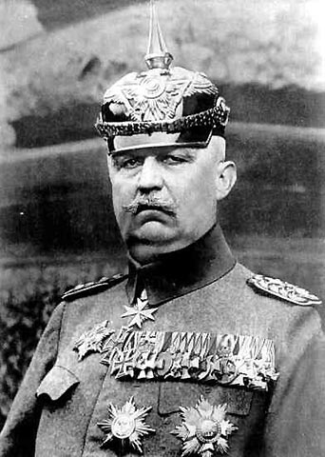

- Oct 27 1922 – U.S. Navy: The Navy League of the United States sponsors the first celebration of Navy Day to focus public attention on the importance of the U.S. Navy. The date is selected because it is Theodore Roosevelt’s birthday. Navy Day is last observed Oct. 27, 1949. In the 1970s, Adm. Elmo R. Zumwalt works with the Navy League to define 13 OCT to celebrate the Navy.

- Oct 27 1940 – WW2 Era: De Gaulle Sets up the Empire Defense Council » French Gen. Charles de Gaulle, speaking for the Free French Forces from his temporary headquarter in equatorial Africa, calls all French men and women everywhere to join the struggle to preserve and defend free French territory and “to attack the enemy wherever it is possible, to mobilize all our military, economic, and moral resources… to make justice reign.” De Gaulle had a long history fighting Germans. He sustained multiple injuries fighting at Verdun in World War I. He escaped German POW camps five times, only to be recaptured each time. (At 6 feet, 4 inches tall, it was hard for de Gaulle to remain inconspicuous.)

- Oct 27 1941 – WW2 Era: In a broadcast to the nation on Navy Day, President Franklin Roosevelt declares: "America has been attacked, the shooting has started." He does not ask for full–scale war yet, realizing that many Americans are not yet ready for such a step.

- Oct 27 1944 – WW2: Aircraft from USS Essex (CV 9) sink the Japanese destroyer Fujinami while aircraft from USS Enterprise (CV 6) sink the Japanese destroyer Shiranui 80 miles north of Iloilo, Panay.

- Oct 27 1954 – U.S. Air Force: Benjamin O. Davis Jr. becomes the first African-American general in the United States Air Force.
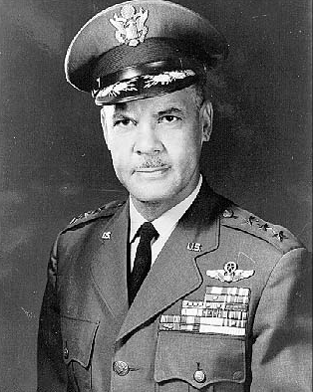

- Oct 27 1962 – Cuban Missile Crisis: First Casualty » 72,000 feet above Cuba, an American U2 spy plane flies over the island, capturing photo intelligence. It’s been 13 days since the CIA discovered Soviet nuclear missiles stationed in Cuba, pointed directly at the US. Soviet defense forces on the ground catch the spy plane on their radar. They name it Target Number 33. The lower-level Soviet officers are getting nervous that this spy is capturing critical intelligence. Unable to reach their general, they make the call: destroy Target Number 33. In that moment, the pilot becomes the first casualty of the Cuban Missile Crisis.

- Oct 27 1962 – Cuban Missile Crisis: U.S. & Soviet Union Step Back from Brink of Nuclear War » Complicated and tension-filled negotiations between the United States and the Soviet Union finally result in a plan to end the two-week-old Cuban Missile Crisis. A frightening period in which nuclear holocaust seemed imminent began to come to an end. Since President John F. Kennedy’s October 22 address warning the Soviets to cease their reckless program to put nuclear weapons in Cuba and announcing a naval “quarantine” against additional weapons shipments into Cuba, the world held its breath waiting to see whether the two superpowers would come to blows.

U.S. armed forces went on alert and the Strategic Air Command went to a Stage 4 alert (one step away from nuclear attack). On 24 OCT, millions waited to see whether Soviet ships bound for Cuba carrying additional missiles would try to break the U.S. naval blockade around the island. At the last minute, the vessels turned around and returned to the Soviet Union. On 26 OCT, Soviet leader Nikita Khrushchev responded to the quarantine by sending a long and rather disjointed letter to Kennedy offering a deal: Soviet ships bound for Cuba would “not carry any kind of armaments” if the United States vowed never to invade Cuba. He pleaded, “let us show good sense,” and appealed to Kennedy to “weigh well what the aggressive, piratical actions, which you have declared the U.S.A. intends to carry out in international waters, would lead to.” He followed this with another letter the next day offering to remove the missiles from Cuba if the United States would remove its nuclear missiles from Turkey.

Kennedy and his officials debated the proper U.S. response to these offers. Attorney General Robert Kennedy ultimately devised an acceptable plan: take up Khrushchev’s first offer and ignore the second letter. Although the United States had been considering the removal of the missiles from Turkey for some time, agreeing to the Soviet demand for their removal might give the appearance of weakness. Nevertheless, behind the scenes, Russian diplomats were informed that the missiles in Turkey would be removed after the Soviet missiles in Cuba were taken away. This information was accompanied by a threat: If the Cuban missiles were not removed in two days, the United States would resort to military action. It was now Khrushchev’s turn to consider an offer to end the standoff.

- Oct 27 1966 – Vietnam War: Ambassador Harriman Sent to Explain Manila Offer » U.S. Ambassador-at-Large Averell Harriman visits 10 nations to explain the results of the Manila conference and the current U.S. evaluation of the situation in Southeast Asia. The Communist Chinese news agency Hsinhua had already denounced the Manila pledge to remove troops as “out-and-out blackmail and shameless humbug.” The North Vietnamese did not respond favorably to the Manila pledge and it had no impact on the conduct of the war, which continued unabated.

- Oct 27 1971 – Vietnam War: Cambodian Troops Battle Communists North of Phnom Penh » Fighting intensifies as Cambodian government forces battle with Khmer Rouge, Viet Cong, and North Vietnamese forces northeast of Phnom Penh. In March 1970, a coup led by Cambodian General Lon Nol had overthrown the government of Prince Norodom Sihanouk in Phnom Penh. Lon Nol and his army, the Forces Armees Nationale Khmer (FANK), with U.S. support and military aid, fought the Communist Khmer Rouge for control of Cambodia. In addition, the government forces had to contend with the North Vietnamese and Viet Cong, who continued to use Cambodia as a sanctuary for their forces attacking into South Vietnam. In this round of the fighting, the major engagements occurred around the provincial capitals of Kompong Thom and Rumlong. The Communists began a siege of these garrisons after their demolition frogmen destroyed a crucial bridge along Route 6, the main supply line for the 20,000 Cambodians on the northeast front. Some 400 government soldiers were reported dead as a result of the combat.

- Oct 27 1988 – Cold War: U.S. Embassy Moscow » President Ronald Reagan decides to tear down the new U.S. Embassy in Moscow because of Soviet listening devices in the building structure. The project had cost $136 million.

The Soviet Union and the United States had begun negotiating over new embassy buildings in the 1960s and finally agreed in 1969 to allow each other to construct them in Washington and Moscow. The U.S. Embassy construction began in 1979, using supports built by Soviet workers. By 1985, U.S. officials discovered the supports had eavesdropping equipment embedded throughout. The building was abandoned, a lonely red-brick box left standing at one end of the compound of townhouses built at the same time for American diplomats. The project had cost $136 million. The embassy offices remained in the old building up the block. In retaliation, the United States refused to allow the Soviet Union to occupy its new embassy in Washington. By the time that embassy was opened, it was 1994 and the Soviet Union had died and been succeeded by Russia.

At the end of 1991, as the Soviet Union fell apart. Vadim Bakatin, the head of the KGB at the time, presented U.S. Ambassador Robert Strauss with the blueprints for the embassy bugs. Until that moment, the Soviet Union had steadfastly denied the bugging. It was a gesture of friendship, Bakatin said. And he hoped the United States would be able to debug the building and move in, he said. The United States, however, was afraid of being tricked again. Finally, at a cost of $240 million, the bugged embassy was taken apart brick by brick and rebuilt stone by stone. The top two floors were knocked off and replaced by four new secure floors. The stone and glass post-modern building was unofficially opened in May 2000 after a delay of 15 years.

- Oct 27 2019 – Middle East: Abu Bakr al-Baghdadi Dies » The Islamic Iraq State leader ym"sh blew himself up during a raid by U.S. special operations forces on his compound in Syria. Upon assuming leadership Baghdadi's claim to be "caliph" was almost universally rejected by the Muslim community. The Islamic State in Iraq and the Levant (ISIL) was designated as a terrorist organization by the United Nations and almost all sovereign states, and Baghdadi was individually considered a terrorist by the United States and many other countries. As leader of ISIL, Baghdadi led and lost the Islamic State's wars against Iraq and Syria. Baghdadi directed the use of extremely controversial tactics, including the mass use of suicide bombings and the execution of prisoners of war. ISIL briefly captured substantial territory in Iraq and Syria, but lost almost all of its territory and fighters during Baghdadi's tenure as emir.

Baghdadi became directly involved in ISIL's atrocities and human rights violations. These included the genocide of Yazidis in Iraq, extensive sexual slavery, organized rape, floggings, and systematic executions. He directed terrorist activities and massacres. He embraced brutality as part of the organization's propaganda efforts, producing videos displaying sexual slavery and executions via hacking, stoning, and burning. Baghdadi himself was a rapist who kept several personal sex slaves. On 27 OCT, Baghdadi killed himself and two children by detonating a suicide vest during the Barisha raid, conducted by the United States following approval from President Donald Trump, in Syria's northwestern Idlib Province. After being offered Islamic funeral rites, his body was buried at sea. ISIL confirmed his death and named Abu Ibrahim al-Hashimi al-Qurashi as his replacement.

-o-o-O-o-o-

- Oct 28 1775 – American Revolution Era: British Proclamation Forbids Residents from Leaving Boston » The new commander in chief of the British army, Major General Sir William Howe, issues a proclamation to the residents of Boston which forbade any person from leaving the city and ordered citizens to organize into military companies in order to “contribute all in his power for the preservation of order and good government within the town of Boston.”

- Oct 28 1776 – American Revolutionary War: Battle of White Plains » Following the retreat of George Washington's Continental Army northward from New York City, British General William Howe landed troops in Westchester County, intending to cut off Washington's escape route. Alerted to this move, Washington retreated farther, establishing a position in the village of White Plains but failed to establish firm control over local high ground. Howe's troops drove Washington's troops from a hill near the village; following this loss, Washington ordered the Americans to retreat farther north. Later British movements chased Washington across New Jersey and into Pennsylvania. Washington then crossed the Delaware and surprised a brigade of Hessian troops in the December 26 Battle of Trenton. Casualties and losses: US 434 - GB 233.

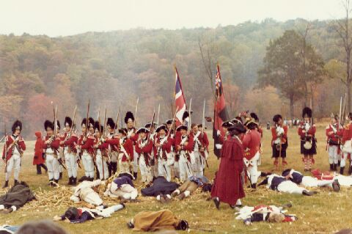

- Oct 28 1812 –War of 1812: The brig Argus, commanded by Commodore Arthur Sinclair, captures the British merchant brig Fly in the North Atlantic.

- Oct 28 1864 – Civil War: Battle at Wauhatchie (28-29 OCT) » Fought in Hamilton and Marion Counties, Tennessee, and Dade County, Georgia. Union forces on 27 OCT seized Brown's Ferry on the Tennessee River with a simultaneous advance up Lookout Valley, securing the Kelley's Ferry Road and opening a supply line to the Union army in Chattanooga. Confederate forces attempted to defeat the Union force defending the ferry and again close this supply line but were defeated. A rumor circulated through the Union camps that Union mules stampeded by the fight had made the Confederates believe they were being attacked by cavalry, causing the Southern retreat; the Union soldiers joked that the mules be "breveted as horses". In truth, the Hampton Legion was disordered by the mules for only a short time. However, this lull allowed the 137th New York to plug a gap in the Federal line. Union losses in the battle were 78 killed, 327 wounded, and 15 missing. The Confederates reported their losses as 34 killed, 305 wounded, and 69 missing. Wauhatchie was one of the few night battles of the Civil War.

- Oct 28 1864 – Civil War: Second Battle of Newtonia » Major General Sterling Price's Confederate cavalry force was in full retreat following its expedition into Missouri. On this day, it stopped to rest about two miles south of Newtonia, Missouri. About 3:00 p.m., Maj. Gen. James G. Blunt's Union cavalrymen spotted the rear of Price’s supply train entering the woods south of town on the Cassville road. McLain's Colorado Light Artillery, supported by the 15th Kansas Cavalry, opened on the rebels. Blunt formed the 16th Kansas and 2nd Colorado Cavalry in two lines and personally led a charge behind a screen of skirmishers toward the fleeing supply train.

Most of the rebel skirmishers were in no condition (physically or mentally) to resist, and they were soon tumbling backwards. Brig. Gen. Joseph O. (Jo) Shelby's mounted infantry division, including his "Iron Brigade", rode to the front, dismounted, and engaged the Union force. Shelby's men overlapped the flanks of the smaller Union force and forced it back into a large cornfield near the Matthew H. Ritchey estate. There, fighting raged until Federal cannon fire and reinforcements under Brig. Gen. John B. Sanborn finally caused the Confederates to retreat at nightfall. However, Shelby had accomplished his mission in holding up the Union pursuers. By morning, Price had retreated across the desolate prairie towards the Indian Territory. Despite the duration and ferocity of the firefight, casualties were rather light (400 for the Federals versus 250 for the Confederates).

- Oct 28 1886 – United States: Statue of Liberty Dedicated » The statue, a gift to the people of the United States from the people of France commemorating the Franco-American alliance during the American Revolution, is dedicated in New York Harbor by President Grover Cleveland. Originally known as “Liberty Enlightening the World,” the statue was proposed by the French historian Edouard de Laboulaye to commemorate the Franco-American alliance during the American Revolution. Designed by French sculptor Frederic-Auguste Bartholdi, the 151-foot statue was the form of a woman with an uplifted arm holding a torch. Its framework of gigantic steel supports was designed by Eugene-Emmanuel Viollet-le-Duc and Alexandre-Gustave Eiffel, the latter famous for his design of the Eiffel Tower in Paris.

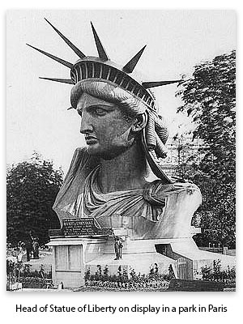

On its 50th anniversary in 1936 FDR rededicated Statue with the pledge that ‘we will not forget that liberty has here made her home; nor shall her chosen altar be neglected.’ During those 50 years,” the president added, “that covenant between ourselves and our most cherished convictions has not been broken.” FDR also said: “For over three centuries a steady stream of men, women and children followed the beacon of liberty which this light symbolizes. They brought to us strength and moral fiber developed in a civilization centuries old but fired anew by the dream of a better life in America. They brought to one new country the cultures of a hundred old ones.

- Oct 28 1918 – WWI: German Sailors Begin to Mutiny » Sailors in the German High Seas Fleet steadfastly refuse to obey an order from the German Admiralty to go to sea to launch one final attack on the mighty British navy, echoing the frustrated, despondent mood of many on the side of the Central Powers during the last days of World War I.

By the last week of October 1918, three of the Central Powers—Germany, Austria-Hungary and the Ottoman Empire—were at least in talks with the Allies about reaching an armistice, while the fourth, Bulgaria, had already concluded one at the end of September. With the end of the war seemingly in sight, the German naval command—led by the Admiralty’s chief of staff, Reinhardt Scheer—decided to launch a last-ditch effort against the British in the North Sea in a desperate attempt to restore the German navy’s prestige. In the words of Reinhardt Scheer, chief of staff of the German Admiralty, “An honorable battle by the fleet—even if it should be a fight to the death—will sow the seed of a new German fleet of the future. There can be no future for a fleet fettered by a dishonorable peace.” Choosing not to inform the chancellor, Max von Baden, of its plans, the German Admiralty issued the order to leave port on 28 OCT.

The sailors themselves, however, believing the attack to be a suicide mission, would have none of it. Though the order was given five times, each time they resisted. In total, 1,000 mutineers were arrested, leaving the Imperial Fleet immobilized. By 30 OCT, the resistance had engulfed the German naval base at Kiel, where sailors and industrial workers alike took part in the rebellion; within a week, it had spread across the country, with revolts in Hamburg, Bremen and Lubeck on November 4 and 5 and in Munich two days later. This widespread discontent led Socialist members of the German Reichstag, or parliament, to declare the country a republic on 9 NOV, followed swiftly by Kaiser Wilhelm’s abdication and finally, on 11 NOV, by the end of the First World War.

- Oct 28 1919 – Post WWI: Czechoslovakia Gains Independence » Czechoslovakia was created with the dissolution of Austria-Hungary at the end of World War I. In 1918, a meeting took place in Pittsburgh, Pennsylvania, United States, where the future Czechoslovak president Tomáš Garrigue Masaryk and other Czech and Slovak representatives signed the Pittsburgh Agreement, which promised a common state consisting of two equal nations, Slovaks and Czechs. Soon after, the philosophy of Edvard Beneš pushed for greater unity and a single nation. Some Slovaks were not in favor of this change, and in March 1939, with pressure from Adolf Hitler, the First Slovak Republic was created as a satellite state of Germany with limited sovereignty. Occupation by the Soviet Union after World War II oversaw their reunification into the third Czechoslovak republic.

In 1968, the Constitutional Law of Federation reinstated an official federal structure (of the 1917 type), but during the "Normalization period" in the 1970s, Gustáv Husák (although a Slovak himself) returned most of the control to Prague. This approach encouraged a regrowth of separatism after the fall of communism.

- Oct 28 1919 – Post WWI: Prohibition » Congress overrode President Woodrow Wilson’s veto of the Volstead Act, formally known as the National Prohibition Act. The legislation, which barred the sale of alcoholic beverages, was named for Rep. Andrew Volstead (R-MN), chairman of the House Judiciary Committee. Dubbed at the time The Noble Experiment, it defined intoxicating liquor as any beverage containing more than 0.5 percent alcohol and superseded all existing state prohibition laws.

After a prolonged struggle, Congress had enacted a temporary wartime ban on liquor in November 1918, which the U.S. Supreme Court subsequently upheld, just as World War I drew to a close. The Volstead Act served as enabling legislation for the recently ratified 18th Amendment, which was repealed by the 21st Amendment in 1933, thus ending the Prohibition era. Volstead had introduced the measure on May 28, 1919. Democrats countered with what would be known as the “wet law,” which would have repealed wartime prohibition. The battle between the “wets” and the “bone-drys,” as prohibition supporters were known, raged all summer in the House. During one debate, Volstead, in defending the proposed act, declared, “The American people have said that they do not want any liquor sold, and they have said it emphatically by passing almost unanimously the constitutional amendment.” The law cleared the chamber convincingly, 225-59, with a solid Republican majority.

Although Volstead led the fight in Congress for the permanent legislation, it was conceived and drafted by National Anti-Saloon League’s Wayne Wheeler. The league organized itself at the grass-roots level, often working through churches. It supported or opposed candidates based solely on their position on prohibition and nothing else. Volstead, who had served 10 terms in Congress, lost his seat in 1922, falling victim to low farm prices rather than his sponsorship of prohibition.

- Oct 28 1922 – Italy: March on Rome (28-29 OCT) » The march was an organized mass demonstration which resulted in Benito Mussolini's National Fascist Party (Partito Nazionale Fascista, or PNF) ascending to power in the Kingdom of Italy. In late October 1922, Fascist Party leaders planned an insurrection, to take place on 28 October. When fascist troops entered Rome, Prime Minister Luigi Facta wished to declare a state of siege, but this was overruled by King Victor Emmanuel III. On the following day the King appointed Mussolini as Prime Minister, thereby transferring political power to the fascists without armed conflict.

- Oct 28 1939 – WW2 Era: Spitfire shoots German Heinkel-111 down above Scotland.

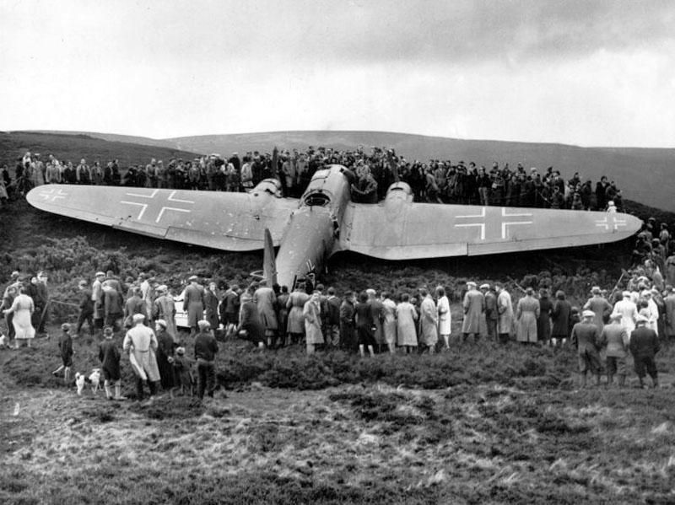

- Oct 28 1940 – WW2 Era: Italy Unsuccessfully Invades Greece » After the Greeks reject a three-hour ultimatum, Mussolini’s army already occupying Albania, invades Greece in what will prove to be a disastrous military campaign for the Duce’s forces. Mussolini surprised everyone with this move against Greece; even his ally, Adolf Hitler, was caught off-guard, especially since the Duce had led Hitler to believe he had no such intention. Hitler denounced the move as a major strategic blunder. According to Hitler, Mussolini should have concentrated on North Africa, continuing the advance into Egypt. Even Mussolini’s own chief of army staff found out about the invasion only after the fact.

But despite being warned off an invasion of Greece by his own generals, despite the lack of preparedness on the part of his military, despite that it would mean getting bogged down in a mountainous country during the rainy season against an army willing to fight tooth and nail to defend its autonomy, Mussolini moved ahead out of sheer hubris, convinced he could defeat the Greeks in a matter of days. He also knew a secret, that millions of lire had been put aside to bribe Greek politicians and generals not to resist the Italian invasion. Whether the money ever made it past the Italian fascist agents delegated with the responsibility is unclear; if it did, it clearly made no difference whatsoever - the Greeks succeeded in pushing the Italian invaders back into Albania after just one week, and the Axis power spent the next three months fighting for its life in a defensive battle. To make matters worse, virtually half the Italian fleet at Taranto had been crippled by a British carrier-based attack. Mussolini had been humiliated.

- Oct 28 1940 – WW2 Era: Hitler and Mussolini meet in Florence to discuss Italy's invasion of Greece. It is the sixth of their fourteen meetings.

- Oct 28 1943 – WW2: German Submarine U-220 Sunk » U-220 was launched on 16 January 1943 and commissioned on 27 March 1943 under the command of Oberleutnant zur See Bruno Barber. Following a short journey from Kiel to Bergen in Norway, the submarine set out on patrol on 8 SEP through the gap between Iceland and the Faroe Islands, heading for the North American coast. Off St. Johns in Canada, she laid 66 magnetic mines on 9 OCT, one of which sank U.S. cargo ship Delisle on the 19th. Also lost on the same day was the U.S. cargo ship Penolver. The master of Delisle was trapped on the sinking ship by his wooden leg. He was freed by removing it, rescued and taken to a hospital, minus his leg. He could not be released due to the wartime shortage of artificial limbs, but his original leg was found, washed up on a beach and recovered. On 28 Oct U-220 was sunk east of Newfoundland by depth charges dropped by ATF Avenger piloted by Lt. Franklin M. Murray and a FM-2 Wildcat piloted by Ensign Gerald L. Handshuh from Composite Squadron (VC) 1 from the carrier USS Block Island. Fifty-six men died; there were no survivors.

- Oct 28 1943 – WW2: Philadelphia Experiment » Alleged date of the first test on the USS Eldridge supposed to have been carried out by the U.S. Navy at the Philadelphia Naval Shipyard in Philadelphia, Pennsylvania. The ship was claimed to have been rendered invisible (or "cloaked") to enemy devices. The story first appeared in 1955, in letters of unknown origin sent to a writer and astronomer, Morris K. Jessup. It is widely understood to be a hoax; the U.S. Navy maintains that no such experiment was ever conducted, that the details of the story contradict well-established facts about USS Eldridge, and that the alleged claims do not conform to known physical laws.

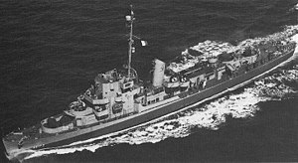
USS Eldridge

An alternative explanation of the test actually conducted is offered by Researcher Jacques Vallée who describes a procedure on board USS Engstrom, which was docked alongside the Eldridge in 1943. The operation involved the generation of a powerful electromagnetic field on board the ship in order to deperm or degauss it, with the goal of rendering the ship undetectable or "invisible" to magnetically fused undersea mines and torpedoes. This system was invented by a Canadian, Charles F. Goodeve, when he held the rank of commander in the Royal Canadian Naval Volunteer Reserve. The Royal Navy and other navies used it widely during World War II. British ships of the era often included such degaussing systems built into the upper decks (the conduits are still visible on the deck of HMS Belfast in London, for example). Degaussing is still used today. However, it has no effect on visible light or radar. Vallée speculates that accounts of USS Engstrom's degaussing might have been garbled and confabulated in subsequent retellings, and that these accounts may have influenced the story of "The Philadelphia Experiment."

- Oct 28 1944 - WW2: USS Gleaves (DD 423), while operating off the Franco-Italian coast, bombards German troop concentrations, barracks, and gun emplacements. Enemy shore fire at the destroyer is inaccurate, but Gleaves achieves excellent return fire results.

- Oct 28 1944 - WW2: The first B-29 Superfortress bomber mission flies from the airfields in the Mariana Islands in a strike against the Japanese base at Truk.

- Oct 28 1946 – Post WW2: German Rocket Engineers Begin Work in USSR » Given a pathological obsession of the Soviet government with secrecy, it was a remarkable phenomenon that Joseph Stalin did allow hundreds of Soviet specialists, many of them recent GULAG (forced labor camp) inmates, travel to postwar Germany and work side by side with their German colleagues on the development of rocket technology. Inevitably, the whole endeavor had a temporary nature, aimed to train Soviet cadre in the industry that was virtually nonexistent in the USSR at the time. From the outset of the program, Soviet authorities had grave concerns about engaging thousands of Germans, who had relative freedom of movement, into the sensitive defense project.

In October 1946, the best German engineers who worked for the Soviet missile program were ordered on the trains and sent to the various locations in the USSR to assist in the organization of missile production and design. By the beginning of the 1947, Soviets completed the transfer of all works on rocket technology from Germany into secret locations in the USSR. In the fall of 1947, Soviet-German team launched eleven A-4 rockets near the village of Kapustin Yar in the steppes north of the Caspian Sea.

- Oct 28 1962 – Cuban Missile Crisis: Khrushchev Orders Withdrawal Of Missiles from Cuba » In 1960, Khrushchev had launched plans to install medium and intermediate range ballistic missiles in Cuba that would put the eastern United States within range of nuclear attack. In the summer of 1962, U.S. spy planes flying over Cuba had photographed construction work on missile facilities. President John F. Kennedy announced a naval blockade to prevent the arrival of more missiles and demanded that the Soviets dismantle and remove the weapons already in Cuba. The situation was extremely tense and could have resulted in war between the United States and the Soviet Union, but at the last minute, Khrushchev turned the Soviet ships around that were to deliver more missiles to Cuba and agreed to dismantle and remove the weapons that were already there.

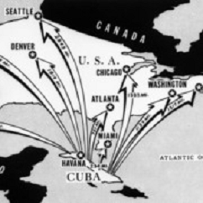

This ended nearly two weeks of anxiety and tensions between the United States and the Soviet Union that came close to provoking a nuclear conflict. The consequences of the crisis were many and varied. Relations between Cuba and the Soviet Union were on shaky ground for some time after Khrushchev’s removal of the missiles, as Fidel Castro accused the Russians of backing down from the Americans and deserting the Cuban revolution. European allies of the United States were also angered, not because of the U.S. stance during the crisis, but because the Kennedy administration kept them virtually in the dark about negotiations that might have led to an atomic war.

Inside the Soviet Union, hard-liners were appalled at Khrushchev’s withdrawal of the weapons. Two years later, in 1964, Leonid Brezhnev and Aleksei Kosygin pushed him from power and proceeded to lead the Soviet Union on a massive military buildup. There was perhaps one positive aspect of the crisis. Having gone to the edge of what President Kennedy referred to as the “abyss of destruction,” cooler heads in both nations initiated steps to begin some control over nuclear weapons. Less than a year after the crisis ended, the United States and Soviet Union signed an agreement to end aboveground testing; in 1968, both nations signed a non-proliferation treaty.

- Oct 28 1964 – Vietnam War Era: U.S. Officials Deny Any Involvement in bombing of North Vietnam » U.S. T-28 airplanes flown by Thai pilots bomb and strafe North Vietnamese villages in the Mugia Pass area. North Vietnam charged publicly that U.S. personnel participated in the raids, but U.S. officials denied that any Americans were involved.

- Oct 28 1965 – Vietnam War: Viet Cong commandos damage and destroy a number of allied aircraft in two separate raids on U.S. air bases, including Chu Lai, on the coast of the South China Sea in Quang Tin Province, I Corps.

- Oct 28 2006 – Post WWII: Funeral service for the peace of the executed at Bykivnia forest, outside of Kiev, Ukraine, with reburial of 817 Ukrainian civilians (out of some 100,000) executed by Bolsheviks at Bykivnia in 1930s - early 1940s.

-o-o-O-o-o-

- Oct 29 1814 – U.S. Navy: The first steam-powered U.S. Navy warship, Fulton, launches at New York City. Commissioned in June 1816, she carries President James Monroe on a day cruise in New York Harbor a year later.

- Oct 29 1863 – Civil War: Battle of Wauhatchie (Brown's Ferry) Concludes » Union Forces under General Ulysses S. Grant repel a Confederate night attack led by General James Longstreet opening a supply line into Chattanooga, Tennessee. Casualties and losses: US 420 - CSA 408.

- Oct 29 1914 – WWI Era: The Ottoman Empire (Turkey) enters the war on the side of the Germans as three warships shell the Russian port of Odessa. Three days later, Russia declares war on Turkey. Russian and Turkish troops then prepare for battle along the common border of the Russian Caucasus and the Ottoman Empire.

- Oct 29 1915 – WWI Era: Jane Addams Writes to Woodrow Wilson about Dangers Of Preparing for War » Addams, the celebrated founder of Hull House, a social settlement that served as a welfare agency for needy families in Chicago, had also become a leading international voice for peace and the chairwoman of the Women’s Peace Party. In April 1915, she attended the International Congress of Women at The Hague in the Netherlands, an assemblage of women from around the world, including the belligerent nations, who advocated a non-violent method of conflict resolution. Disturbed by Wilson’s call for increased military preparedness, Addams wrote to the president in the name of the Women’s Peace Party.
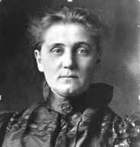

Above all, Addams expressed concern that the rich, powerful U.S. was setting an example for other, poorer nations, who would feel compelled to increase their own preparedness and move the world ever further from the ideal of peace and international cooperation. “At this crisis of the world, to establish a ‘citizen soldiery’ and enormously to increase our fighting equipment would inevitably make all other nations fear instead of trust us,” Adams argued. “It has been the proud hope of American citizens who love their kind, a hope nobly expressed in some of your own messages, that to the United States might be granted the unique privilege not only of helping the war-worn world to a lasting peace, but of aiding toward a gradual and proportional lessening of that vast burden of armament which has crushed to poverty the people of the old world.”

- Oct 29 1940 –WW2 Era: Secretary of War Henry L Stimson draws the 1st number - #158 - in the 1st peacetime military draft in US history

- Oct 29 1941 – Holocaust: Lithuania, Soviet and German Involvement » Between 1920 and 1940, Kaunas (Kovno) was Lithuania's capital and largest city. It had a Jewish population of 35,000 to 40,000, about one-fourth of the city's total population. Jews were concentrated in the city's commercial, artisan, and professional sectors. Kaunas was also a center of Jewish learning. The yeshiva in Slobodka, an impoverished district of the city, was one of Europe's most prestigious institutions of higher Jewish learning, with a rich and varied Jewish culture. The city had almost 100 Jewish organizations, 40 synagogues, many Yiddish schools, 4 Hebrew high schools, a Jewish hospital, and scores of Jewish-owned businesses. It was also an important Zionist center.

Kaunas’ Jewish life was disrupted when the Soviet Union occupied Lithuania in June 1940. The occupation was accompanied by arrests, confiscations, and the elimination of all free institutions. Jewish communal organizations disappeared almost overnight. Soviet authorities confiscated the property of many Jews. Meanwhile, the Lithuanian Activist Front, founded by Lithuanian nationalist emigres in Berlin, clandestinely disseminated anti-Semitic literature in Lithuania. Among other themes, the literature blamed Jews for the Soviet occupation. Hundreds of Jews were exiled to Siberia.

Following Germany's invasion of the Soviet Union on 22 June 1941, Soviet forces fled Kaunas. Immediately before and following the German occupation of the city on 24 JUN, anti-Communist, pro-German Lithuanian mobs began to attack Jews (whom they unfairly blamed for Soviet repression), especially along Jurbarko and Krisciukaicio streets. These right-wing vigilantes murdered hundreds of Jews and took dozens more Jews to the Lietukis Garage, in the city center, and killed them there.

In early July 1941, German Einsatzgruppe (mobile killing unit) detachments and their Lithuanian auxiliaries began systematic massacres of Jews in several of the forts around Kaunas. These forts had been constructed by the Russian tsars in the nineteenth century for the defense of the city. Einsatzgruppe detachments and Lithuanian auxiliaries shot thousands of Jewish men, women, and children, primarily in the Ninth Fort, but also in the Fourth and Seventh forts. Within six months of the German occupation of the city, the Germans and their Lithuanian collaborators had murdered half of all Jews in Kaunas.

The Nazis established a civilian administration under SA Major General Hans Kramer. Between July and 15 August 1941, the Germans concentrated the remaining Jews, some 29,000 people, in a ghetto established in Slobodka. It was an area of small primitive houses and no running water. The ghetto had two parts, called the "small" and "large" ghetto, separated by Paneriu Street. In the autumn of 1943, the SS assumed control of the ghetto and converted it into the Kauen concentration camp. On 8 July 1944, the Germans evacuated the camp, deporting most of the remaining Jews to the Dachau concentration camp in Germany or to the Stutthof camp, near Danzig, on the Baltic coast. Three weeks before the Soviet army arrived in Kaunas, the German razed the ghetto to the ground with grenades and dynamite. As many as 2,000 people burned to death or were shot while trying to escape.

At its peak, the Ghetto held 40,000 people, most of whom were later sent to concentration and extermination camps, or were shot, 10,000 of them, at the Ninth Fort massacre known as the "Great Action. About 500 Jews escaped from work details and directly from the Ghetto, and joined Soviet partisan forces in the distant forests of southeast Lithuania and Belarus. Of the 250,000 Jews living in Lithuania in 1939, only between 12,500 and 17,500 survived the war.

- Oct 29 1942 – Holocaust: In the former Soviet Union city of Pinsk approximately 16,000 Jews were murdered this day by the Nazis in the same method as happened in the Auschwitz concentration camp. According to some witnesses and by some sources also, they could smell the dead as far as in the next city due to the number of murders done.

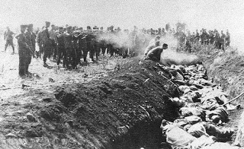

- Oct 29 1942 – WW2: The British Protest Against the Persecution of Jews » Leading British clergymen and political figures hold a public meeting to register their outrage over the persecution of Jews by Nazi Germany. In a message sent to the meeting, Prime Minister Winston Churchill summed up the sentiments of all present: “The systematic cruelties to which the Jewish people-men, women, and children-have been exposed under the Nazi regime are amongst the most terrible events of history, and place an indelible stain upon all who perpetrate and instigate them. Free men and women,” Churchill continued, “denounce these vile crimes, and when this world struggle ends with the enthronement of human rights, racial persecution will be ended.” The very next day, the power of protest over cruelty was made evident elsewhere in Europe. When Gestapo officers in Brussels removed more than 100 Jewish children from a children’s home for deportation, staff members refused to leave the sides of their young charges. Both the staff and the children were removed to a deportation camp set up in Malines. Protests rained down on the Germans, who had occupied the nation for more than two years, including one lodged by the Belgian secretary-general of the Ministry of Justice. The children and staff were returned to the home.

- Oct 29 1942 – WW2: PBY-5 Catalinas from Patrol Squadron (VP) 11 sink Japanese submarine I 172.

- Oct 29 1944 – WW2: Breda, Netherlands Liberated » After the fall of Poland and then France in 1940, the remaining Poles that had fought in both campaigns retreated with the British Army to the United Kingdom. In 1942 they formed the 1st Armoued Polish Division under the command of Major General Stanisław Maczek which at its peak numbered approximately 16,000 soldiers. The division served in the final phases of the Battle of Normandy. After the Allied armies broke out from Normandy, the Division fought the Germans along the coast of the English Channel. Thanks to an outflanking maneuver, it proved possible to free Breda in the Netherlands after a hard fight but without incurring losses in the town's population. A petition on behalf of 40,000 inhabitants of Breda resulted in Maczek being made an honorary Dutch citizen after the war. The Division's finest hour came when its forces accepted the surrender of the German naval base of Wilhelmshaven, taking captive the entire garrison, together with some 200 vessels of Hitler's Kriegsmarine.

- Oct 29 1953 – Cold War: Netherlands Missile Protest » More than 550,000 people took to the streets to demonstrate against the placement of 48 Ground Launched Cruise Missiles fitted with nuclear warheads for the 486th Tactical Missile Wing of the U.S. Seventeenth Air Force at Woensdrecht Air Base run by the Royal Netherlands Air Force. The U.S. missile wing would have had a maximum complement of 1100 personnel. However, just after completion of the required facilities, the Intermediate-Range Nuclear Forces Treaty put a halt to these plans. The demonstration was the biggest in Dutch history. Two years later, the Cruise missiles protestors offered the Netherland’s Prime Minister Ruud Lubbers 3.7 million signatures. When the prime minister gave a speech, the demonstrators massively turned their backs on him, but he continued his speech. Kind of a bad moment for him but in the end he kind of ‘won’ the argument since one of the things that brought the Soviet Union down was their massive defense spending in order to keep up the arms race with the West.

- Oct 29 1956 – Cold War: Suez Crisis Begins » Israeli armed forces push into Egypt toward the Suez Canal, initiating the Suez Crisis. They would soon be joined by French and British forces, creating a serious Cold War problem in the Middle East.

The catalyst for the joint Israeli-British-French attack on Egypt was the nationalization of the Suez Canal by Egyptian leader General Gamal Abdel Nasser in July 1956. The situation had been brewing for some time. Two years earlier, the Egyptian military had begun pressuring the British to end its military presence (which had been granted in the 1936 Anglo-Egyptian Treaty) in the Canal Zone. Nasser’s armed forces also engaged in sporadic battles with Israeli soldiers along the border between the two nations, and the Egyptian leader did nothing to conceal his antipathy toward the Zionist nation. Supported by Soviet arms and money, and furious with the United States for reneging on a promise to provide funds for construction of the Aswan Dam on the Nile River, Nasser ordered the Suez Canal seized and nationalized.

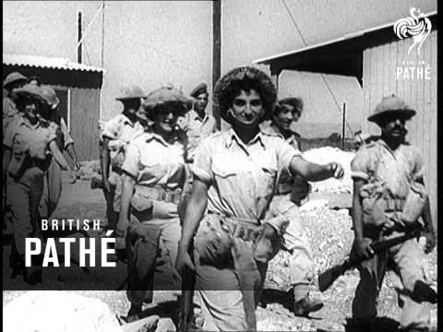

The British were angry with the move and sought the support of France (which believed that Nasser was supporting rebels in the French colony of Algeria), and Israel (which needed little provocation to strike at the enemy on its border), in an armed assault to retake the canal. The Israelis struck first, but were shocked to find that British and French forces did not immediately follow behind them. Instead of a lightning strike by overwhelming force, the attack bogged down. The United Nations quickly passed a resolution calling for a cease-fire.

The Soviet Union began to issue ominous threats about coming to Egypt’s aid. A dangerous situation developed quickly, one that the Eisenhower administration hoped to defuse before it turned into a Soviet-U.S. confrontation. Though the United States sternly warned the Soviet Union to stay out of the situation, Eisenhower also pressured the British, French, and Israeli governments to withdraw their troops. They eventually did so in late 1956 and early 1957.

- Oct 29 1956 – Cold War: The 6th Fleet is ordered to evacuate U.S. nationals during the Suez Canal Crisis. Some of the ships involved are USS Coral Sea (CVA 43), USS Randolph (CVA 15), USS Antietam (CVA 36), and a series of support vessels. By Nov. 3, approximately 2,000 people are evacuated.

- Oct 29 1971 – Vietnam War: U.S. Troop Strength Reaches Five-Year Low » The total number of U.S. troops remaining in Vietnam drops to 196,700 – the lowest level since January 1966. This was a result of the Vietnamization program announced by President Richard Nixon at the June 1969 Midway Conference.

- Oct 29 1980 – U.S. Navy: USS Parsons (DDG 33) rescues 110 Vietnamese refugees 330 miles south of Saigon.

- Oct 29 1997– Middle East: Iraq's Revolution Command Council announces that it will no longer allow US citizens and US aircraft to serve with UN arms inspection teams.

- Oct 29 1998 – NASA: John Glenn Returns to Space » Nearly four decades after he became the first American to orbit the Earth, Senator John Hershel Glenn, Jr., is launched into space again as a payload specialist aboard the space shuttle Discovery. At 77 years of age, Glenn was the oldest human ever to travel in space. During the nine-day mission, he served as part of a NASA study on health problems associated with aging. Glenn, a lieutenant colonel in the U.S. Marine Corps, was among the seven men chosen by the National Aeronautics and Space Administration (NASA) in 1959 to become America’s first astronauts. A decorated pilot, he had flown nearly 150 combat missions during World War II and the Korean War. In 1957, he made the first nonstop supersonic flight across the United States, flying from Los Angeles to New York in three hours and 23 minutes.

- Oct 29 2004 – War On Terrorism: For the first time, Osama bin Laden admits direct responsibility for the Sept. 11, 2001 terrorist attacks in the US; his comments are part of a video broadcast by the Al Jazeera network.

-o-o-O-o-o-

- Oct 30 1775 – American Revolution Era: Naval Committee Established by Congress » The Continental Congress appoints seven members to serve on an administrative naval committee tasked with the acquisition, outfitting and manning of a naval fleet to be used in defense against the British. Almost two weeks earlier, on October 13, 1775, Congress had authorized the construction and arming of vessels for the country’s first navy.

- Oct 30 1863 –Civil War: The wooden side-wheel steam ship Vanderbilt captures the bark Saxon, which was suspected of having rendezvoused with and taken cargo from CSS Tuscaloosa at Angra Pequena, Africa.

- Oct 30 1917 –WWI : Battle of Passchendaele (31 JUL – 10 Nov) » The battle, also known as The Third Battle of Ypres, was a campaign fought by the Allies against the German Empire for control of the ridges south and east of the Belgian city of Ypres in West Flanders. It was part of a strategy decided by the Allies at conferences in November 1916 and May 1917. Passchendaele lies on the last ridge east of Ypres, 5 mi from Roulers junction of the Bruges to Kortrijk railway. The station at Roulers was on the main supply route of the German 4th Army. Once Passchendaele Ridge had been captured, the Allied advance was to continue to a line from Thourout to Couckelaere.

The resistance of the 4th Army, unusually wet weather in August, the beginning of the autumn rains in October and the diversion of British and French resources to Italy, enabled the Germans to avoid the general withdrawal which had seemed inevitable in early October. The campaign ended in November, when the Canadian Corps captured Passchendaele on 30 OCT, apart from local attacks in December and early in the new year. The Battle of the Lys (Fourth Battle of Ypres) and the Fifth Battle of Ypres of 1918, were fought before the Allies occupied the Belgian coast and reached the Dutch frontier.

A campaign in Flanders was controversial in 1917 and has remained so. The British Prime Minister, David Lloyd George, opposed the offensive, as did General Ferdinand Foch, the Chief of Staff of the French Army. Field Marshal Sir Douglas Haig, commander of the British Expeditionary Force (BEF), did not receive approval for the Flanders operation from the War Cabinet until 25 JUL. Matters of dispute by the participants, writers and historians since 1917 include the wisdom of pursuing an offensive strategy in the wake of the Nivelle Offensive, rather than waiting for the arrival of the American Expeditionary Force (AEF) in France.

The choice of Flanders, its climate, the selection of General Hubert Gough and the Fifth Army to conduct the offensive, debates over the nature of the opening attack and between advocates of shallow and deeper objectives, remain controversial. The time between the Battle of Messines (7–14 June) and the first Allied attack (31 July), the extent to which the internal troubles of the French armies influenced the British, the effect of the exceptional weather, the decision to continue the offensive in October and the human costs of the campaign, are also debated. Casualties and losses: British Empire, French, and Belgium 240,000 to 448,614 (disputed) – German Empire 217,000–400,000 (disputed) including 24,065 prisoners.

- Oct 30 1918 – WWI: Ottoman Empire Signs Treaty with Allies » Aboard the British battleship Agamemnon, anchored in the port of Mudros on the Aegean island of Lemnos, representatives of Great Britain and the Ottoman Empire sign an armistice treaty marking the end of Ottoman participation in the First World War.

Though the Ottoman Empire—in a period of relative decline since the late 16th century—had initially aimed to stay neutral in World War I, it soon concluded an alliance with Germany and entered the war on the side of the Central Powers in October 1914. The Turks fought fiercely and successfully defended the Gallipoli Peninsula against a massive Allied invasion in 1915-1916, but by 1918 defeat by invading British and Russian forces and an Arab revolt had combined to destroy the Ottoman economy and devastate its land, leaving some six million people dead and millions more starving.

As early as the first week of October 1918, both the Ottoman government and several individual Turkish leaders contacted the Allies to feel out peace possibilities. Britain, whose forces then occupied much of the Ottoman territories, was loath to step aside for its allies, particularly France, which according to an agreement concluded in 1916 would take control of the Syrian coast and much of modern-day Lebanon. In a move that enraged his French counterpart, Georges Clemenceau, Prime Minister David Lloyd George and his cabinet authorized Admiral Arthur Calthorpe, Britain’s naval commander in the Aegean Sea, to negotiate an immediate armistice with Turkey without consulting France. Though Britain alone would engineer the Ottoman exit from the war, the two powerful Allies would continue to grapple over control in the region at the Paris Peace Conference, and for years beyond.

Negotiations between Calthorpe’s team and the delegation from Constantinople, led by the Ottoman Minister of Marine Affairs Rauf Bey, began at 9:30 on the morning of 30 OCT, aboard the Agamemnon. The Treaty of Mudros, signed that evening, stated that hostilities would end at noon the following day. By its terms, Turkey had to open the Dardanelle and Bosporus straits to Allied warships and its forts to military occupation; it was also to demobilize its army, release all prisoners of war and evacuate its Arab provinces, the majority of which were already under Allied control. Bey and his fellow delegates refused to paint the treaty as an act of surrender for Turkey—later causing disillusionment and anger in Constantinople—but in fact that is what it was. The Treaty of Mudros ended Ottoman participation in World War I and effectively—if not legally—marked the dissolution of a once mighty empire. From its ruins, the victors of the First World War attempted to use the post-war peace negotiations to create a new, more unpredictable entity: the modern Middle East.

- Oct 30 1922 – Italy: Mussolini sends his black shirts into Rome. The Fascist takeover is almost without bloodshed. The next day, Mussolini is made prime minister. He centralizes all power in himself as leader of the Fascist party and attempts to create an Italian empire, ultimately in alliance with Hitler‘s Germany.

- Oct 30 1939 – WW2 Era: German submarine U-56 fails on attack of English battleship Nelson with Winston Churchill, Dudley Pound & Charles Forbes aboard.

- Oct 30 1941 – WW2 Era: Navy Oiler Torpedoed by German Sub » The USS Salinas (AO-19), a United States Navy Patoka-class replenishment oiler, is torpedoed near Newfoundland by German submarine U-106. At 0712, Salinas took a torpedo portside, at her number 9 tank. A second torpedo followed, hitting portside at tanks 2 and 3. Salinas settled to near her loaded waterline and remained there. A submarine was sighted on the surface at 0730, close aboard on the starboard quarter. The U-boat fired three torpedoes, all misses — two ahead, one astern of the damaged oiler — then submerged. Salinas's stern gun opened fire on the disappearing U-boat, possibly hitting it. USS Du Pont (DD-152) then moved in and dropped a string of depth charges on the submarine's estimated position. Salinas's crew, having suffered no serious injuries (one man was lightly wounded), clear the wreckage and moved south, to Brooklyn, New York, for repair

- Oct 30 1941 – WW2 Era: US Navy destroyer Anderson (DD-411) made sonar contact with U-boat and depth charged it (possibly sinking it). Anderson's men saw an oil slick and lowered a bucket that, when drawn up, contained a mixture of oil, water, and burnt TNT.

- Oct 30 1941 – WW2 Era: FDR approves Lend-Lease aid to the USSR » President Roosevelt, determined to keep the United States out of the war while helping those allies already mired in it, approves $1 billion in Lend-Lease loans to the Soviet Union. The terms: no interest and repayment did not have to start until five years after the war was over.

The Lend-Lease program was devised by President Roosevelt and passed by Congress on March 11, 1941. Originally, it was meant to aid Great Britain in its war effort against the Germans by giving the chief executive the power to “sell, transfer title to, exchange, lease, lend, or otherwise dispose of” any military resources the president deemed ultimately in the interest of the defense of the United States. The reasoning was: If a neighbor was successful in defending his home, the security of your home was enhanced. Although the Soviet Union had already been the recipient of American military weapons, and now had been promised $1 billion in financial aid, formal approval to extend the Lend-Lease program to the USSR had to be given by Congress. 7 NOV.

By the end of the war, more than $50 billion in funds, weapons, aircraft, and ships had been distributed to 44 countries. After the war, the Lend-Lease program morphed into the Marshall Plan, which allocated funds for the revitalization of “friendly” democratic nations—even if they were former enemies.

- Oct 30 1942 – WW2: USS Enterprise Arrives Noumea, New Caledonia » Repaired at Pearl Harbor from 10 SEP to 16 OCT, USS Enterprise (CV-6) departed once more for the South Pacific where with USS Hornet (CV-8), she formed TF 61. On 26 OCT, the carrier scout planes located a Japanese carrier force and the Battle of the Santa Cruz Island was underway. Enterprise aircraft struck carriers, battleships, and cruisers during the struggle, while the "Big E" herself underwent intensive attack. Hit twice by bombs, USS Enterprise lost 44 killed and had 75 wounded.

Despite serious damage, she continued in action and took on board a large number of planes from Hornet when that carrier had to be abandoned. Though the American losses of a carrier and a destroyer were more severe than the Japanese loss of one light cruiser, the battle gained priceless time to reinforce Guadalcanal against the next enemy onslaught.

On 30 OCT USS Enterprise entered Noumea for repairs, but a new Japanese thrust at the Solomons demanded her presence and she again sailed on 11 NOV, repair crews from USS Vestal (AR 4) still on board, working vigorously. Two days later, "Big E" planes swarmed down on an enemy force and disabled a battleship which was sunk later by other American aircraft, and on 14 NOV, aviators from Enterprise helped to dispatch a heavy cruiser. When the Naval Battle of Guadalcanal ended on November 15th, CV-6 had shared in sinking 16 ships and damaging 8 more. The carrier returned to Noumea on 16 NOV to complete her repairs.

Sailing again on 4 DEC, USS Enterprise trained out of Espiritu Santo, New Hebrides, until January 28, 1943 when she departed for the Solomons area. On 30 JAN her fighters flew combat air patrol for a cruiser-destroyer group during the Battle of Rennell Island. Despite the destruction of a large majority of the attacking Japanese bombers by Enterprise planes, USS Chicago (CA-29) was sunk by aerial torpedoes. Detached after the battle, the carrier arrived at Espiritu Santo on 1 FEB, and for the next 3 months operated out of that base, covering U.S. surface forces up to the Solomons. The ship then steamed to Pearl Harbor where on May 27, 1943, Admiral Chester W. Nimitz presented the ship with the first Presidential Unit Citation won by an aircraft carrier. On July 20, 1943 she entered Puget Sound Navy Yard, Bremerton, Wash., for a much needed overhaul.

- Oct 30 1942 – WW2: Lt. Tony Fasson, Able Seaman Colin Grazier and canteen assistant Tommy Brown from HMS Petard board U-559, retrieving material which would lead to the decryption of the German Enigma code.

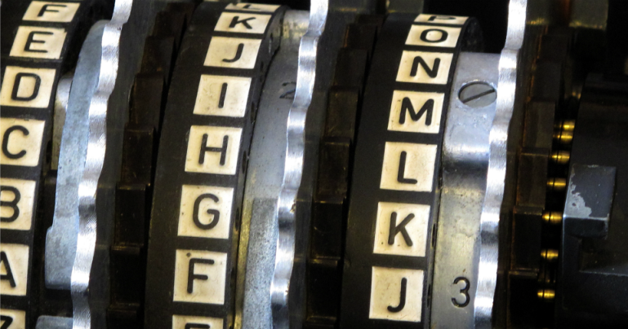

- Oct 30 1944 – WW2: USS Argus (PY-14) rescues all survivors of the U.S. freighter John A. Johnson, which was sunk by Japanese submarine I-12 the previous day, north of Oahu.

- Oct 30 1944 – WW2: USS Franklin (CV-13) and USS Belleau Wood (CVL-24) are hit by a Japanese kamikaze near the Philippines. The attack on Franklin kills 56 of her crew and the attack on Belleau Wood sees 92 of her crew killed or missing. Both ships return to the U.S. for repairs.

  - Oct 30 1945 – Post WW2: Shoe Rationing » The U.S. government announced the end of shoe rationing, effective at midnight. Serious rubber shortages at the time it was implemented meant that rubber shoes were in very short supply, and the military’s leather requirements (for boots, jackets and more) resulted in limitations also being placed on leather shoes. Effective February 9, 1942 rubber boots and rubber work shoes were rationed – you had to apply for a new pair at a rationing board, and if your application was approved, you had to turn in your old pair. And only work shoes were allowed – no sports sneakers could be purchased. Similarly, rationing of leather shoes started in 1943. Each person (adult and child) was allowed up to 3 pairs of new leather shoes per year, bought using special rationing stamps.

- Oct 30 1950 – Korean War: The First Marine Division is ordered to replace the entire South Korean I Corps at the Chosin Reservoir area.

- Oct 30 1953 – Cold War: Eisenhower Approves NSC 162/2 » U.S. President Dwight D. Eisenhower formally approves the top secret document National Security Council Paper No. 162/2, which states that the United States' arsenal of nuclear weapons must be maintained and expanded to counter the communist threat. It also made clear the connection between military spending and a sound American economy. The paper began by warning that the Soviet Union already possessed sufficient atomic weapons and delivery capabilities to inflict a “crippling blow to our industrial base and our continued ability to prosecute a war.” While in the short-term such action by the Soviets seemed unlikely, this did not mean that the United States could afford to slacken its efforts to stockpile “sufficient atomic weapons.” In specific situations, the United States should “make clear to the USSR and Communist China…its intention to react with military force against any aggression by Soviet bloc armed forces.” Nuclear weapons should be “as available for use as other weapons.” NSC 162/2 indicated the growing reliance of the United States on its nuclear arsenal as a deterrent to communist aggression during the Eisenhower years. It also suggested that concerns were being raised about the ability of the American economy to support both a booming domestic standard of living and massive military expenditures. Its approval by the President was a definite sign of his so-called “New Look” foreign policy that depended on more cost efficient nuclear weapons to fight the Cold War.

- Oct 30 1961 – Cold War: The USSR detonates “Tsar Bomba,” at Novaya Zemlya, an archipelago in the Arctic Ocean in northern Russia. At 58 megatons of yield, it is still the largest nuclear device ever detonated. Nikita Kruschev announces that the scientists had planned to make it 100 megatons, but had reduced the yield so as to avoid breaking all the windows in Moscow.

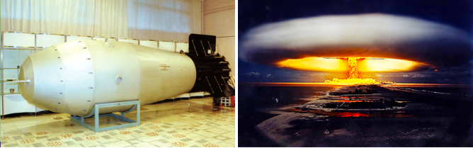

- Oct 30 1965 – Vietnam War: Marines Repel Attack Near Da Nang » Just miles from Da Nang, United States Marines repel an intense attack by wave after wave of Viet Cong forces, killing 56 guerrillas. Among the dead, a sketch of Marine positions is found on the body of a 13–year–old Vietnamese boy who sold drinks to the Marines the day before.

- Oct 30 1970 – Vietnam War: Monsoon Rains Halt War » The worst monsoon to hit the area in six years causes large floods, kills 293, leaves 200,000 homeless and virtually halts the Vietnam War. The resultant floods killed 293 people and left more than 200,000 homeless.

- Oct 30 2010 – Terrorism: Security screening of cargo and air passengers in the United States, Britain and Canada was stepped up after bombs were found in packages from Yemen to two Chicago synagogues.

-o-o-O-o-o-

- Oct 31 1776 – American Revolutionary War: George III’s First Speech Since Independence Declared » In his first speech before British Parliament since the leaders of the American Revolution came together to sign of the Declaration of Independence that summer, King George III acknowledges that all was not going well for Britain in the war with the United States.

In his address, the king spoke about the signing of the U.S. Declaration of Independence and the revolutionary leaders who signed it, saying, “for daring and desperate is the spirit of those leaders, whose object has always been dominion and power, that they have now openly renounced all allegiance to the crown, and all political connection with this country.” The king went on to inform Parliament of the successful British victory over General George Washington and the Continental Army at the Battle of Long Island on August 27, 1776, but warned them that, “notwithstanding the fair prospect, it was necessary to prepare for another campaign.”

Despite George III’s harsh words, General William Howe and his brother, Admiral Richard Howe, still hoped to convince the Americans to rejoin the British Empire in the wake of the colonists’ humiliating defeat at the Battle of Long Island. The British could easily have prevented Washington’s retreat from Long Island and captured most of the Patriot officer corps, including the commander in chief. However, instead of forcing the former colonies into submission by executing Washington and his officers as traitors, the Howe brothers let them go with the hope of swaying Patriot opinion towards a return to the mother country.

The Howe brothers’ attempts at negotiation failed, and the War for Independence dragged on for another four years, until the formal surrender of the British to the Americans on October 19, 1781, after the Battle of Yorktown.

- Oct 31 1803 – U.S. Navy: The frigate Philadelphia runs aground near Tripoli while pursuing an enemy vessel in shallow water. As a result, the Tripolitans send a large gunboat force and attack Philadelphia. Stuck fast and listing, she is defenseless and Capt. William Bainbridge surrenders. Under Commodore Edward Prebles orders, Lt. Stephen Decatur leads a mission to burn Philadelphia early the following year.

- Oct 31 1861 – Civil War: Gen. Winfield Scott Steps Down » Citing failing health, General Winfield Scott, commander of the Union forces, retires from service on this day in 1861. The hero of the Mexican War recognized early in the Civil War that his health and advancing years were a liability in the daunting task of directing the Federal war effort. Scott was asked by U.S. President Abraham Lincoln to devise a comprehensive plan to defeat the Confederacy. The strategy Scott developed called for the blockading of ports to isolate the South economically, to be followed by an offensive down the Mississippi River. In the optimistic early days of the war, this strategy seemed hopelessly sluggish—in fact, critics dubbed it the “Anaconda Plan” after the giant Amazonian snake that slowly strangles its prey.

Despite this initial criticism, it was the basic strategy that eventually won the war for the Union. Scott also drew criticism for ordering the advance of General Irwin McDowell’s army into Virginia, which resulted in the disastrous Union defeat at the First Battle of Bull Run on July 21, 1861. With the arrival of George McClellan as commander of the Army of the Potomac shortly after, Scott’s influence waned. He weighed over 300 pounds, suffered from gout and rheumatism, and was unable to mount a horse. His resignation on 31 OCT did not end his influence on the war, however. Lincoln occasionally sought his counsel, and many of his former officers commanded forces and executed the same maneuvers that he had used in Mexico. Scott retired to West Point to write his memoirs and died in 1866.

- Oct 31 1917 – WWI: Battle of Beersheba » Allied victory. Australian mounted division conduct the last successful cavalry charge in history.

During this fighting, the 3rd Light Horse Brigade had been sent to reinforce the Anzac Mounted Division, while the 5th Mounted Brigade remained in corps reserve armed with swords. With all brigades of both mounted divisions already committed to the battle, the only brigade available was the 4th Light Horse Brigade, which was ordered to capture Beersheba. These swordless mounted infantrymen galloped over the plain, riding towards the town and a redoubt supported by entrenchments on a mound of Tel es Saba south-east of Beersheba. The 4th Light Horse Regiment on the right jumped trenches before turning to make a dismounted attack on the Ottoman infantry in the trenches, gun pits, and redoubts. Most of the 12th Light Horse Regiment on the left rode on across the face of the main redoubt to find a gap in the Ottoman defenses, crossing the railway line into Beersheba to complete the first step of an offensive which culminated in the British Empire's Egyptian Expeditionary Force (EEF) capturing Jerusalem six weeks later. Casualties and losses: Allies 171 - Ottoman/German Empires 1900.

- Oct 31 1926 – Italy: Failed assassination attempt on Benito Mussolini by 15-year-old Anteo Zamboni, who was lynched on the spot.

- Oct 31 1940 – WW2 Era: Battle of Britain Ends (10 JUL - 31 OCT) » A military campaign in which the Royal Air Force (RAF) defended the United Kingdom (UK) against large-scale attacks by Nazi Germany's air force, the Luftwaffe. It has been described as the first major military campaign fought entirely by air forces. The British officially recognize the battle's duration as being from 10 July until 31 October 1940, which overlaps the period of large-scale night attacks known as the Blitz, which lasted from 7 September 1940 to 11 May 1941. German historians do not accept this subdivision and regard the battle as a single campaign lasting from July 1940 to June 1941, including the Blitz.

The primary objective of the German forces was to compel Britain to agree to a negotiated peace settlement. In July 1940, the air and sea blockade began, with the Luftwaffe mainly targeting coastal-shipping convoys, ports and shipping centers, such as Portsmouth. On 1 AUG the Luftwaffe was directed to achieve air superiority over the RAF with the aim of incapacitating RAF Fighter Command; 12 days later, it shifted the attacks to RAF airfields and infrastructure. As the battle progressed, the Luftwaffe also targeted factories involved in aircraft production and strategic infrastructure. Eventually, it employed terror bombing on areas of political significance and on civilians.

The Germans had rapidly overwhelmed France and the Low Countries, leaving Britain to face the threat of invasion by sea. The German high command knew the difficulties of a seaborne attack and its impracticality while the Royal Navy controlled the English Channel and the North Sea. On 16 July, Adolf Hitler ordered the preparation of Operation Sea Lion as a potential amphibious and airborne assault on Britain, to follow once the Luftwaffe had air superiority over the UK. In September, RAF Bomber Command night raids disrupted the German preparation of converted barges, and the Luftwaffe's failure to overwhelm the RAF forced Hitler to postpone and eventually cancel Operation Sea Lion. Germany proved unable to sustain daylight raids, but their continued night-bombing operations on Britain became known as the Blitz.

Historian Stephen Bungay cited Germany's failure to destroy Britain's air defenses to force an armistice (or even outright surrender) as the first major German defeat in World War II and a crucial turning point in the conflict. The Battle of Britain takes its name from a speech given by Prime Minister Winston Churchill to the House of Commons on 18 JUN: "What General Weygand called the 'Battle of France' is over. I expect that the Battle of Britain is about to begin."

- Oct 31 1941 – WW2 Era: German submarine U-562 sinks USS Reuben James (DD 245) as she escorted Convoy HX 156, killing 115 of her crew. Reuben James is the first U.S. Navy ship lost to enemy action in World War II.

- Oct 31 1941 – WW2 Era: U.S. Navy destroyer DuPont (DD-152), on convoy escort duty is attacked by a German U-boat. The torpedo misses the ship.

- Oct 31 1942 – WW2: U-boats sink and damage 120 allied ships this month (659,457 tons).

- Oct 31 1943 – WW2: An F4U Corsair fighter plane accomplishes the first successful radar–guided interception.

- Oct 31 1952 – Cold War: The U.S. explodes the first hydrogen bomb at Eniwetok Atoll in the Pacific.

- Oct 31 1955 – U.S. Marine Corps: Lewis B. “Chesty” Puller retires from the US Marine Corps as a Lieutenant General. He was nicknamed “Chesty” because of his perfect posture and the fact that his torso somewhat resembled a full-size beer keg full of lead bricks, raw muscle and horse steroids. He was a hard-as-shit Marine who is almost universally-recognized as the most badass dude to ever wear the uniform of the United States Marine Corps. Not bad, considering that being revered as the pinnacle of toughness by the USMC is kind of like being King of the Vikings or the toughest Klingon to ever set foot on the planet Kronos.

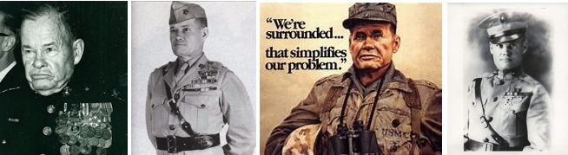

In his thirty-seven years of service to the Corps, Puller would rise through the ranks from Private to General, kick more asses than Juan Valdez on an insane bender, and become the most decorated Marine in American history. He fought guerrillas in Haiti and Nicaragua, and participated in battles of World War II and the Korean War. He was the second of two US servicemen to ever receive five Navy Crosses; US Navy submarine commander Roy Milton Davenport was the first. As it should be for any good badass military commander, Chesty Puller was admired by his men and feared by his enemies. He always led from the front, fighting in the trenches with the men, and never flinched under even the most serious fire. One time a grenade landed next to him, and when the rest of the guys around him dove for cover he glanced at it and nonchalantly said, “Oh, that. It’s a dud.”

He inspired loyalty and courage in his Marines, treated his men well, insisted on the best equipment and discipline for his troops, and had a no fear, win-at-all-costs attitude that won him fourteen medals for combat bravery in addition to countless unit citations and campaign ribbons. He is the most highly-decorated Marine in history, and a legendary figure amongst his brethren. To this day, Marines at Parris Island end their day by saying, "Good night Chesty Puller, wherever you are!"

- Oct 31 1956 – U.S. Navy: The U.S. Navy lands seven men in an R4D Skytrain on the ice at the South Pole. They are the first men to stand on the South Pole since Capt. Robert F. Scott in 1912.

- Oct 31 1956 – Cold War: British and French Troops Land in Suez Canal Zone » Two days after Israeli sent forces into Egypt initiating the Suez Crisis, British and French military forces join them in the canal zone to try to retake the canal. Originally, forces from the three countries were set to strike at once, intent on foiling Egypt’s plans to nationalize the canal, but the British and French troops were delayed. The entry of Britain and France into the struggle nearly brought the Soviet Union into the conflict, and seriously damaged their relationships with the United States. Behind schedule, but ultimately successful, the British and French forces took control of the area around the Suez Canal.

However, their hesitation had given the Soviet Union-also confronted with a growing crisis in Hungary–time to respond. The Soviets, eager to exploit Arab nationalism and gain a foothold in the Middle East, supplied arms from Czechoslovakia to the Egyptian government beginning in 1955, and eventually helped Egypt construct the Aswan Dam on the Nile River after the United States refused to support the project. Soviet leader Khrushchev railed against the invasion and threatened to rain down nuclear missiles on Western Europe if the Israeli-French-British force did not withdraw. The Eisenhower administration’s response was measured. It warned the Soviets that reckless talk of nuclear conflict would only make matters worse, and cautioned Khrushchev to refrain from direct intervention in the conflict.

However, Eisenhower also gave stern warnings to the French, British, and Israelis to give up their campaign and withdraw from Egyptian soil. Eisenhower was personally furious with the British, in particular, for not keeping the United States informed about their intentions. The United States threatened all three nations with economic sanctions if they persisted in their attack. The threats did their work. The British and French forces withdrew by December; Israel finally bowed to U.S. pressure in March 1957. While the U.S. action helped to avoid an escalation of the conflict in the Middle East, the damage to relations with France, Britain, and Israel took years to repair.

- Oct 31 1961 – Russia: Stalin’s Body Removed from Lenin’s Tomb » Five years after Soviet leader Nikita Khrushchev denounced Stalinism and the “personality cult” of Soviet rulers at the 20th Party Congress, Joseph Stalin’s embalmed body is removed from Lenin’s tomb in Moscow’s Red Square. When Vladimir Lenin died in 1924, the leader of Russia’s Bolshevik revolution was embalmed and placed in a special mausoleum before the Kremlin wall. Featuring glass casing, the tomb made the father of Soviet Russia visible for all posterity. Lenin was succeeded as Soviet leader by Joseph Stalin, who ruled over the USSR with an iron fist for three decades, executing or working to death millions of Soviets who stood in the way of his ruthless political and economic plans. However, Stalin also led his country to a hard-won victory over German invaders during World War II, and when died in 1953 he joined Lenin in his tomb. Within a few years of Stalin’s death, however, Soviet authorities uniformly condemned the brutal leader. In October 1961, his body was removed from public display in Red Square and shunted off to a nearby tomb.

- Oct 31 1966 – Vietnam War: While serving as boat captain and patrol officer on board River Patrol Boat (PBR) 105 in Vietnam, Boatswains Mate 1st Class James E. Williams and his crew are taken under fire, facing a superior number of enemy vessels. Williams leads his men to sink 65 enemy craft and inflict numerous casualties among the enemy. He is awarded the Medal of Honor for his actions. The USS James E. Williams (DDG 95) is named in his honor.

- Oct 31 1968 – Vietnam War: President Johnson Announces Bombing Halt » In a televised address to the nation five days before the presidential election, President Lyndon Johnson announces that on the basis of developments in the Paris peace negotiations, he has ordered the complete cessation of “all air, naval, and artillery bombardment of North Vietnam.” Accordingly, effective 1 NOV, the U.S. Air Force called a halt to the air raids on North Vietnam known as Operation Rolling Thunder.

- Oct 31 1970 – Vietnam War: Thieu Vows to Never Accept a Coalition Government » South Vietnamese President Nguyen Van Thieu delivers a speech on the state of the nation before a joint session of the South Vietnamese National Assembly, asserting that 99.1 percent of the country had been “pacified.” The pacification program that he alluded to had been a long-term multi-faceted effort to provide territorial security, destroy the enemy’s underground government, reassert political control, involve the people in their own government, and provide for economic and social reforms. Citing success in this program, Thieu said that a military victory was close at hand and that “we are seeing the light at the end of the tunnel.” With regard to the ongoing peace talks in Paris, the South Vietnamese president declared that the Communists viewed negotiations merely as a way to gain time and “to achieve victory gradually.” He said he would never accept a coalition government with the Communists, because “countless past experiences” had already shown that such an approach would not bring peace.

- Oct 31 1971 – Vietnam War: Saigon begins the release of 1,938 Hanoi POW’s.

- Oct 31 1972 – Vietnam War: While participating in a daring operation against enemy forces in the Republic of Vietnam, Engineman 1st Class Michael E. Thornton and Lt. Thomas R. Norris come under fire from a numerically superior force. Calling in for support and engaging the enemy, Norris is wounded by enemy fire. Learning that his lieutenant is down, Thornton bravely rushes through a hail of fire, fights off two enemy soldiers, and succeeds in removing Norris. Inflating Norris lifejacket, Thornton then tows him seaward for approximately two hours until they are picked up by support craft. Thornton is later awarded the Medal of Honor for his actions.

- Oct 31 1998 – Middle East: Iraq Disarmament Crisis Begins » Iraq announces it would no longer cooperate with United Nations weapons inspectors. The Iraq disarmament crisis was claimed as one of primary issues that led to the multinational invasion of Iraq on 20 March 2003. Since the 1980s, Iraq was widely assumed to have been producing and extensively running the programs of biological, chemical and nuclear weapons. Iraq made extensive use of chemical weapons during the Iran–Iraq War in the 1980s, including against its own Kurdish population. France and the Soviet Union assisted Iraq in the development of its nuclear program, but its primary facility was destroyed by Israel in 1981 in a surprise air strike.

After the Gulf War in 1990, the United Nations located and destroyed large quantities of Iraqi chemical weapons and related equipment and materials with varying degrees of Iraqi cooperation and obstruction, but the Iraqi cooperation later diminished in 1998. The disarmament issue remained tense throughout the 1990s with U.S. at the UN, repeatedly demanding Iraq to allow inspections teams to its facilities. Finally, this disarmament crises reached to its climax in 2002-2003, when U.S. President George W. Bush demanded a complete end to what he alleged was Iraqi production of weapons of mass destruction, and reasoned with Iraqi President Saddam Hussein to comply with UN Resolutions requiring UN weapons inspectors unfettered access to areas those inspectors thought might have weapons production facilities.

Since the Gulf War in 1991, Iraq had been restricted by the United Nations (UN) from developing or possessing such weapons. It was also required to permit inspections to confirm Iraqi compliance. Bush repeatedly backed demands for unfettered inspection and disarmament with threats of invasion. On 20 March 2003, a multinational alliance containing the armed forces of the United States and United Kingdom launched an invasion of Iraq in 2003. After the invasion of Iraq, the Iraq Survey Group, headed by David Kay was formed to find the alleged weapons of mass destruction. Apart from a small quantity of degraded pre-1991 shells, nothing was found. After the withdrawal of U.S. troops from Iraq in 2011, a number of failed Iraqi peace initiatives were revealed.

- Oct 31 2017 – War On Terrorism: New York City » Terrorist attack in New York when a truck driven by 29-year-old Sayfullo Saipov of Tampa, Florida mows down people on a cycle lane, killing 8, injuring 10. He was reported to have screamed "Allahu Akbar" after the crash. After a collision with a school bus he exited the vehicle brandishing what appeared to be two handguns, police said. A uniformed police officer confronted the suspect and shot him in the abdomen.

Derivative Sources:
- www.history.com/this-day-in-history
- https://www.historycentral.com
- https://www.wwiidogtags.com/ww2-history/october-16
- https://www.historyanswers.co.uk/history-of-war/day
- https://worldwar2daybyday.blogspot.com/2009/10/
- https://www.navalhistory.org
- https://www.warhistoryonline.com/category/war-articles
- https://en.wikipedia.org/wiki/October_1915 thru 1921
- https://en.wikipedia.org/wiki/October_1939 thru 1945
- https://www.history.navy.mil/today-in-history/october-16.html
- https://www.pbs.org/battlefieldvietnam/timeline/index.html
- https://www.answers.com
- https://weaponsandwarfare.com/category

To subscribe contact Lt. James “EMO” Tichacek, USN (Ret) Email: raoemo@sbcglobal.net or raoemo77@gmail.com Tel: (858) 842-1111. [Source: RAO Bulletin Attachment | October 2021 ++]

